Sunday 4 October, St Francis Day

Minister: Peter Trudinger Worship Leader: Margaret Cargill
Bible Reader: Ruth Pitt Piano: Eunice Sullivan
Singers: Anne Ind, Rhonda Amber Welcome: Bruce Ind
Communion stewards: Pam Ayles, Ruth Pitt, Margaret and Peter
Communion prep: Margaret Clogg, Ruth Wise
Audio: John Drew Projection: John Thornton
Camera 6, HSO: Ray Clogg Camera 8: Colin Cargill
Vision Director: Chris Ayles Vision switcher: John Secombe
Video editor: John Secombe

Picture on screen first
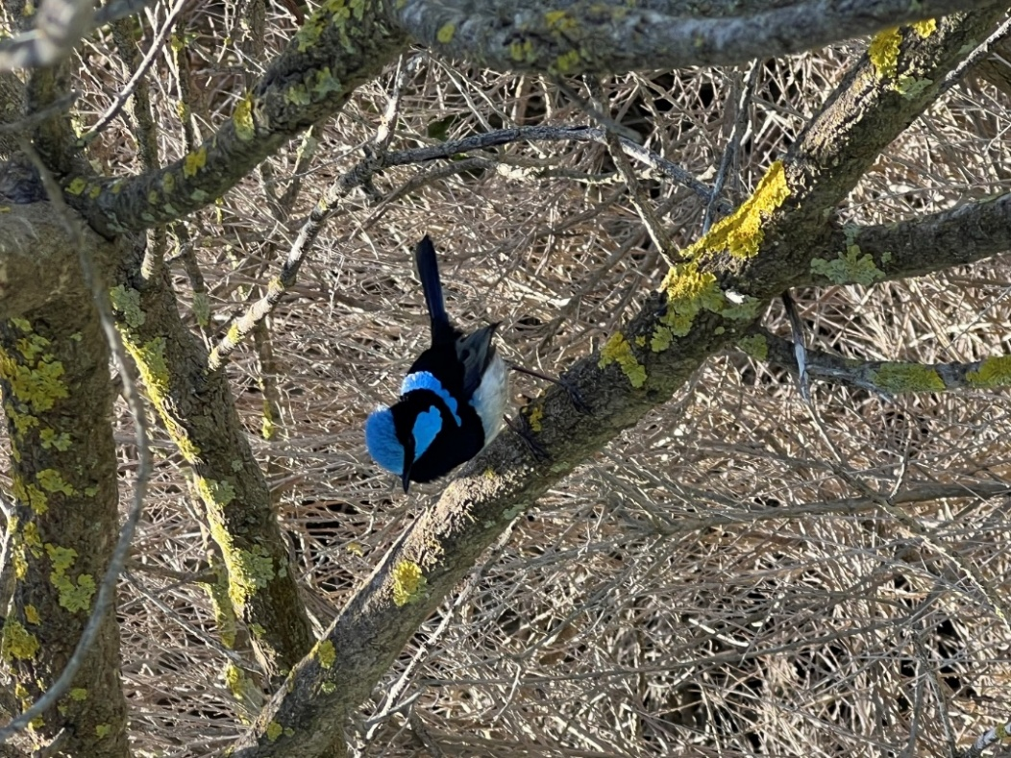

Meditation On screen and newsletter front page
Be kind and merciful.
Let no one ever come to you
without leaving better and happier. (Mother Teresa)

Sing-through 9:30, ends 9:50. Pre-service music. Candles lit.

All at lectern unless otherwise noted.

10:00 – Red light displayed, Intro video plays

MC: Welcome Lectern
A very warm welcome to everyone joining in this service of worship – those here in the building and all those online, as we meet, or at any time and in any place. You are all highly valued members of our gathering.

In September, we celebrated the Season of Creation. That season ends on St Francis Day, which is today. 2026 is the 800th anniversary of the death of St Francis, on October 3rd. Our service today reflects on St Francis of Assisi. Prompted by the example of Francis, we shall also remember and give thanks for the animals that are in our lives. If you are online, and if you have one or more companion animals that share your life, you may wish to bring them to join as you participate with us.

MC Acknowledgement of Country
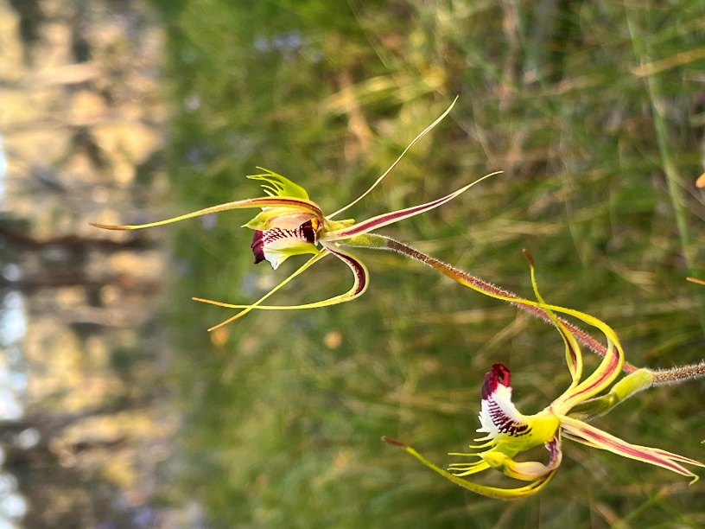
Today we remember the love poured out by those who have cared for this Land since time beyond measure. We honour those who have gone before and those who are yet to come. May we be mindful of the calling God places on humanity to care for all Creation. May we take the lead from the Kaurna People whose stories are entwined with the stewarding of this place, and from the First nations people of all places where this service is shared. May we learn from them and walk with them in God’s Covenant.

MC: Call to Worship
The skies above declare the glory of God;
The solid earth beneath proclaims God’s skill.
Daylight babbles in excitement;
Night-time instructs with gentle wisdom.
They do not speak in human words;
The sounds they make are silent
Yet their voice is heard throughout space;
Their praise echoes through all time.
Let us join our voices with theirs;
Let us praise our great Creator.
Based on Psalm 19:1-4

MC: Song All creatures worship God most high (TiS 100 verses 1, 2, 4, 5, 7) Stand or sit as you prefer.

1 All creatures worship God most high,
lift up your voice and with us sing
alleluia, alleluia;
O burning sun with golden beam,
and silver moon with softer gleam,
O praise him, O praise him,
alleluia, alleluia, alleluia!

2 Swift-rushing winds that are so strong,
and clouds that sail in heaven along,
O praise him, alleluia;
fresh-rising morn, in praise rejoice,
and lights of evening, find a voice:
O praise him ...

4 Dear mother earth, who day by day
unfold rich blessings on our way,
O praise him, alleluia!
All flowers and fruits that in you grow,
let them his glory also show;
O praise him ...

5 And everyone of tender heart,
forgiving others, take your part,
O praise him, alleluia!
All who long pain and sorrow bear
praise God and on him cast your care;
O praise him ...

7 Let all things their Creator bless,
and worship him in humbleness;
O praise him, alleluia!
Praise, praise the Father, praise the Son,
and praise the Spirit, Three in One:
O praise him, O praise him,
alleluia, alleluia, alleluia!
Based on Laudato sia Dio mio Signore, the `Canticle of the Sun' of Francis of Assisi 1182-1226 by William Henry Draper 1855-1933 alt. Public Domain

MC: Prayer of Confession
Loving God, you have showered us with blessings
and even adopted us as your children,
yet we ignore the inheritance you have given us.

You tell us not to worry,
yet we cannot seem to help ourselves
and fill our lives with concerns.

With refrigerators full of food
we still make grocery lists.
with closets so full of clothes we cannot shut the doors
we run out and buy new outfits.
with a simple invitation to “follow”
we form committees and debate what to do.
Forgive us, we pray,
May we learn to put love first.

MC: Assurance of Pardon and Renewal
Our God, who created all things, is kind and loving.
When we fail we are not condemned.
Rather we are called back into grace
and reminded that we are God's beloved children.
We can rely on this eternal promise
and within this grace we can live
and become authentic people of compassion.
My friends, hear the Good News:

In Christ Jesus, we are forgiven and made whole.
Thanks be to God.

PLT: The Scripture for Today
(Peter introduces the reading)

RP: Matthew 6:25-34
(Jesus said to the people:)
25 "Therefore I tell you,
do not worry about your life, what you will eat or what you will drink, or about your body, what you will wear.
Is not life more than food, and the body more than clothing?
26 Look at the birds of the air; they neither sow nor reap nor gather into barns, and yet your heavenly Father feeds them. Are you not of more value than they?
27 And can any of you by worrying add a single hour to your span of life?
28 And why do you worry about clothing?
Consider the lilies of the field, how they grow; they neither toil nor spin, 29 yet I tell you, even Solomon in all his glory was not clothed like one of these.
30 But if God so clothes the grass of the field, which is alive today and tomorrow is thrown into the oven, will he not much more clothe you - you of little faith?
31 Therefore do not worry, saying,
"What will we eat?'
or "What will we drink?'
or "What will we wear?'
32 For it is the Gentiles who strive for all these things; and indeed your heavenly Father knows that you need all these things.
33 But strive first for the kingdom of God and his righteousness, and all these things will be given to you as well.
34 "So do not worry about tomorrow, for tomorrow will bring worries of its own. Today's trouble is enough for today.

In this is the word of God.
Thank you, God, for speaking to us.

RP: Song Creative God, you spread the earth (Tune Kingsfold, arr Ralph Vaughan Williams, TiS 262, 585)

1. Creative God, you spread the earth
with life in many forms:
koala, gum and platypus,
galah in shrieking swarms.
Forgive us for each flow’r and bird
now vanished by our hand.
Teach us to treat with loving care
the creatures of the land.
2. The planet teemed with living things
before all human birth,
and even fire and beasts of prey
renewed the life of earth.
Forgive us, that the last to come,
we threaten sea and air.
Teach us to tend life’s fragile web
with wise and tender care.
3. O playful God, you fill the field
with lavender and blue.
You paint the bird with indigo,
with red or tawny hue.
Forgive us that we grieve your heart,
destroying what you do,
and teach us simpler, gentler ways
to live on earth with you.
Words: Ruth Duck. Reproduced with permission under OneLicense #A-604530. All rights reserved.

PLT: Message

MC: Prayers of the People

Loving God, because the world’s problems and miseries are so vast and complex, and because we are neither wise enough, nor resourceful and strong enough to put things to right, we pray for your divine assistance in every sphere.

Please assist those who are struggling for justice and peace among nations and communities.

Please assist those who care and advocate for our planet with its many environments and inhabitants, human and non-human.

Please assist those who are displaced from their homes and communities by wars and violence.

Please assist those who through research or hands-on care are fighting disease and suffering.

Please assist those who are trying to govern wisely, and those who administer justice.

Please assist those who care for the dignity of the unemployed, handicapped and the homeless.

Please assist those who give schooling to our children and advanced skills to young adults.

Please assist those who are pastors in churches, hospitals, industry and aged care facilities.

Please assist all those who in spite of the help that is offered are still finding it hard to cope and find themselves at their wits’ end.

Please assist us to recognize when we can take some action to assist others and live as members of your community of divine love.

Loving God, Friend of all who turn to you, and Friend also of those who in anger turn away from you, in your love embrace this world with your almighty tenderness, and lead us from all that is hurtful and destructive to grace, mercy and peace. In the name of Christ Jesus.

MC introduces a Time of silence. (count of 25 by John T)

Loving God, we offer our spoken prayers to you
and the prayers that lie too deep for words.
Amen

MC: We join these prayers together in the prayer that Jesus taught…

Our Father in heaven,
hallowed be your name,
your kingdom come,
your will be done,
on earth as in heaven.
Give us today our daily bread.
Forgive us our sins,
as we forgive those who sin against us.
Save us from the time of trial
and deliver us from evil.
For the kingdom, the power, and the glory are yours
now and for ever. Amen.

MC: Notices including: Kym concert; advert for AV hands-on vision training next Saturday with food: cameras, backroom vision directing and switching; come and see what goes on and have a try.

MC: Song Let us talents and tongues employ (TiS 537)
1 Let us talents and tongues employ,
reaching out with a shout of joy;
bread is broken, the wine is poured,
Christ is spoken and seen and heard.
Jesus lives again, earth can breathe again,
pass the Word around: loaves abound!
2 Christ is able to make us one,
at the table he sets the tone,
teaching people to live to bless,
love in word and in deed express.
Refrain
3 Jesus calls us in, sends us out Bowl brought forward
bearing fruit in a world of doubt,
gives us love to tell, bread to share:
God-Immanuel everywhere.
Refrain
Words: Frederik Herman Kaan. Reproduced with permission under OneLicense#A-604530. All rights reserved.

MC: Prayer of Dedication Between lectern and table
God of community and care,
may these gifts that we bring
touch the tender places of the world,
and help bring healing and wholeness.
Amen

The Communion
Peter behind communion table.
Margaret to his left, between table and font

MC: Explanation of what is to happen.
We now move into a service of communion.
In the spirit of St Francis, today we are going to extend the scope of our communion. St Francis recognized that our family extended beyond humans to include non-humans. He spoke of the animals and heavenly bodies as if they were kin. So, our communion will include more than just us. We’ll explain more later.

The procedure for communion is this:
The servers and musicians will receive first.
Then you are invited to come forward as you are able.
Then we shall serve those unable to come forward.
(Please indicate if you are one of those.)
At this time, the AV people will also be served.
Then we shall have a blessing of animals. Again, more explanation later.
Our table is open to all. Anyone is welcome to take communion with us.

PLT: Invitation
Friends,
this is the table of the Lord
and he calls us to this sacred feast.
Come, not because you are strong,
but because you are weak;
come, not because of any goodness of your own,
but because you need mercy and help;
come, because you love the Lord a little
and would like to love him more;
come, because he loves you
and gave himself for you.

PLT: Great Prayer of Thanksgiving
God, the Creator, be with you.
And also with you.
Lift up your hearts.
We lift them to our Creator.
Let us give thanks to the Maker of Heaven and Earth.
It is right to join creation in thanking God.

MC:
You called, Gentle Creator,
and creation stepped out of the shadows and into the light of goodness.
You offered to feed us from bounty of your grace,
you offered to shelter us from the hazards of our cares,
but we could not stop worrying about what to wear, …
what to eat, …
how long our lives would last,
and so we turned to empty things to look for comforting answers
which turned out to be neither comforting nor answers.

PLT: Prophets came, assuring us that you had not forgotten us,
and that you longed to help us.
But we did not hear them, and we continued to trust in the world's seductions.
We chased the breeze and split in jealous groups each at odds with the other.
Then your compassion overflowed as you sent Jesus to bring us back to the waters
of life and hope.

MC: So, with those of every time and place,
we lift our hearts to you, bursting into songs of joy:
Holy, holy, holy Lord, God of power and might,
Heaven and earth are full of your glory.
Hosanna in the highest.
Blessed is the one who comes
in the name of the Lord.
Hosanna in the highest.
MC: Holy are you, God of Peace, and blessed is Jesus Christ, your Compassion, our Saviour.
When our days were filled with despair, he came bringing the day of hope.
When our days overflowed with grief and pain, he came to bring the day of joy and life.
When our names were down on death's calendar, he came to bring the day of salvation.

PLT: At this time, we remember how on the night of his betrayal,
Jesus took bread, gave you thanks, broke it, and gave it to his disciples.
and later took the cup, gave thanks, and gave it to them, saying:
Do these things for the remembrance of me.

PLT: Pour out your Spirit upon these simple gifts from creation's goodness,
and upon your children gathered in your name.
Given as a sign of your love, may the bread we eat
strengthen us to serve those for whom the world has no pity.
Given as a seal of your compassion,
may the cup we drink nourish us so we can guide our sisters and brothers to your justice and peace.
MC: As we eat and drink today we look forward to the time
when we will gather around your Table with all creation,
fed by your grace and mercy, and lifting our hearts singing your praises,
O God, our Creator, Restorer and Sustainer.
Amen.
PLT: Breaking of the Bread
Christ is the bread of life,
food for healing and wholeness.
Christ is the cup of hope,
wellspring of resurrection life.

Lift both
The gifts of God for the people of God.
Not judgement but mercy;
Not condemnation but forgiveness;
Not anger but love;
Not weapons but bread.
Come, for all things are now ready.
Come and share with all in need!

PLT and servers: The Communion No projection, no audio
Bread of Christ, food for healing and wholeness
Amen.
The cup of hope, to revive our spirit Amen.
Servers and musicians receive first.
Then people come forward.
Then Peter and Margaret serve those remaining in the pews
And go back to serve the AV people.
Peter will bless any animals present (Oakland, Margaret Clogg’s dog?)

MC, between font and table
Peter in front of table to the right. (his blessing position).

Blessing of the animals

PLT: Explanation
You may have noticed that I paused to bless the dogs present. St Francis felt a family relationship with nature. There are stories about him preaching to the birds, negotiating a peaceful coexistence between a wolf and a village, calling Fire his brother, and more. In keeping with this, we are now going to incorporate a blessing of animals into our communion.

MC: Prayer
We start with a general blessing.
Let us pray to God the creator of all:

You who created them
and called them good:
bless again these creatures
who come to us
as a blessing
fashioned of fur
or feather
or fin,
formed of flesh
that breathes with
your own breath,
that you have made
from sheer delight,
that you have given
in dazzling variety.

Bless them
who curl themselves
around our hearts,
who twine themselves
through our days,
who companion us
in our labor,
who call us
to come and play.

Bless them
who will never be
entirely tamed
and so remind us
that you love
what is wild,
that you rejoice
in what lives close
to the earth,
that your heart beats
in the heart of these creatures
you have entrusted
to our care.
—Jan Richardson

PLT: Individual blessing
I invite you now call to mind an animal, probably a pet, that is or was important in your life. If you have a photograph, please take it out and hold it. You can show it to your neighbour, if you wish.
Pause 5 seconds

Now, please, call out the name of your critter. When we have named them all, I will bless them. The blessing is printed in the notice sheet. Please pass it on when you return home.

MC: I remember MacGregor, Schroeder and Rada

PLT: For me, I remember George and Walter, and Cupcake and Toothless.
…
First, a blessing for those who are still with us, just not here today:
Dear Friend whom we have named, you were created by God, and you are loved by God. May you and your human family experience joy and companionship together, and continue to be a blessing to each other.
Amen.

Remembrance of those who have died
We also remember our animal companions who are no longer with us physically. Let us give thanks to God for their lives with us:
Dear Friend, you were created by God, and you are loved by God. We give thanks for the gifts you gave to us and the variety of ways you enriched and blessed our lives. We rejoice in the confidence that our Creator continues to care for you.
Amen

MC: Prayer after communion Between table and font
Let us pray:
We thank you, Christ, for the meal and the memories
we have celebrated with you,
and we pray that through these gifts of bread and wine and companionship
we may be healed
and become agents of healing for others.
Amen.

MC: Song Make me a channel of your peace. (TiS 607)
1. Make me a channel of your peace.
Where there is hatred let me bring your love;
Where there is injury, your pardon, Lord;
and where there's doubt, true faith in you.
Refrain
O Master, grant that I may never seek
so much to be consoled as to console,
to be understood as to understand,
to be loved as to love with all my soul.
2. Make me a channel of your peace
Where there's despair in life, let me bring hope;
where there is darkness, let me bring your light;
and where there's sadness, ever joy.
Refrain
3. Make me a channel of your peace.
It is in pardoning that we are pardoned,
In giving of ourselves that we receive,
and in dying that we're born to eternal life.
(No refrain)
Words: Sebastian Temple. Reproduced with permission under OneLicense #A-604530. All rights reserved.

MC: Commissioning Lectern
Go to live as the Christ’s servants
at work, at home, while shopping, while playing,
wherever your days take you.
Seek the way of doing right,
put love first and surround others in love.

PLT: Blessing Front of table
We will close with a blessing of St Clare of Assisi. Clare was born to a wealthy and noble family. She gave it all up to become one of the first followers of St Francis, and founded an order of sisters who followed a rule of poverty. She was called another Francis.

Live without fear:
your Creator has made you holy,
has always protected you,
and loves you as a mother.
Go in peace to follow the good road
and may God’s blessing be with you always.
Amen

Post-service music

