Nov 1 2026 All Saints Day

Minister: Anne Butler* Welcome: Leonie Brown
Worship Leader: June Searle* Piano: Eunice Sullivan
Bible Reader: Dawn Colegrove* Guitar:
Camera 6: Pam Ayles Singers: Anne Ind Rhonda Amber
Camera 8: Colin Cargill Audio: John Drew
Video editor: John Secombe Projection: Sharon Mackenzie
Reader: Chris Ayles Vision Switcher: John Secombe
Extra Server: Bruce Ind*
PICTURE ON SCREEN FIRST – 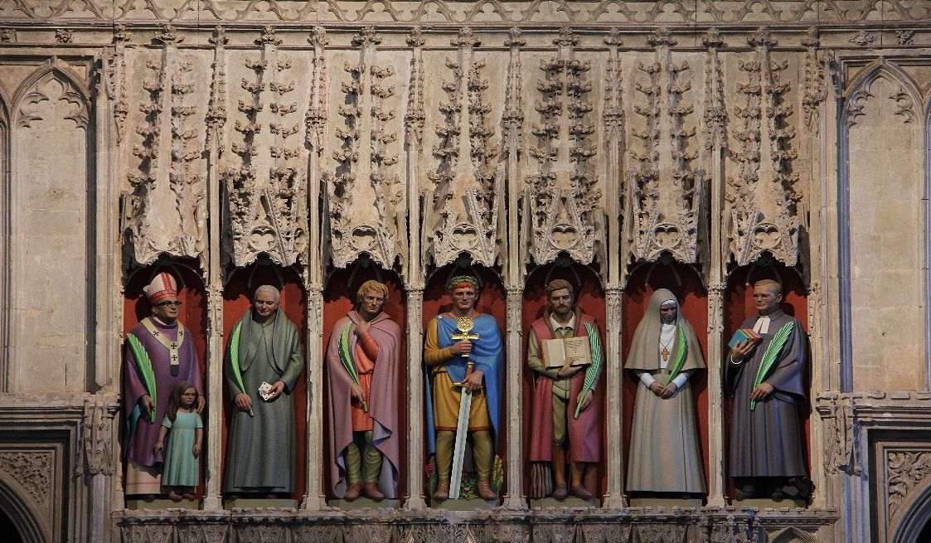

ALL AT LECTERN UNLESS OTHERWISE SHOWN.
Sing-through: 9:30, ends at 9:50 Pre-service music
10.00am Red light displayed: Intro video plays
Candles lit.
JS Welcome From behind the Communion Table
Welcome. Reminder that we will be having communion today.

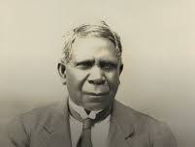 David Unaipon, an SA inventor, writer, orator and campaigner., Ngarrindjeri man
JS Acknowledgement From behind the Communion Table
As we gather in this place we give thanks for all indigenous people, wherever this service is seen. We acknowledge the commitment their ancestors made across the generations to nurturing this land. We pay our respects to their Elders, past, present and to come.
JS CANDLES ETC
The Christ candle is lit, symbolising Christ in our midst, the light of the world; the peace candle is burning, symbolizing the peace we all pray for and work towards in this troubled world. The Bible is open, stories and wisdom of God’s faithful people through the ages; the water is poured, a symbol of our own baptism and adoption into God’s family.
JS Call to Worship Lectern
We gather with the noble saints of old
We gather with the saints from huge ‘successful’ churches
We gather with those saints who meet in secret in countries where they are outlawed
We gather with saints who meet in the open
We gather with our saints at Morialta and we gather with our saints who watch from afar.
We gather to honour our God and our saints around a table of plenty.

JS Prayer
Almighty God, you have knit together your people in one communion and fellowship in the mystical body of your Son Christ our Lord: grant us grace so to follow your blessed saints in all loving and kind living that we may come to those inexpressible joys that you have prepared for those who truly love you; through Jesus Christ your Son our Lord, who is alive and reigns with you, in the unity of the Holy Spirit, one God, now and for ever. Amen. May the infinite and glorious Trinity, the Father, the Son, and the Holy Spirit, direct our life in good works, and after our journey through this world, grant us eternal rest with all the saints.
Amen!

JS Song Rejoice in God's saints, TIS 470
Rejoice in God's saints, today and all days!
A world without saints forgets how to praise.
Their faith in acquiring the habit of prayer,
their depth of adoring, Lord, help us to share.
Some march with events, to turn them God's way;
some need to withdraw, the better to pray;
some carry the gospel through fire and through flood:
our world is their parish: their purpose is God.
Rejoice in those saints, unpraised and unknown,
who bear someone's cross, or shoulder their own:
they shame our complaining, our comforts, our cares:
what patience in caring, what courage is theirs!
Rejoice in God's saints, whose legends and deeds
Speak clear words of hope for those in great need.
O Holy Saint Nicholas, join in our prayer,
As we now our love show, as people who care.
Rejoice in God's saints, today and all days!
A world without saints forgets how to praise.
in loving, in living, they prove it is true:
The way of self-giving, Lord, leads us to you.
Fred Pratt Green, Sydney Hugo Nicholson Reproduced with permission CCLI License #22260685, all rights reserved
AB Prayer of confession
If we have placed our only hope in the things we can see and touch, and have denied ourselves, or those close to us, that greater`hope in the glory of things unseen.
Lord have mercy.
Lord have mercy.

If we have chosen to nurse our grief for the loss of dear ones, with the bitterness of those who weep without hope or faith in your saving love, Christ have mercy.
Christ have mercy.

If we put the saints on pious pedestals and restrict ourselves to a diminished respect for our own capacity to grow in the knowledge and love of God, Lord have mercy.
Lord have mercy.

God of love, we thank your for your patience. You have given us so many guides and helpers to inspire us, and have given us the word that one day we shall be as Christ Jesus is; yet we have been slow to hear, reluctant to learn and sluggish in our efforts. We repent this our lack of faith and love, and ask that the love of Jesus Christ which so healed and uplifted the saints, may mercifully deal with our negativity and empower our renewed good intentions.
Through Christ Jesus our Saviour
Amen!
Bruce Prewer
DC Reading Matthew 5:1-12
When Jesus saw the crowds, he went up the mountain; and after he sat down, his disciples came to him. ² Then he began to speak, and taught them, saying:
³ ‘Blessed are the poor in spirit, for theirs is the kingdom of heaven.
⁴ ‘Blessed are those who mourn, for they will be comforted.
⁵ ‘Blessed are the meek, for they will inherit the earth.
⁶ ‘Blessed are those who hunger and thirst for righteousness, for they will be filled.
⁷ ‘Blessed are the merciful, for they will receive mercy.
⁸ ‘Blessed are the pure in heart, for they will see God.
⁹ ‘Blessed are the peacemakers, for they will be called children of God.
¹⁰ ‘Blessed are those who are persecuted for righteousness’ sake, for theirs is the kingdom of heaven.
¹¹ ‘Blessed are you when people revile you and persecute you and utter all kinds of evil against you falsely on my account. ¹² Rejoice and be glad, for your reward is great in heaven, for in the same way they persecuted the prophets who were before you.
DC Reading – Matthew 23:1-12
Then Jesus said to the crowds and to his disciples, ² ‘The scribes and the Pharisees sit on Moses’ seat; ³ therefore, do whatever they teach you and follow it; but do not do as they do, for they do not practise what they teach. ⁴ They tie up heavy burdens, hard to bear, and lay them on the shoulders of others; but they themselves are unwilling to lift a finger to move them. ⁵ They do all their deeds to be seen by others; for they make their phylacteries broad and their fringes long. ⁶ They love to have the place of honour at banquets and the best seats in the synagogues, ⁷ and to be greeted with respect in the market-places, and to have people call them rabbi. ⁸ But you are not to be called rabbi, for you have one teacher, and you are all students. ⁹ And call no one your father on earth, for you have one Father—the one in heaven. ¹⁰ Nor are you to be called instructors, for you have one instructor, the Messiah. ¹¹ The greatest among you will be your servant. ¹² All who exalt themselves will be humbled, and all who humble themselves will be exalted.
DC In these ancient words the Spirit finds meaning for today. Thanks be to God
DC Song I sing a song of the saints of God (Aussie version) AHB 551
1 I sing a song of the saints of God,
patient and brave and true,
who toiled and fought and lived and died
for the Lord they loved and knew.
And one was a doctor, and one was a queen,
and one wore a cap of baggy green
they were all of them saints of God, and I mean,
God helping, to be one too.
2 They loved their Lord so dear, so dear,
and His love made them strong,
and they followed the right for Jesus’ sake,
the whole of their good lives long.
And one was a soldier, and one was a priest,
and one was slain by a fierce wild beast;
and there’s not any reason, no, not the least,
why I shouldn’t be one too.
3 They lived not only in ages past;
there are hundreds of thousands still.
The world is bright with the joyous saints
who love to do Jesus’ will.
You can meet them in school, on the street, in the store,
in church, by the sea, in the house next door,
they are saints of God whether rich or poor,
and I mean to be one too.
Lesbia Scott, Carlyle Sharpe Reproduced with permission CCLI License #22260685, all rights reserved
AB Message-Slides
AB song We are your people, Spirit of grace TIS 468 please remain standing
We are your people, Spirit of grace,
you dare to make us to all our neighbours
Christ's living voice, hands and face.

Joined in community, treasured and fed,
may we discover gifts in each other,
willing to lead and be led.

Rich in diversity, help us to live
closer than neighbours, open to strangers,
able to clash and forgive.

Glad of tradition, help us to see
in all life's changing where you are leading,
where our best efforts should be.

Give, as we venture justice and care
(peaceful, resisting, waiting or risking)
wisdom to know when and where.

Spirit, unite us; make us, by grace, Bowl brought forward
willing and ready, Christ's living body,
loving the whole human race.
Brian Arthur Wren, Reproduced with permission CCLI License #22260685, all rights reserved
JS Offering and prayer – between lectern and table
To be a saint involves sacrifice – may these offerings which we have given sacrificially, be used in love for all your people.
Please be seated.

JS NOTICES - lectern
JS Prayers of the People Lectern,

Response: we pray.to you
Lord, hear our prayer

Today we pray for the world that God loves.
For the Church: That we may inspire all people in love and communion with you
For World Leaders: That they may be inspired by the saints to act with justice, honesty, and care for the vulnerable, we pray to you.
Lord, hear our prayer
For those sick and suffering: that all those afflicted may find strength and hope through the prayers of the faithful, we pray to you.
Lord, hear our prayer
For Our Congregations and Communities: That we may show love, mercy, and charity as the saints did and do, we pray to you
Lord, hear our prayer
For those who died with faith in the infinite love of God: That our loved ones may join the saints in praising God forever, we pray to you.
Lord, hear our prayer.
For ourselves – that we may become more Christ-like each day, living our faith and trust in you, seeing the world as You see it, spending ourselves in faithful actions, generous in our love. May we be the poor in Spirit, the mourners, the meek, those who thirst for righteousness, the merciful, the pure in heart and the peacemakers. And where there is persecution, may we be brave and remember Jesus, in whose name we pray, Amen.

AB Invitation – The table is laden with good things, the saints have always gathered to share in the blessings of the holy meal. No one is here by right, but the love of God extends an invitation to any and all who would like to follow the way of Jesus. This love extends to those not physically with us here and now, but those who open their hearts are always welcome at the table of plenty,

THE GREAT THANKSGIVING
God is with us
the Spirit proclaims it.
Lift your hearts.
We lift them up to God.
Let us give thanks to the God we love.
We freely give God thanks and praise.
We give our thanks and praise to you,
Holy and merciful God,
Through Jesus Christ, our Savior And the assurance of the Spirit.
And so, in grateful procession of endless praise
With the church that is, was, and shall be forever,
We glorify you, joining this unending cry:
Holy, holy, holy Lord, God of the power of love,
heaven and earth are full of your glory.
Hosanna in the highest.
Blessed is the one who comes in the name of the Lord.
Hosanna in the highest.
You are the Eternal One.
forming the earth and the universe, Peopling it with multitudes Giving them the responsibility of passing it to the next generations.
You choose the way of Love You look upon the lowly as your most cherished beings.
You visit the downtrodden
With presence, grace, and the promise of eternal justice and mercy.
You came to be with us in Jesus,
Who reached into unexpected places,
Calling women beyond the limits of their times
Equipping men for nurturing love
Welcoming children into your holy embrace.
And so we recall that on the night of betrayal and desertion,
The light and lover of the world took bread, broke and gave it to the disciples, saying: “This is my body, given for you.
Do this for the remembrance of me.” And, in like manner,
Jesus took the cup and after giving thanks give it to them saying, “This is the cup of the new covenant
poured out for you and for all people
for the forgiveness of sins.
Do this, as often as you drink of it,
for the remembrance of me.”
Life’s greatest feast before us,
We excitedly proclaim:
Christ has died
Christ is risen
Christ will come again.
Hold us as your own
Renew us as your people
For the sake of the world you love.
For all honour and glory are yours, O God,
Through Jesus Christ,
Who lives and reigns and loves with you and the Holy Spirit in your glorious creation
Both now and forever.
Amen.
Lord’s Prayer
Our Father in heaven
hallowed be your name,
your kingdom come,
your will be done, on earth as in heaven.
Give us today our daily bread.
Forgive us our sins
as we forgive those who sin against us.
Save us from the time of trial
and deliver us from evil.
For the Kingdom, the power
and the glory are yours,
Now and forever, Amen
Distribution – Servers and musicians come forward to be served then the people
Post-Communion Prayer
Let us pray:
We have been fed, Holy One, by your presence.
We have been led, Eternal One, by your light.
We have been shown the way of Love. May we bask in this love
Now and forevermore. Amen.
AB Song For all the saints who've shown your love Tune TIS536 O Waly Waly

For all the saints who've shown your love
in how they live and where they move,
for mindful women, caring men,
accept our gratitude again.
For all the saints who loved your name,
whose faith increased the Savior's fame,
who sang your songs and share your word,
accept our gratitude, good Lord.
For all the saints who named your will,
and showed the kingdom coming still
through selfless protest, prayer, and praise,
accept the gratitude we raise.
Bless all whose will or name or love
reflects the grace of heave above.
Though unacclaimed by earthly powers,
your life through theirs has hallowed ours.
Graham Maule, John L. Bell Reproduced with permission CCLI License #22260685, all rights reserved
Commissioning Front of table
Go on your way rejoicing;
Surrounded as you are by such a great cloud of witnesses,
take courage as you face each new challenge,
and comfort when you pick yourself up from a fall,
In whatever good you choose to do,
precede it with hope,
accompany it with prayer,
and follow it with thanksgiving.

The blessing of God Most Wonderful,
whom the saints have trusted as
Father, Son and Holy Spirit,
will be with you
now and ever more.
Blessing song : May the feet of God walk with you TIS 779 sung once.
May the feet of God walk with you
and God’s hand hold you tight.
May the eye of God rest on you
and God’s ear hear your cry.
May the smile of God be for you
and God’s breath give you life.
May the Child of God grow in you
and God’s love bring you home.
Words: Aubrey Podlich; Music: Robin Mann © 1983 Reproduced with permission CCLI License #22260685, all rights reserved
AV Team gather at the table for communion

