- Sunday 6th Sept Week 1 (Forest Sunday): Genesis 2:4b–22 | Psalm 139:13–16 | Acts 17:22–28 | John 3:1–16

Minister: Anne Butler* Welcome: Leonie Brown
Worship Leader: Margaret Cargill* Piano: Anne Ind
Bible Reader: Ruth Wise*
Camera 6: Carole Lyons Singers: n/a
Camera 8: Ray Clogg Audio: John Drew
Video editor: John Secombe Projection: Colin Cargill
Reader: Chris Ayles Vision Switcher: John Secombe
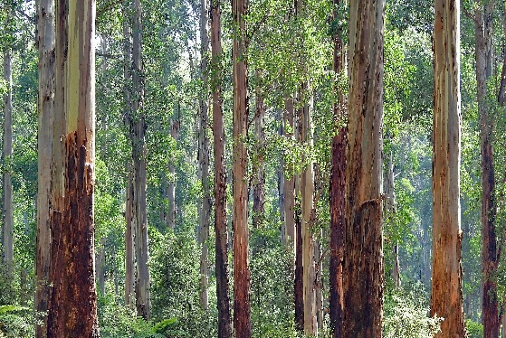
Extra Server: Rhonda Amber*
PICTURE ON SCREEN FIRST Candles lit.
ALL AT LECTERN UNLESS OTHERWISE SHOWN.
Sing-through: 9:30, ends at 9:50 Pre-service music
Photo by David Clode on Unsplash
10.00am Red light displayed: Intro video plays
MC Welcome From behind the Communion Table
Welcome. Include online congregation. Remember Fathers. Reminder that we will be having communion today.
MC Acknowledgement From behind the Communion Table
We give thanks for creation:
its vibrant genesis and evolution
its wonder and mystery
its delicacy and strength
its wordless word
it’s yes!
We give thanks for the Kaurna people, and the Aboriginal peoples of all lands where this service is shared, who nurtured this land:
for their stories of the dreaming
for their connection with the sacred
for their yes!
We give thanks for the gift of this community:
for calling us to be present to one another
for the mystery of grace in our lives
for your yes!
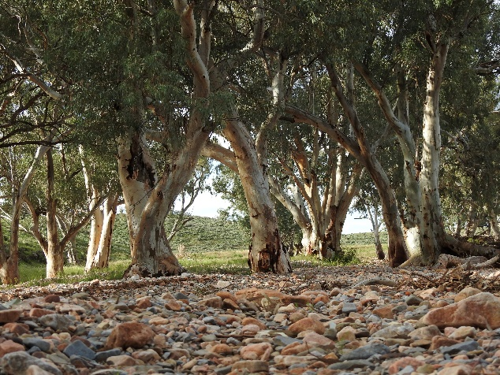
MC CANDLES
The Christ candle is lit, symbolising Christ in our midst, the light of the world; the peace candle is burning, symbolizing the peace we all pray for and work towards in this troubled world. The Bible is open, stories and wisdom of God’s faithful people through the ages; the water is poured, a symbol of our own baptism.
MC: Call to Worship Lectern
Come and celebrate our common home
we gather with the family of humanity.
The mountains, islands and desert
we honour the glory of God in creation.
The lakes, rivers and seas
we come to the source of living water.
With the land, its soil, seeds and sustenance
we give thanks for God’s generous provision.
With the forests of great trees, the lungs of the planet
we will sing with joy and clap our hands.
We join with the whole of creation, inspired by those who have gone before and the prophetic voices of today. Amen.
(Adapted from ‘We are the Amazon’, an ecumenical act of solidarity and justice for the Amazon and its people.)
MC Prayer Beginning with a poem:
I never knew
I never knew the trees were
Speaking to each other out of sight
Or how Hildegard could know
They make energy from light
Or that the green earth is conscious
Is breathing, is alive
That there are ecosystems of hope
Inside this wild entangled life
I never knew we were relatives
The sun, the moon, the sea, the sky
I never knew we were stardust
You and me, blown into time
Until I learned to speak
In the language of leaves
The one they sing together
As a breeze blows in the trees.
(Source: This Heart: Poems from the universe inside by Martin Wroe, Iona Publication)
Ever-present God of mystery and love, may we hear the words of the poet and seek to learn the language of forests and of all your creation and incorporate it into our attempts to be your love in our world. Amen
MC: Song – Touch the earth lightly (TiS 668 ) https://www.youtube.com/watch?v=wnWUglp7unQ&t=138s
Words not projected
Touch the earth lightly, use the earth gently,
nourish the life of the world in our care:
gift of great wonder, ours to surrender,
trust for the children tomorrow will bear.

We who endanger, who create hunger,
agents of death for all creatures that live,
we who would foster clouds of disaster—
God of our planet, forestall and forgive!

Let there be greening, birth from the burning,
water that blesses and air that is sweet,
health in God’s garden, hope in God’s children,
regeneration that peace will complete.

God of all living, God of all loving,
God of the seedling, the snow and the sun,
teach us, deflect us, Christ reconnect us,
using us gently, and making us one.
Shirley Erena Murray Reproduced with permission CCLI License #22260685, all rights reserved
AB Prayer of confession lectern
When our brief lives are too short to absorb
the thousand year miracle that is forest
Come silently and remind us
When we have arrogantly seen ourselves
as the pinnacle of creation not the partner
Come silently and remind us
When we have seen the green growing world as weeds to be eliminated
Come silently and remind us
When we have reduced the good earth to dirt
to be avoided and overcome
Come silently and remind us
Return us O God
to the simple appreciation
of all the growing things. Amen

RW Reading Psalm 104:10-17
¹⁰ You make springs gush forth in the valleys;
they flow between the hills,
¹¹ giving drink to every wild animal;
the wild asses quench their thirst.
¹² By the streams the birds of the air have their habitation;
they sing among the branches.
¹³ From your lofty abode you water the mountains;
the earth is satisfied with the fruit of your work.
¹⁴ You cause the grass to grow for the cattle,
and plants for people to use,
to bring forth food from the earth,
¹⁵ and wine to gladden the human heart,
oil to make the face shine,
and bread to strengthen the human heart.
¹⁶ The trees of the Lord are watered abundantly,
the cedars of Lebanon that he planted.
¹⁷ In them the birds build their nests;
the stork has its home in the fir trees.

RW Reading – A Forest Hymn - William Cullen Bryant (extracts) Editor of New York Post for many years in 19th-century
The groves were God's first temples. Ere man learned
To hew the shaft, and lay the architrave,
And spread the roof above them—
Amidst the cool and silence, he knelt down,
And offered to the Mightiest solemn thanks
And supplication... Ah, why
Should we, in the world's riper years, neglect
God's ancient sanctuaries, and adore
Only among the crowd, and under roofs
That our frail hands have raised?
Father, thy hand
Hath reared these venerable columns, Thou didst weave this verdant roof. Thou didst look down
Upon the naked earth, and, forthwith, rose
All these fair ranks of trees. They, in thy sun,
Budded, and shook their green leaves in thy breeze,
And shot towards heaven. Fit shrine for humble worshipper to hold
Communion with their Maker. Thou art here—thou fill'st
The solitude. Thou art in the soft winds
That run along the summit of these trees in music;
Here is continual worship;—Nature, here,
In the tranquillity that thou dost love,
Enjoys thy presence. Noiselessly, around,
From perch to perch, the solitary bird
Passes; and yon clear spring, that, midst its herbs,
Wells softly forth and wandering steeps the roots
Of half the mighty forest, tells no tale
Of all the good it does.
Grandeur, strength, and grace,
Are here to speak of thee. That delicate forest flower,
With scented breath and look so like a smile,
Seems, as it issues from the shapeless mould,
An emanation of the indwelling Life,
A visible token of the upholding Love,
That are the soul of this great universe.
My heart is awed within me when I think
Of the great miracle that still goes on,
In silence, round me—the perpetual work
Of thy creation, finished, yet renewed
Forever. Written on thy works I read
The lesson of thy own eternity.
Lo! all grow old and die—but see again,
How on the faltering footsteps of decay
Youth presses,—ever-gay and beautiful youth
In all its beautiful forms. Be it ours to meditate,
In these calm shades, thy milder majesty,
And to the beautiful order of thy works
Learn to conform the order of our lives.
RW: In these words the Spirit finds meaning for today. Thanks be to God
RW Song: God walks with us in shimmering heat Tune ‘Repton’ TiS 598 https://www.youtube.com/watch?v=agHyyJgAxhE Anne Ind to sing
God walks with us in shimmering heat
and thund’ring skies of grey,
In nature’s wildest alchemy
And stone of regal majesty,
Such glory on display,
Such glory on display.

In banksia shades of sunset bloom,
In Gouldian finch array,
The artist’s joy seen unashamed,
From pallet bright and unexplained,
What wonders in our day!
What wonders in our day!

God hovers round this captured rock,
And all the universe,
Yet Christ comes here to show God’s face,
To make the holy common-place,
To let God’s voice be heard.
To let God’s voice be heard.

God sings to us from in the soil,
From in the rain and air,
This fabric on which we depend,
We hardly, barely understand,
This web in disrepair. This web in disrepair.

Now fire and flood and brooding storm
Fragment this Earth, our home,
As summer lengthens year by year,
And precious waters disappear,
We pray your call be known.
We pray your call be known.

Come, Jesus, walk with us each day,
Forgive our blinkered ways.
Bring hope when storms assail the land,
Turn hearts and hands to work your plan.
Inspire us all our days.
Let love lead all our ways.
Leigh Newton, Reproduced with permission CCLI License #22260685, all rights reserved
AB Message- to be shown as big as possible please. One per slide.
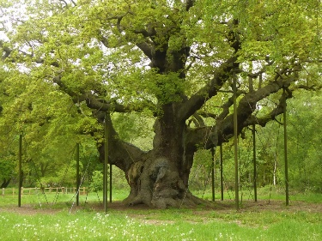
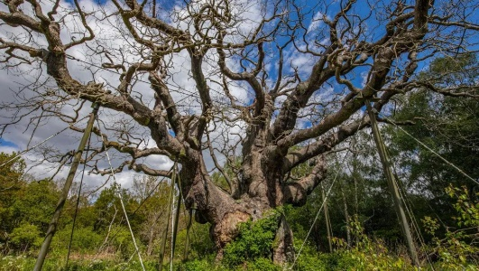

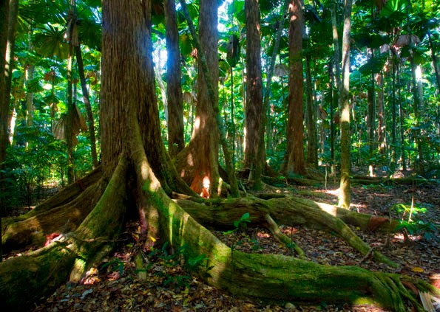
This Photo by Unknown Author is licensed under CC BY-NC-ND
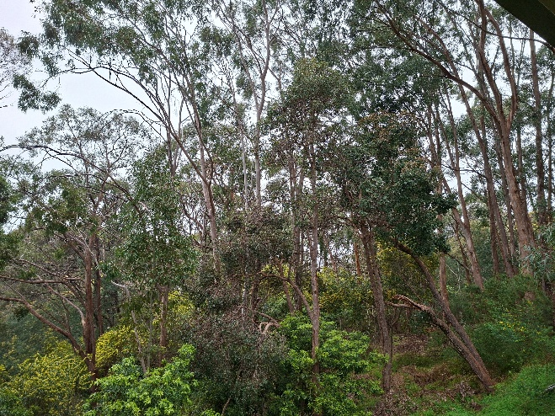
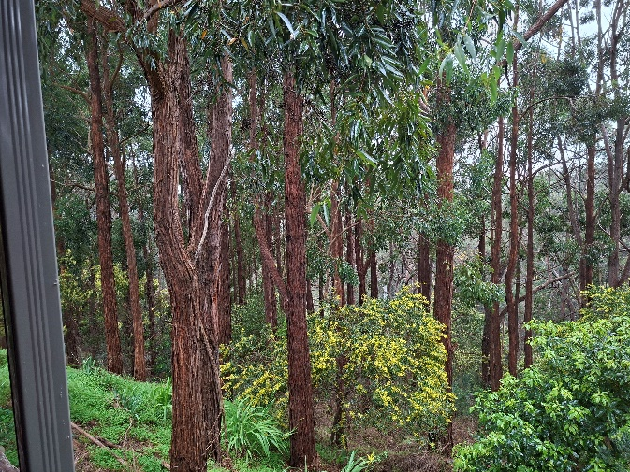

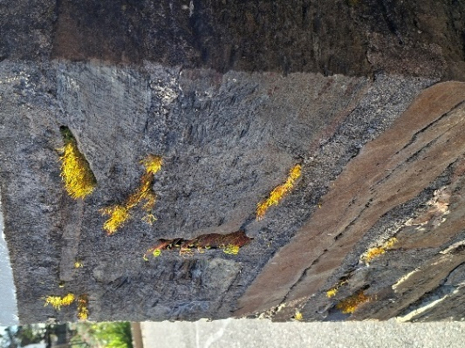
MC Offering and prayer – Bowl brought forward side of Table
Thank you, God, for giving us the opportunity to give,
In the bowl or electronically,
which we do with joyful, grateful hearts.
We look at the needs of the world,
and our offerings are small.
May they be like yeast,
gifts that grow your kingdom.
We pray this in Jesus’ name, Amen.

MC NOTICES - lectern
MC Prayers of the People Lectern
God of abundant life, we see Your goodness all around us and we thank You for every part of it:
from the plants and animals which play their part in complex ecosystems,
to the dry deserts and stormy seas which test the limits of life.
We pray that in this time of climate crisis and ecological emergency,
You may help us to rediscover
Your love of creation and to reflect that in our own lives.
God, in Your mercy
hear our prayer.
God who speaks through unexpected people,
We thank You for contemporary prophets
who are challenging us to act on climate change;
for indigenous people and their invaluable knowledge
of the land and sea where they live,
for scientists dedicating their careers to warning us
about changes to the planet,
and for young people striking for their future.
We pray that You will help those in power to hear their prophetic voices.
Help them to see beyond short-term political priorities and business plans.
Give them wisdom and courage when they face difficult decisions.
God, in Your mercy
hear our prayer.
God of second chances,
we recognise the damage we have done to the Earth
and the injustice we see in society every day,
fuelled by worship of profit and possessions.
We pray for the coming of a better world
with justice, kindness and humility at its heart.
We ask that You guide us to be co-creators of this new world.
Give us confidence to follow the prophetic voices,
to stand against injustice to people and to planet.
So that together, in Your strength,
we stop this climate crisis.
God, in Your mercy
hear our prayer. (Source: Wendy Lloyd, Church of Scotland)
MC This litany by Bruce & Carolyn Winfrey Gillette was written to recognize the connections between the Lord’s Prayer and caring for God’s creation..
Loving God, we remember that Jesus taught us to pray saying, “OurFather…”
You created us, you made this world,
and you called your creation very good.
Yet often we forget that you are our loving Parent
who continues to bless your world.
Jesus told us that you are “…in heaven…”
Yet we fail to live in awe of you.
We take you for granted,
and we don’t see the awesome beauty
of the world you have made.
We pray, “Hallowed be your name…”
We confess that our reverence
for you does not always lead us to care reverently
for your earth, sky and sea.
We pray, “Your kingdom come, your will be done,
on earth as it is in heaven…”
We confess that we often put our own interests first
—exploiting your creation,
and living for our own convenience and self-interest.
We pray, “Give us today our daily bread.”
We confess that we consume more
than our share of the world’s resources,
while billions go hungry every day
and your whole creation suffers.
We pray, “Forgive us our sins
as we forgive those who sin against us.”
We confess that we see these words only in spiritual terms,
while the Bible is filled with teachings
about economic justice and creation care.
We pray, “Save us from the time of trial.”
Help us to resist the temptations of spending more,
using more, acquiring more, and wasting more.
We pray, “Deliver us from evil…”
Free us from greed and self-centeredness
that separate us from you and others.
We pray, “For the kingdom, the power, and the glory are yours
now and forever.”
Help us to know that in caring for your wonderful world,
we are working for your kingdom,
being good stewards of your creative power,
and giving you glory.
We pray, “Amen.”
We end our prayers with “Amen,”
a word that means “let it be so.”
We know we can be faithful disciples by your grace. Amen!
MC Song: Spirit of Creation https://vimeo.com/517722828 Words not for projection)
Spirit soaring o’er creation,
Breathing rainbow world to birth,
Trinity’s imagination,
Singing joy upon the earth.

Spirit sighing in creation,
Rising oceans, warming lands,
Seasons changing, creatures dying,
Havoc brought by human hands.

God hear our cry, for all you’ve made,
Renew your world, show us your way,
God, hear our cry for all we’ve marred,
Transform our lives, change us we pray.

Spirit groaning in creation,
Crying for her planet’s mess,
longing for its transformation,
all that’s broken to be blessed.

God hear our cry for all you’ve made,
Renew your world, show us your way,
God, hear our cry for all we’ve marred,
Transform our lives, change us we pray.

Spirit weaving through creation,
Bringing mending in our hearts,
Hope restoring in the dawning,
Joining all that is apart.

Spirit praying for creation,
With a plea too deep for words,
Yearning for shalom that’s coming,
Bringing healing to God’s world.

God hear our cry, for all you’ve made,
Renew your world, show us your way,
God, hear our cry for all we’ve marred,
Transform our lives, change us we pray.
Craig Mitchell, sung by Leigh Newton. Reproduced with permission CCLI License #22260685, all rights reserved
AB Invitation Table

AB THE GREAT THANKSGIVING
The Holy One is with us
the Spirit proclaims it.
Lift your hearts.
We lift them up to God.
Let us give thanks to the God we love.
We freely give God thanks and praise.
It is right and meet, beautiful and holy
that we should, in ceaseless joy
Give our thanks and praise to you,
Holy and merciful God,
Through Jesus Christ, our Savior And the assurance of the Spirit.
And so, in grateful procession of endless praise
With the church that is, was, and shall be forever,
We glorify you, joining this unending cry:
Holy, holy, holy Lord, God of power and love,
heaven and earth are full of your glory.
Hosanna in the highest.
Blessed is the one who comes in the name of the Lord.
Hosanna in the highest.
Holy are you, Eternal One.
You sit above, through, within the circle of the earth
Setting light into being
Casting the stars in the sky
Founding the evolving earth
And all that dwell within it. Is green your favourite colour? Or the blue of the ocean and sky? Perhaps the red of the centre and our lifeblood or the black and white of the night sky, the milky way and dark emu?
You came to be with us in Jesus,
Who reached into unexpected places,
Calling women beyond the limits of their times
Equipping men for nurturing love
Welcoming children into your holy embrace. And so we recall that on the night of betrayal and desertion,
The light of the world took bread, broke and gave it to the disciples, saying: “This is my body, given for you.
Do this to remember me.” And Jesus took the cup and after giving thanks give it to them saying, “This is the cup of the new agreement
poured out for you and for all people
for the renewal of your relationship with God.
Do this, as often as you drink of it,
to remember me.” You transform all that is before you
So that at the touch of your grace
We are never the same. Dear God, you illumine.
You bring light to all peoples
Light to the nations
Light into our hearts
Light on your Way. Dear God, we pray for your World
Transform, illumine, bless, create wonder. Help us love what you love.
Make these ordinary gifts of bread and cup
Into the extraordinary presence of Christ with us. Amen.
Breaking of Bread Distribution – Servers and musicians come forward to be served then the people
AB Post-Communion Prayer behind table
Let us pray:
We have been fed, Holy One, by your presence.
We have been led, Eternal One, by your light.
May we bask in this glow, changing who we are,
Now and forevermore. Amen.
AB Song O God, We share the Power TIS 457AURELIA 7.6.7.6 D
O God, we share the power to bring back what is yours —
to bring life’s joy and wonder to toxic, lifeless shores.
Where earth has been depleted, where nothing seems to grow,
we’ve seen you cleanse and nurture till blessings overflow.

Ezekiel had a vision of hopeful signs like these —
of waters bringing healing — and fish and plants and trees.
He dreamed of Living Water that flowed at your command —
that spread out like a river upon your thirsty land.
When we pollute your rivers and drain your wetlands dry,
when we cause harm to waters, we see creation cry.
And yet Ezekiel’s vision reminds us once again:
Your will is restoration. Your waters sing, “Amen!”

O God, in your creation, we see your strength and care.
Clean water is a blessing! May this become our prayer:
Your will is restoration. You seek to make things new.
Give us new dedication to heal the earth with you.
Carolyn Winfrey Gillette Reproduced with permission of author
AB Reminder to AV team
Commissioning Front table May God bless us with wonder at creation’s glory.
May God bless us with outrage at creation’s spoiling.
May God bless us with courage at this critical hour.
And may the blessing of God, Father, Son and Holy Spirit,
Rest upon us and on all creation,
This day and for the future to come. Amen. (Source: ACT Alliance)
Blessing song : May the feet of God walk with you TIS 779 May the feet of God walk with you
and God’s hand hold you tight.
May the eye of God rest on you
and God’s ear hear your cry.
May the smile of God be for you
and God’s breath give you life.
May the Child of God grow in you
and God’s love bring you home
Words: Aubrey Podlich; Music: Robin Mann © 1983 Reproduced with permission CCLI License #22260685, all rights reserved
AV Team gather at the table for communion

