River Sunday. 27 September 2026

Minister: Peter Trudinger Worship Leader: Bev Tredrea
Bible Reader: John Thornton Piano: Eunice Sullivan
Singers: Anne Ind, Rhonda Amber Welcome: Ruth Wise
Projection: Colin Cargill Audio: Ray Clogg
Camera 6/HSO: Jenny Swanbury Camera 8: Peter Thornley
Reader: Joan Morrison Vision Switcher: Margaret Cargill
Video Editor: John Drew

Picture on screen first

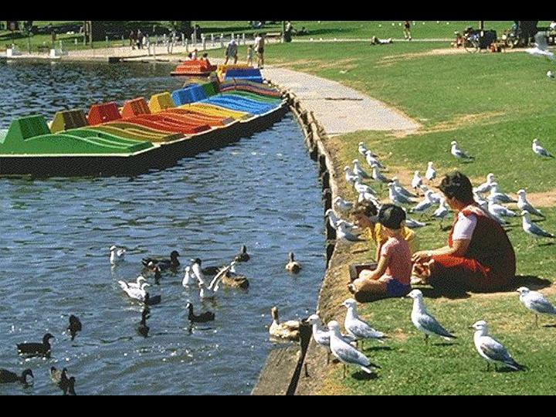

Meditation (On first screen and newsletter)
If you're going to care about the fall of the sparrow
you can't pick and choose who's going to be the sparrow.
It's everybody. (Madeleine L'Engle)

Sing-through 9:30, ends 9:50. Pre-service music. Candles lit.
All at lectern unless otherwise noted. Easel w. painting placed near font (TBC on the day)

10:00 – Red light displayed, Intro video plays

BT: Welcome Kimba? (Behind table)
Welcome to you on this beautiful Sunday morning. We are pleased that you have joined the Morialta Worship service whether you are present in the church or joining us on line.

BT: Candles table
Our candles are lit, the Bible is open and the water is poured. All signs that we are here to worship, to pray and praise the Holy within our midst.

BT: Acknowledgement of traditional custodians table
Many have gone before who have honoured God by caring for the land in ways they have lived and the stories they have shared. We give thanks for the Kaurna people, who have held sacred the duty of protecting the land and living on harmony with it. We pay our respect to their elders past and present.

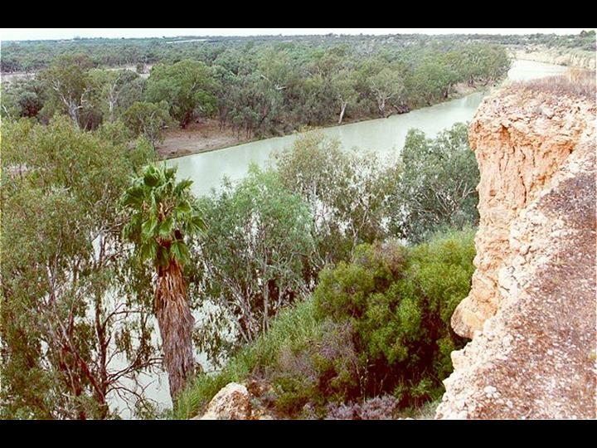

BT: Introduction table
In September we are celebrating the Season of Creation – four Sundays dedicated to worshipping alongside other members of the Earth Community. Note the language: we are not worshipping creation, but alongside or with creation, just as you are worshipping here today with other human members of the congregation of Morialta, and alongside those using our streaming service, who might be scattered throughout Australia, even the world, and also spread across time, because they are viewing this service on YouTube. Wow! We worship together across space and time, and across species, human and non-human. All together, all part of God’s family.

Each week we focus on one member of that family. So far this month, this has been Forests, Land and Outback (or Wilderness). Today we focus on Rivers.

To lectern
BT: Call to Worship
For the forests: trees soaring tall or spreading wide,
bearing fruit and spreading the fragrance of the bush,
making sacred space for creatures large and small –
With Eucalypts and T-trees, Old Man Banksia and naughty grevilleas,
With possums and koalas, echidnas and kangaroos,
green tree frogs and swirling bats,
We rejoice with God in the forests.
For land and soil:
birthing crops, grounding our steps,
anchoring our homes and hopes –
For the foothills, the plains, Kangaroo Island, the Coorong,
for all the variety of landscapes around us
We rejoice with God in the land.
For outback and wilderness:
harbouring wildness,
restoring awe, bearing mystery –
For the Flinders Ranges, Wilpena Pound, Uluru
We rejoice with God
in the wilderness and outback.
On this day in particular, we praise with rivers and lakes
and all manner of waters:
quenching thirsts,
restoring wildflowers and birds, bestowing life –
For the Murray River, Lake Eyre, the Onkaparinga and the Torrens,
for waterfalls singing upstream
and waves dancing at the river mouth
With perch and platypuses,
with ducks and dragonflies,
We rejoice with God in the rivers and waters.

BT: Opening Prayer
God, our Creator,
may your Spirit flow through us
like a river running through a fertile land.
May it fill us with wisdom,
as water fills a lake.
May it renew our hearts and minds,
like water restoring life to dry soil.
We ask this in the name of Christ,
who reconciles and renews all things.
Amen

BT: Song Come, O God of all the earth (TiS 181, verses 1, 2, 4, 5)
1. Come, O God of all the earth:
come to us, O Righteous One.
Come and bring our love to birth:
in the glory of your Son.
Chorus:
Sing out, earth and skies!
Sing of the God who loves you.
Raise your joyful cries;
Dance to the life around you.
2. Come, O God of wind and flame:
fill the earth with righteousness;
Teach us all to sing your name;
may our lives your love confess.
Chorus
4. Come, O God of snow and rain:
shower down upon the earth;
Come, O God of joy and pain:
God of sorrow, God of mirth.
Chorus
5. Come, O Justice, come, O Peace:
come and shape our hearts anew;
Come and make oppression cease;
bring us all to life in you.
Chorus
Words: Marty Haugen. Reproduced with permission under OneLicense #A-604530. All rights reserved.

BT: Prayer of Confession

God, giver of life,
We gather today acknowledging the harm
we have done to your creation and one another.
We pollute the rivers and endanger the creatures within them,
rather than caring for them as part of our family.
We seek control and have power over the waters,
rather than respecting their nature.
We overlook the many enslaved
and vulnerable lost in the waters,
rather than acknowledging our role in this violence.
We focus on our own desires,
rather than seeing how they impact the world around us.
Christ, source of all life,
We are sorry. We are sorry.

We come yearning to be refreshed and replenished
by the water of life,
so that we might seek ways to honour you better
and all of creation.

Forgive us for the injury we have caused.
Inspire us in seeking new ways to participate in and with your creation.
Renew us with your life-giving water.
Amen.

BT: Assurance of Pardon
God invites us to come to the water in our entirety,
with our flaws and questions, gifts and joys.
May this water remind us of God’s promise –
we are forgiven, loved children of God.
May this promise help us strive to be better stewards of God’s love
with one another and all of creation.
Thanks be to God.

PT: Introduction of first reading

JT: Genesis 8:20-22, 9:12-17
After the Flood, God makes a promise to Noah
20 Then Noah built an altar to the LORD, and took of every clean animal and of every clean bird, and offered burnt offerings on the altar. And when the LORD smelled the pleasing odor, the LORD said in his heart,
"I will never again curse the ground because of humankind, for the inclination of the human heart is evil from youth; nor will I ever again destroy every living creature as I have done.
As long as the earth endures,
seedtime and harvest, cold and heat,
summer and winter, day and night,
shall not cease."
12 God said,
"This is the sign of the covenant that I make between me and you and every living creature that is with you, for all future generations: I have set my bow in the clouds, and it shall be a sign of the covenant between me and the earth.
When I bring clouds over the earth and the bow is seen in the clouds, I will remember my covenant that is between me and you and every living creature of all flesh; and the waters shall never again become a flood to destroy all flesh.
When the bow is in the clouds, I will see it and remember the everlasting covenant between God and every living creature of all flesh that is on the earth."
17 God said to Noah,
"This is the sign of the covenant that I have established between me and all flesh that is on the earth."

PT: Introduction to second reading

JT: Ezekiel 47:1-2, 6b-12
Ezekiel’s vision of the river in the restored Jerusalem
Then [the man, whose appearance shone like bronze,] brought me back to the entrance of the temple; there, water was flowing from below the threshold of the temple... 6. Then he led me back along the bank of the river. As I came back, I saw on the bank of the river a great many trees on the one side and on the other.
He said to me,
“This water flows toward the eastern region and goes down into the Arabah; and when it enters the sea, the sea of stagnant waters (that is, the Dead Sea), the water will become fresh. Wherever the river goes, every living creature that swarms will live, and there will be very many fish, once these waters reach there. It will become fresh; and everything will live where the river goes. People will stand fishing beside the sea from En-gedi to En-eglaim; it will be a place for the spreading of nets; its fish will be of a great many kinds, like the fish of the Great Sea. But its swamps and marshes will not become fresh; they are to be left for salt.
On the banks, on both sides of the river, there will grow all kinds of trees for food. Their leaves will not wither nor their fruit fail, but they will bear fresh fruit every month, because the water for them flows from the sanctuary. Their fruit will be for food, and their leaves for healing.”

PT: Introduction to the third reading (and explanation of painting)

JT: Revelation 22:1-5
The River of Life in the City of God
1 Then the angel showed me the river of the water of life, bright as crystal, flowing from the throne of God and of the Lamb through the middle of the street of the city. On either side of the river is the tree of life with its twelve kinds of fruit, producing its fruit each month; and the leaves of the tree are for the healing of the nations.
3 Nothing accursed will be found there any more.
But the throne of God and of the Lamb will be in it,
and his servants will worship him;
they will see his face,
and his name will be on their foreheads.

5 And there will be no more night;
they need no light of lamp or sun,
for the Lord God will be their light,
and they will reign forever and ever.

JT: In this is the word of God.
Thank you, God, for speaking to us.

JT: Song God who made the earth (TiS 146)
1 God, who made the earth,
the air, the sky, the sea,
who gave the light its birth,
God cares for me.
2 God, who made the grass,
the flower, the fruit, the tree,
the day and night to pass,
will care for me.
3 God who made the sun,
the moon, the stars, is he
who, when life's clouds come on,
still cares for me.
4 God, who sent his Son
to die on Calvary,
has shown how lovingly
he cares for me.
Words: Sarah Betts Rhodes. Public Domain

PT: Message

PT: Song God you touch the earth with beauty (TiS 610)
1. God, you touch the earth with beauty,
make my heart anew,
with your Spirit re-create me,
pure and strong and true.
2. Like your springs and running waters,
make me crystal pure;
like your rocks of towering grandeur,
make me strong and sure.
3. Like your dancing waves in sunlight,
make me glad and free;
like the straightness of the pine trees,
let me upright be.

4. Like the arching of the heavens, Bowl brought forward
lift my thoughts above,
turn my dreams to noble action,
ministries of love.
5. God, you touch the earth with beauty,
make my heart anew,
with your Spirit re-create me,
pure and strong and true.
Words: Mary Susannah Edgar. Reproduced with permission under OneLicense #A-604530. All rights reserved.

BT: Prayer of Dedication Between table and lectern
God of forests, land, rivers and outback,
your shower us with wonder and mystery,
break through our bleakest moments
and touch us with healing
Accept these gifts we offer today
and inspire us to join with you
to refresh, revive and renew all the Earth.

BT: Notices Lectern

BT: Prayers of the People
A Prayer for creation
Hear our prayers, O God, that rise up from and for the whole of your creation:
We pray for rivers to flow free: rivers of grace that offer
and receive forgiveness and welcome;
rivers of fresh and refreshing water that quench the thirsts of dry throats or arid hopes.

We pray for wilderness and wilds to stand free: places on this earth that restore awe and wonder;
places in our spirits where your Spirit leads us into the mystery of holy encounter.

We pray for land to harbour life: for the bearing of crops in fruitful and shared harvest; for the sheltering of those without home or place; for peace rather than blood upon the land.

We pray for forests and trees to grow: for roots sunk deep into soil that nourishes, for leaves to breathe
back oxygen into this creation for the sake of life, the same prayer we raise for ourselves – to return life as we have freely received it.

Hear our prayers, O God, that rise up from and for the whole of your beloved creation.
Amen

The Lord’s Prayer
Our Father in heaven,
hallowed be your name,
your kingdom come,
your will be done,
on earth as in heaven.
Give us today our daily bread.
Forgive us our sins,
as we forgive those who sin against us.
Save us from the time of trial
and deliver us from evil.
For the kingdom, the power, and the glory are yours
now and for ever. Amen.

BT: Song All creatures of our God and king (TiS 100, verses 1, 3, 4, 5, 7)

1 All creatures of our God and King,
lift up your voice and with us sing
alleluia, alleluia;
O burning sun with golden beam,
and silver moon with softer gleam,
O praise him, O praise him,
alleluia, alleluia, alleluia!
3 O flowing water, pure and clear,
make music for your Lord to hear,
alleluia, alleluia!
O fire, so masterful and bright,
providing us with warmth and light,
O praise him ...
4 Dear mother earth, who day by day
unfold rich blessings on our way,
O praise him, alleluia!
All flowers and fruits that in you grow,
let them his glory also show;
O praise him ...
5 And everyone of tender heart,
forgiving others, take your part,
O praise him, alleluia!
All who long pain and sorrow bear
praise God and on him cast your care;
O praise him ...
7 Let all things their Creator bless,
and worship him in humbleness;
O praise him, alleluia!
Praise, praise the Father, praise the Son,
and praise the Spirit, Three in One:
O praise him, O praise him,
alleluia, alleluia, alleluia!
William Henry Draper. Public Domain

Litany of Praise (Bev and Peter)
Bev goes to the lectern; Peter goes to stand near the font

BT: We are going to say together a Litany of Praise. This will take the form of a series of quotes, each followed by a response written by Hildegard of Bingen. Please Stand.

BT: The Earth … is a sparkling blue and white jewel…laced with slowly swirling veils of white… like a small pearl in a thick sea of black mystery. (Edgar Mitchell, US Astronaut)
All creation is a song of praise to God.
PT: O moving force of Wisdom, you encircle the wheel of the cosmos, you encompass all that is, all that has life, in one vast circle. (Hildegard of Bingen, Christian Mystic)
All creation is a song of praise to God.
BT: It could be that God has not absconded but spread, as our vision and understanding of the universe have spread, to a fabric of spirit and sense so grand and subtle, powerful in a new way, that we can only feel blindly of its hem. (Annie Dillard, writer)
All creation is a song of praise to God.
PT: Stardust is not just fairy-tale magic; it is what we are really made of. (Elisabet Sahtouris, Ecofeminist)
All creation is a song of praise to God.
BT: Give me the strength to walk the soft earth, a relative to all that is! (Black Elk, Native American)
All creation is a song of praise to God.
PT: For in God we live, and move, and have our being. (Acts 17:28)
All creation is a song of praise to God.
BT: We shall not cease from exploration.
And the end of all our exploring.
Will be to arrive where we started.
And know the place for the first time. (T. S. Eliot, poet)
All creation is a song of praise to God.
BT: Commissioning
Go from this place of refreshment
to awaken hope,
share healing,
and restore justice.

PT: Blessing Front of table
May the Spirit of God,
like a life-giving river
flow in and through you,
filling you with the assurance of gracious acceptance
and pouring out the blessing
of God’s love for one another
and for all the earth.
Now and forever…

Post service music

