Minister: Peter Trudinger Worship Leader: Leonie Brown
Bible Reader: Pam Ayles Piano: Eunice Sullivan
Singer: Anne Ind Welcome: B. Ind
Camera 6 and HSO: Ray Clogg Camera 8: P Thornley
Audio: John Drew Projection: John Thornton
Video editor: John Secombe Vision Director: Andrew Pill
Vision Switcher: John Secombe

Picture on screen first

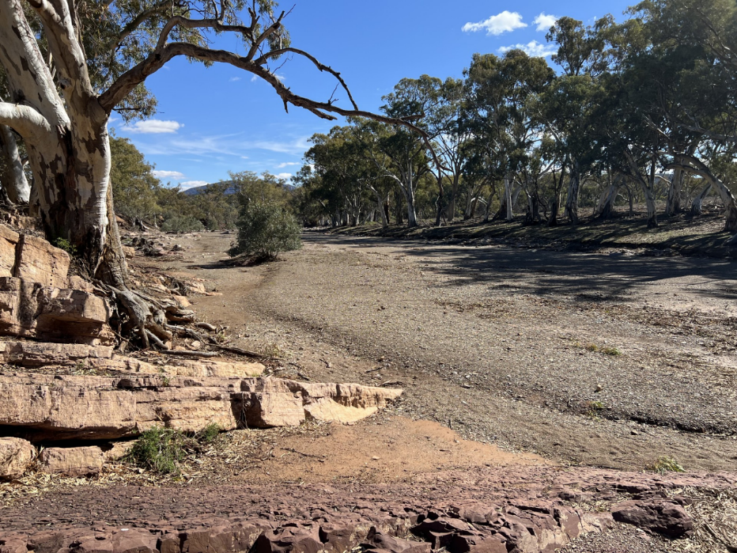

Meditation (on first screen and newsletter front page)
You should not see the desert
simply as some faraway place of little rain.
There are many forms of thirst. (William Langewiesche)

Sing-through 9:30, ends 9:50. Pre-service music. Candles lit.

10:00am – Red light displayed, intro video plays.
All at lectern unless otherwise indicated

LB: Welcome Lectern (Kimba? – John S will confirm on the day)

In September we are celebrating the Season of Creation – four Sundays dedicated to worshipping alongside other members of the Earth Community. Note the language: we are not worshipping creation, but alongside or with creation, just as you are worshipping here today with other human members of the congregation of Morialta, and alongside those using out streaming service, who might be scattered throughout Australia, including Kimba this morning, and even the world, and also spread across time, because they are viewing this service on YouTube. Wow! We worship together across space and time, and across species, human and non-human. All together, all part of God’s family.

Each week we focus on one member of that family. The previous two weeks have focused on Forests and on Land. Today we focus on Wilderness, or, in Australia, what we call the Outback.

LB: Candles: Behind table
The Christ candle is lit, symbolizing Christ in our midst, light of the world; the peace candle is lit, symbolizing our ongoing prayer for peace; the Bible is open, stories and wisdom of God’s faithful people through the ages; the water is poured, symbol of our own baptism.

LB: Acknowledgement of traditional custodians Lectern
We meet here on the lands of the Kaurna People of the Adelaide Plains, and where ever you are worshipping at home or in another church, we acknowledge the Elders and communities of the First People’s care for the lands and waters. We ask God’s blessing on those who continue to work for the healing and restoration of this Land and Her Communities.
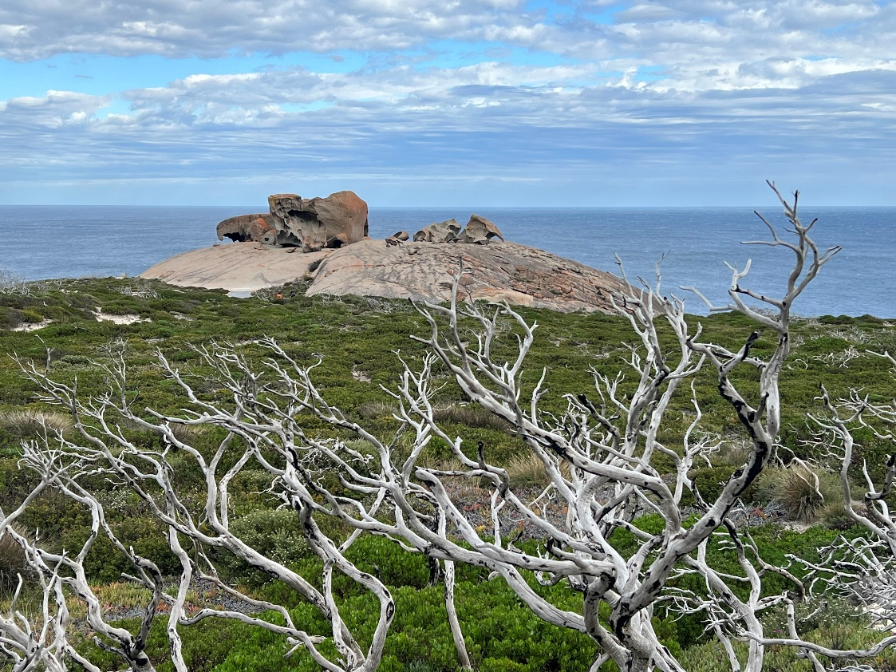

LB: Call to Worship
For the forests: trees soaring tall or spreading wide,
bearing fruit and spreading the fragrance of the bush,
making sacred space for creatures large and small –
With Eucalypts and T-trees, Old Man Banksia and naughty grevilleas,
With possums and koalas, echidnas and kangaroos,
green tree frogs and swirling bats,
We rejoice with God in the forests.
For land and soil:
birthing crops, grounding our steps,
anchoring our homes and hopes –
For the foothills, the plains, Kangaroo Island, the Coorong,
for all the variety of landscapes around us
We rejoice with God in the land.
On this day in particular, we praise with outback and wilderness:
harbouring wildness,
restoring awe, bearing mystery –
with the Flinders Ranges, Wilpena Pound, Uluru
We rejoice with God in the wilderness and outback.

LB: Opening Prayer
Creator God, we gather to worship in the company of the wild places of this planet and our Australian kin, the Outback. Rocky deserts, unkempt gorges, lakes that come and go with the rains that are their partners.

In the comfort of the city, we forget how much we depend on you, Gracious God. The starkness of the Outback reminds us that all life relies on you and your provisioning. For your continuing support, we give you thanks.

We lift our voices with the voice of the outback in praise of you, Source of life and mystery.
Amen

LB: Song: Where wide sky rolls down (TiS 188)
(Projection: note the alteration to words in the third line of verse 4)
1. Where wide sky rolls down and touches red sand,
where sun turns to gold the grass of the land,
let Spinifex, mulga and waterhole tell
their joy in the One who made everything well.
2. Where rain-forest calm meets reef, tide and storm,
where green things grow lush and oceans are warm,
let every sea-creature and tropical bird
exult in the light of the life-giving Word.
3. Where red gum and creek cross hillside and plain,
where cool tree-ferns rise to welcome the rain,
let bushland, farm, mountain-top, all of their days,
delight in the Spirit who formed them for praise.
4. Now, people of faith, come gather around
with songs to be shared, for blessings abound!
Australians, whatever your species or place,
come, lift up your hearts to the Giver of grace.

LB: Prayer of Confession

O God, we thank you for the wonders of creation
and the gift of the Outback.
Yet we remember and confess how we have marred
or destroyed the wild domains you have created.
We have polluted the deserts with our household garbage
and radioactive waste.
Christ, source of all life,
we are sorry, we are sorry.
We have torn holes in the ozone layer
and sent greenhouse gases into the atmosphere
Christ, source of all life,
we are sorry, we are sorry.
We have desecrated the sacred sites in the Outback
and destroyed the homes of the wild creatures.
Christ, source of all life,
we are sorry, we are sorry.
O Lord, we regret that we have forgotten Earth and treated this garden planet as a beast to be tamed and a place to be ruled.
Christ, source of all life,
we are sorry, we are sorry.

LB: Assurance of Pardon and Renewal
Our God is as gentle as a desert flower
and as refreshing as a waterhole in a dry land.
My Friends, hear the Good News:
In Christ Jesus, we are forgiven and made whole.
Thanks be to God.

PT: Intro to first Scripture Reading

PA: Joel 1:8-10, 17-20
8 Lament like a woman dressed in sackcloth
for the husband of her youth.
9 The grain offering and the drink offering are cut off
from the house of the LORD.
The priests mourn,
those who serve the LORD.
10 The fields are devastated,
the ground mourns;
for the grain is destroyed,
the wine dries up,
the oil fails.

17 The seed shrivels under the clods,
the storehouses are desolate;
the granaries are ruined
because the grain has failed.
18 How the animals groan!
The herds of cattle wander about
because there is no pasture for them;
even the flocks of sheep are dazed.
19 To you, O LORD, I cry.
For fire has devoured
the pastures of the wilderness,
and flames have burned
all the trees of the field.
20 Even the wild animals cry to you
because the watercourses are dried up,
and fire has devoured
the pastures of the wilderness.

PT: Introduction to Romans reading

PA: Romans 8:18-26
18 I consider that the sufferings of this present time are not worth comparing with the glory about to be revealed to us. For the creation waits with eager longing for the revealing of the children of God; for the creation was subjected to futility, not of its own will but by the will of the one who subjected it, in hope that the creation itself will be set free from its bondage to decay and will obtain the freedom of the glory of the children of God.
22 We know that the whole creation groans together and suffers agony together in labor pains until now; and not only the creation, but we ourselves, who have the first fruits of the Spirit, groan inwardly while we wait for adoption, the redemption of our bodies. For in hope we were saved. Now hope that is seen is not hope. For who hopes for what is seen? But if we hope for what we do not see, we wait for it with patience. 26 Likewise the Spirit helps us in our weakness; for we do not know how to pray as we ought, but that very Spirit intercedes with groans beyond words.

PT: Introduction to Gospel
Our reading from the New Testament does not continue the motif of lament. Rather, it talks of the first days of the ministry of Jesus – his baptism and the vacation that followed this. We are hearing the shorter version in the Gospel of Mark.

PA: Mark 1:9-13
9 In those days Jesus came from Nazareth of Galilee and was baptized by John in the Jordan. And just as he was coming up out of the water, he saw the heavens torn apart and the Spirit descending like a dove on him. And a voice came from heaven,
"You are my Son, the Beloved; with you I am well pleased."

12 And the Spirit immediately drove him out into the wilderness. He was in the wilderness forty days, tempted by Satan; and he was with the wild beasts; and the angels waited on him.

PA: In this is the word of God.
Thank you, God, for speaking to us.

PA: Song: When we are tested and wrestle alone (Tune TiS 547)
1. When we are tested and wrestle alone,
famished for bread when the world offers stone,
nourish us, God, by your word and your way,
food that sustains us by night and by day.
2. When in the desert we cry for relief,
pleading for paths marked by certain belief,
lift us to love you beyond sign and test,
trusting your presence, our only true rest.
3. When we are tempted to barter our souls,
trading the truth for power to control,
teach us to worship and praise only you,
seeking your will in the work that we do.
4. When we have struggled and searched
through the night,
sorting and sifting the wrong from the right,
Saviour, surround us with circles of care,
angels of healing, of hope, and of prayer.
Ruth Duck. Reproduced with permission under CCLI License # 22260685, all rights reserved.
PT: Message

PT: Song: Lord of Earth and all creation (TiS 672(ii))
1. Lord of earth and all creation,
let your love possess our land:
wealth, and freedom, far horizons,
mountain, forest, shining sand:
may we share, in faith and friendship,
gifts unmeasured from your hand.
2. People of the ancient Dreamtime, Bowl brought forward
they who found this country first,
ask with those, the later comers,
will our dream be blessed or cursed?
Grant us, Lord, new birth, new living,
hope for which our children thirst.
3. Lord, life-giving healing Spirit,
on our hurts your mercy shower;
lead us by your inward dwelling,
guiding, guarding, every hour,
Bless and keep our land Australia:
in your will her peace and power.
Words: © M.R. Thwaites

LB: Dedication of Offering Between table and lectern
Just as rain in the outback can cause wildflowers to bloom in barren places, we pray that our gifts can bring new and colourful life in unexpected ways and places.

LB: Notices Include South American cross description

LB: Prayers of the People

You lead us to a time and place apart, O God, for prayer, prayer that does not seek escape from the world and the wild places, but rather for healing and redemptive actions within them.

Your Spirit prays, and we long, for peace: in the midst of conflicts and hatreds, from lusting for power and wealth. Use our impatience to spur just action, and our patience to hold steady over the long course.

Your Spirit prays, and we long, for creation’s renewal: in the face of declining habitats and wild places, from lusting to control and usurp. Remind us of the integrity of all creation in you, that we not sell out or settle for divide and conquer, or close our eyes to the causes of destructive climate change.

Your Spirit prays, and we long, for justice and a just sharing of what makes for life: food and water, hope and love, justice and mercy, wild places and sanctuaries.

Your Spirit prays, and we long, for the caring for vulnerable ones, human and non-human: that they may not go forgotten or without advocates.

Your Spirit prays, and we long, for coming generations: that our children and children’s children may know they are loved by us as well as you; and that such love be embodied by our passing on of wild places intact.

Your Spirit prays, and we long, for your realm brought to earth: and in such longing and prayer, we open ourselves to your leading, for the sake of your new creation and join together in hope as we say the prayer that Jesus gave us:

(The Lord’s Prayer)
Our Father in heaven,
hallowed be your name,
your kingdom come,
your will be done,
on earth as in heaven.
Give us today our daily bread.
Forgive us our sins,
as we forgive those who sin against us.
Save us from the time of trial
and deliver us from evil.
For the kingdom, the power, and the glory are yours
now and for ever. Amen.

LB: Song The North Wind is tossing the leaves (TiS 322)
1. The north wind is tossing the leaves,
the red dust is over the town,
the sparrows are under the eaves
and the grass in the paddock is brown,
as we lift up our voices and sing
to the Christchild, the heavenly King.
2. The tree-ferns in green gullies sway,
the cool stream flows silently by,
the joy-bells are greeting the day,
and the chimes are adrift in the sky,
as we lift up our voices and sing
to the Christchild, the heavenly King.
Words: John Wheeler, William G. James. Reproduced with permission under CCLI License # 22260685, all rights reserved.

LB: Commissioning Lectern
Go out in joy;
letting yourselves be led into a whole and complete life.
Listen to the hills and mountains bursting with song.
Notice the great trees of the forest joining in the procession,
exuberant with applause.
No more thistles and thorns, but stately Gum trees,
Great and lasting evidence of the wonders of God.
(Based on Isaiah 55:12-13)

PT: Blessing In front of table

May the spirit of God
who is above all and in all and through all
fill you with the knowledge of God’s presence on Earth
and the life-giving power of Christ within you.

Post service music.

