August 23 2026 Pent 13
Minister: Anne Butler Welcome : Margaret Clogg Worship Leader: Pam Ayles Piano: Jey Edwin Bible Reader: Ruth Wise Guitar:
Camera 6: Ray Clogg Singers Rhonda Amber Anne Ind Camera 8 : Peter Thornley Audio: Margaret Cargill
Video Editor: John Drew Projection: Colin Cargill Vision Reader: Chris Ayles Vision Switcher: John Secombe

PICTURE ON SCREEN FIRST – 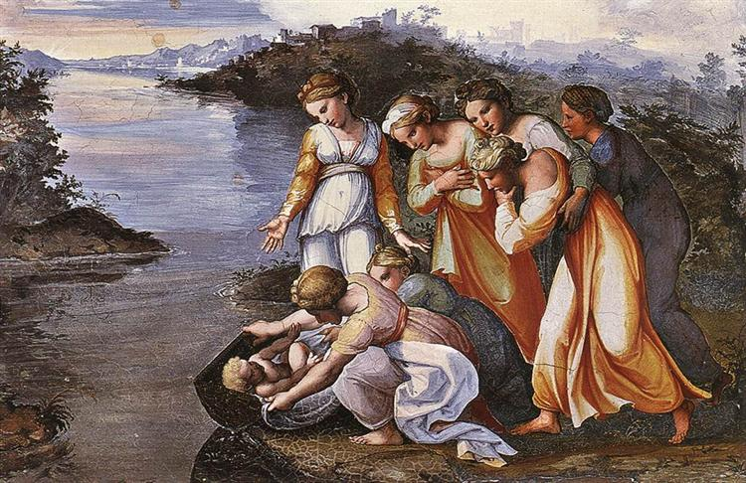
ALL AT LECTERN UNLESS OTHERWISE SHOWN. Candles lit.
Sing-through: 9:30, ends at 9:50 Pre-service music
10.00am Red light displayed: Intro video plays

PA Welcome behind table
A warm welcome to everyone here today and to those online now or joining us later. It is a pleasure to share worship with you.

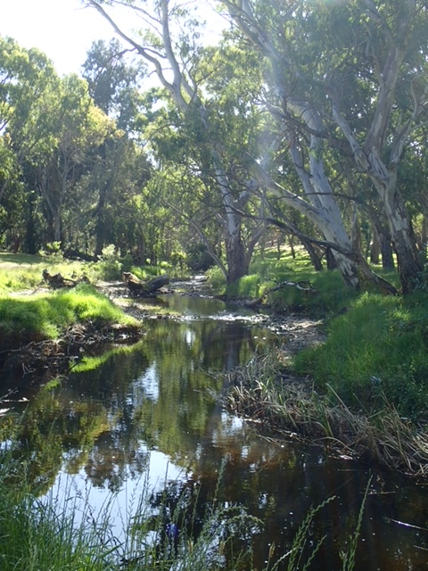 PA Acknowledgement – behind table
We acknowledge the Kaurna people on whose land we at Morialta
are worshipping and first nations people everywhere this service is
seen. They have lived in harmony with the land for millennia. May we
share with them walking carefully and respectfully

PA Candle lighting behind table

The peace candle is lit.
The Christ candle is lit. A light to the world.
The Bible is open. Stories of the relationship between God and
humanity.
The water is poured. A reminder of our baptism.

PA Call to Worship lectern
Be still!
We come to quiet ourselves in this place of holiness.
Be still and know . . .
we come to discern the Word which can set us free.
Be still and know that God is
our Hope, our Help, our Refuge, and our Saviour.
Thom Shuman
PA Prayer
Eternal God, we celebrate the new life which you have given us. We have experienced broken lives made whole, old wounds healed over and tired spirits rejuvenated with new vision. With gratitude we embrace the purpose and possibilities you have placed before us. Help us to move joyfully into a future that more fully points to your love and justice. Amen.
PA Song I danced in the morning TIS 242 (4 verses)
I danced in the morning when the world was begun,
And I danced in the moon and the stars and the sun;
And I came down from heaven and I danced on the earth,
At Bethlehem I had my birth.
Dance, then, wherever you may be, I am the Lord of the Dance, said he,
And I’ll lead you all, wherever you may be,
And I’ll lead you all in the Dance, said he.

I danced for the scribe and the pharisee,
But they would not dance and they wouldn’t follow me.
I danced for the fishermen, for James and John –
They came with me and the Dance went on.
Dance, then, wherever you may be, I am the Lord of the Dance, said he,
And I’ll lead you all, wherever you may be,
And I’ll lead you all in the Dance, said he.

I danced on a Friday when the sky turned black –
It’s hard to dance with the devil on your back.
They buried my body and they thought I’d gone,
But I am the Dance, and I still go on.
Dance, then, wherever you may be, I am the Lord of the Dance, said he,
And I’ll lead you all, wherever you may be,
And I’ll lead you all in the Dance, said he.

They cut me down and I leap up high;
I am the life that’ll never, never die;
I’ll live in you if you’ll live in me –
I am the Lord of the Dance, said he.
Dance, then, wherever you may be, I am the Lord of the Dance, said he,
And I’ll lead you all, wherever you may be,
And I’ll lead you all in the Dance, said he.
Sydney Bertram Carter Reproduced with permission CCLI License #22260685, all rights reserved

AB Prayer of Confession
God of graciousness,
I sometimes forget that I was created for Joy.
My mind is too busy.
My Heart is too heavy
for me to remember that I have been
called to dance the Sacred dance of life.
I was created to smile, to love
To be lifted up and to lift others up.
O Sacred One untangle my feet
from all that ensnares.
Free my soul that we might Dance
and that our dancing might be contagious. Amen ~Hafiz

AB Intro to readings
RW Reading Exodus 1:8-2:10
⁸ Now a new king arose over Egypt, who did not know Joseph. ⁹ He said to his people, ‘Look, the Israelite people are more numerous and more powerful than we. ¹⁰ Come, let us deal shrewdly with them, or they will increase and, in the event of war, join our enemies and fight against us and escape from the land.’ ¹¹ Therefore they set taskmasters over them to oppress them with forced labour. They built supply cities, Pithom and Rameses, for Pharaoh. ¹² But the more they were oppressed, the more they multiplied and spread, so that the Egyptians came to dread the Israelites. ¹³ The Egyptians became ruthless in imposing tasks on the Israelites, ¹⁴ and made their lives bitter with hard service in mortar and brick and in every kind of field labour. They were ruthless in all the tasks that they imposed on them.
¹⁵ The king of Egypt said to the Hebrew midwives, one of whom was named Shiphrah and the other Puah, ¹⁶ ‘When you act as midwives to the Hebrew women, and see them on the birthstool, if it is a boy, kill him; but if it is a girl, she shall live.’ ¹⁷ But the midwives feared God; they did not do as the king of Egypt commanded them, but they let the boys live. ¹⁸ So the king of Egypt summoned the midwives and said to them, ‘Why have you done this, and allowed the boys to live?’ ¹⁹ The midwives said to Pharaoh, ‘Because the Hebrew women are not like the Egyptian women; for they are vigorous and give birth before the midwife comes to them.’ ²⁰ So God dealt well with the midwives; and the people multiplied and became very strong. ²¹ And because the midwives feared God, he gave them families. ²² Then Pharaoh commanded all his people, ‘Every boy that is born to the Hebrews^{[a]} you shall throw into the Nile, but you shall let every girl live.’
Birth and Youth of Moses
2 Now a man from the house of Levi went and married a Levite woman. ² The woman conceived and bore a son; and when she saw that he was a fine baby, she hid him for three months. ³ When she could hide him no longer she got a papyrus basket for him, and plastered it with bitumen and pitch; she put the child in it and placed it among the reeds on the bank of the river. ⁴ His sister stood at a distance, to see what would happen to him.
⁵ The daughter of Pharaoh came down to bathe at the river, while her attendants walked beside the river. She saw the basket among the reeds and sent her maid to bring it. ⁶ When she opened it, she saw the child. He was crying, and she took pity on him. ‘This must be one of the Hebrews’ children,’ she said. ⁷ Then his sister said to Pharaoh’s daughter, ‘Shall I go and get you a nurse from the Hebrew women to nurse the child for you?’ ⁸ Pharaoh’s daughter said to her, ‘Yes.’ So the girl went and called the child’s mother. ⁹ Pharaoh’s daughter said to her, ‘Take this child and nurse it for me, and I will give you your wages.’ So the woman took the child and nursed it. ¹⁰ When the child grew up, she brought him to Pharaoh’s daughter, and she took him as her son. She named him Moses, ‘because’, she said, ‘I drew him out of the water.’

RW Reading Matthew 16:13-20 Peter’s Declaration about Jesus
¹³ Now when Jesus came into the district of Caesarea Philippi, he asked his disciples, ‘Who do people say that the Son of Man is?’ ¹⁴ And they said, ‘Some say John the Baptist, but others Elijah, and still others Jeremiah or one of the prophets.’ ¹⁵ He said to them, ‘But who do you say that I am?’ ¹⁶ Simon Peter answered, ‘You are the Messiah, the Son of the living God.’ ¹⁷ And Jesus answered him, ‘Blessed are you, Simon son of Jonah! For flesh and blood has not revealed this to you, but my Father in heaven. ¹⁸ And I tell you, you are Peter, and on this rock I will build my church, and the gates of Hades will not prevail against it. ¹⁹ I will give you the keys of the kingdom of heaven, and whatever you bind on earth will be bound in heaven, and whatever you loose on earth will be loosed in heaven.’ ²⁰ Then he sternly ordered the disciples not to tell anyone that he was the Messiah.
RW These words have inspired and comforted
generations of humans,
And the understanding changes our lives today.

RW Song: God, Make Us Agents of Joyful Rebellion (tune: Faithfulness TIS 154
God, make us agents of joyful rebellion
called to resist sullen empires of fear.
Fuelled not by hatred but love for all people,
we stand united, assured you are love.

Some will be Marys who sing down injustice.
Others like Moses will speak truth to power.
Few, like brave midwives, will shield life from evil.
All must be prophets awake for this hour.

Laughing in answer to snarling derision,
we dance to counter oppression and pain.
Feasting together despite our divisions,
we pledge ourselves to Christ’s upside-down reign.

God, make us agents of joyful rebellion
called to sing out till our faith is made sight.
Fuelled by the stories of saintly subversives,
we stand united, your justice our light.
David Bjorlin, Benjamin Brody Reproduced with permission under ONE LICENSE #A- 604530. All rights reserved.
AB Message – Who do you say that I am?

AB Song https://youtu.be/_qZ-Nw6C46M?si=KEzNJQ71ogBnt3Pn Teach me to dance (please stop at 3.36) Bowl brought forward when chorus repeated Graham Kendrick, Steve Thompson Reproduced with permission CCLI License #22260685, all rights reserved

PA Offering and prayer between lectern and table
We give thanks for the gifts we have been given. Gifts of love,
abilities, time and money. May we share them with those where they
are most needed, bringing hope and healing. Amen

PA Notices

PA Prayers of the People
As we enter into our Prayers for the People may our response be
guided by the words of John Dominic Crossan. “While we are waiting
for God’s intervention, God is waiting for our collaboration.”
Let us pray
Thank you God for the differing experiences we have encountered.
The future is always evolving. May we be inspired by the midwives
and families as they saved Moses and the other male children. May
we be inspired to help each other.
We pray for people in areas of the world in conflict and for their
leaders. Give them wisdom and courage to build a world of justice,
freedom and truth.
We pray that we may be aware of the needs of those around us that
they may feel loved and valued.
We pray for those suffering from illness, grief and other challenging
life situations.
We pray for those searching for meaning and purpose in their lives.
We thank you Jesus for revealing your special relationship with God
and us. May our understanding of that relationship and our part in it
grow and mature. May we be inspired by to surround those we meet
with kindness, comfort and hope, creating a world where care and
respect, justice and peace for all is possible.

PA we join together in this version of the Lord’s Prayer
Dear One, closer to us than our own hearts,
farther from us than the most distant star,
you are beyond naming.
May your powerful presence become obvious in our world.
Give us what we need, day by day,
to keep body and soul together,
because clever as you have made us,
we still owe our existence to you.
We recognise that to be reconciled with you,
we must live peaceably and justly with other human beings,
putting hate and bitterness behind us.
We are torn between our faith in your goodness
and our awareness of evil,
so deliver us from the temptation to despair.
Yours alone is the universe
and all its majesty and beauty.
So it is, Amen. James Burklo

PA Song I the Lord of Sea and sky TIS 658
I, the Lord of sea and sky,
I have heard my people cry.
All who dwell in dark and sin my hand will save.
I, who made the stars of night,
I will make their darkness bright.
Who will bear my light to them – whom shall I send?
Here I am, Lord. Is it I, Lord?
I have heard you calling in the night.
I will go, Lord, if you lead me;
I will hold your people in my heart.
I, the Lord of snow and rain,
I have borne My people’s pain.
I have wept for love of them; they turn away.
I will break their hearts of stone,
Give them hearts for love alone.
I will speak My Word to them – whom shall I send?
Here I am, Lord. Is it I, Lord?
I have heard you calling in the night.
I will go, Lord, if you lead me;
I will hold your people in my heart.
I, the Lord of wind and flame,
I will tend the poor and lame.
I will set a feast for them; My hand will save.
Finest bread I will provide,
Till their hearts be satisfied.
I will give My life to them – whom shall I send?
Here I am, Lord. Is it I, Lord?
I have heard you calling in the night.
I will go, Lord, if you lead me;
I will hold your people in my heart.
Dan Schutte Reproduced with permission under ONE LICENSE #A- 604530. All rights reserved.
AB Commissioning In front of table
The love of the faithful Creator,
the peace of the wounded Healer,
the joy of the challenging Spirit,
the hope of the Three in One
surround and encourage you,
today, tonight and forever.
(Source: Kathy Galloway, The Pattern Of Our Days, Wild Goose Publications, 1998)
AB Blessing song: TIS 778
Shalom to you now, shalom my friends,
May God’s full mercies bless you, my friends.
In all your living and through your loving,
Christ be your shalom, Christ be your shalom.
Carlton Raymond Young, Elise S. Eslinger Reproduced with permission under CCLI License #22260685, all rights reserved.

