July 26 2026 Pent 9
Minister: Anne Butler Welcome : Leonie Brown
Worship Leader: Carole Lyons Piano: Eunice Sullivan Bible Reader: Pam Ayles Guitar: Austin Phoenix
Camera 6: Colin Cargill Singers Rhonda Amber Anne Ind Camera 8 : John Secombe Audio: Ray Clogg
Vision Editor: John Drew Projection: John Thornton Vision Reader: Margaret Cargill Vision Switcher: Andrew Pill

PICTURE ON SCREEN FIRST - 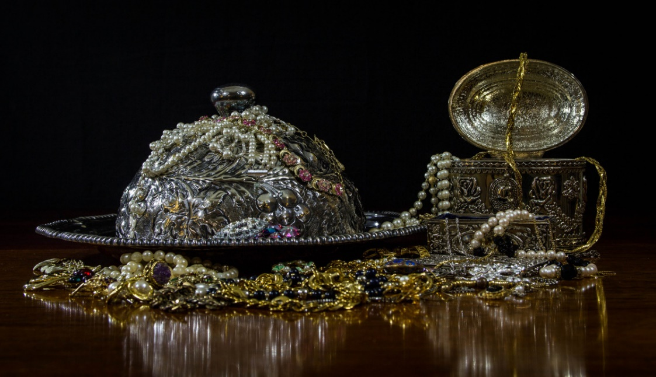
ALL AT LECTERN UNLESS OTHERWISE SHOWN.
Sing-through: 9:30, ends at 9:50 Pre-service music
10.00am Red light displayed: Intro video plays Candles already lit.
CL Welcome behind table
Including live streamers.
CL Acknowledgement – behind table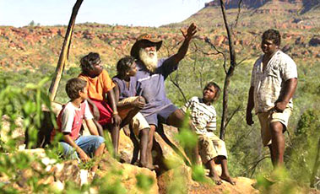 The ancient of Days breathed life into this vast land and her Peoples. From Time beyond our reckoning the Kaurna People have blessed this place through their law and customs. We honour and celebrate the heritage of all First Nations peoples, past, present and future. May we walk gently and respectfully on this land.
This Photo by Unknown Author is licensed under CC BY-SA-NC

CL Candle lighting behind table
The light of Christ shines in the darkness and has not been overcome. The word of God’s faithful people is open for all, and the waters of our baptism make us one people. The light from the candle of peace bravely persists..

CL Call to Worship lectern
We gather, conscious that the Spirit of Wisdom moves in each of us as it has moved in all people since the beginning of human life. Working in and through whom and what it has to work with.
May we be wise in our sharing, ready to listen,
open to learning where new insights and knowledge
may take us, drawing on wisdom that stands the test of time,
and courageous enough to discard whatever can no longer sustain our faith.
We pray that our gathering may allow the Spirit of Wisdom to be expressed here as graciously and as clearly as is humanly possible.
Amen Michael Morwood

CL Song The great love of God TIS164
The great love of God is revealed in the Son,
who came to this earth to redeem everyone.

2. That love, like a stream flowing clear to the sea,
makes clean every heart that from sin would be free.

3. It binds the whole world, every barrier it breaks,
the hills it lays low, and the mountains it shakes.

4. it’s yours, it is ours, O how lavishly given!
the pearl of great price, and the treasure of heaven.
Daniel T. Niles 1908-1970 Public Domain

AB Prayer of Confession
Eternal God, maker of the skies above, lowly Christ,
born amidst the growing earth, Spirit of life, wind over the flowing waters, in earth, sea and sky, you are there.
O hidden mystery, sun behind all suns, soul behind all souls,
in everything we touch, in everyone we meet,
your presence is around us, and we give you thanks.
But when we have not touched but trampled you in Creation,
when we have not met but missed you in one another,
when we have not received but rejected you in the poor,
forgive us, and hear now our plea for mercy."
Hear now the words of Jesus for all who are truly aware and seek to renew their lives: Your sins are forgiven. Go in peace; come and follow me.
Lead us now, O God, to acknowledge your costly generosity
by living as forgiven people, until heaven and earth rejoice
and the whole earth cries Glory! through Christ our Lord. Amen." Prayer of Confession from the Iona Abbey Worship Book:

AB Intro to readings
PA Reading Genesis 29:15-28 ¹⁵ Then Laban said to Jacob, ‘Because you are my kinsman, should you therefore serve me for nothing? Tell me, what shall your wages be?’ ¹⁶ Now Laban had two daughters; the name of the elder was Leah, and the name of the younger was Rachel. ¹⁷ Leah’s eyes were lovely,^{[a]} and Rachel was graceful and beautiful. ¹⁸ Jacob loved Rachel; so he said, ‘I will serve you seven years for your younger daughter Rachel.’ ¹⁹ Laban said, ‘It is better that I give her to you than that I should give her to any other man; stay with me.’ ²⁰ So Jacob served seven years for Rachel, and they seemed to him but a few days because of the love he had for her.
²¹ Then Jacob said to Laban, ‘Give me my wife that I may go in to her, for my time is completed.’ ²² So Laban gathered together all the people of the place, and made a feast. ²³ But in the evening he took his daughter Leah and brought her to Jacob; and he went in to her. ²⁴ (Laban gave his maid Zilpah to his daughter Leah to be her maid.) ²⁵ When morning came, it was Leah! And Jacob said to Laban, ‘What is this you have done to me? Did I not serve with you for Rachel? Why then have you deceived me?’ ²⁶ Laban said, ‘This is not done in our country—giving the younger before the firstborn. ²⁷ Complete the week of this one, and we will give you the other also in return for serving me for another seven years.’ ²⁸ Jacob did so, and completed her week; then Laban gave him his daughter Rachel as a wife.

PA Reading Matthew 13:31-33, 44-52
The Parable of the Mustard Seed
³¹ He put before them another parable: ‘The kingdom of heaven is like a mustard seed that someone took and sowed in his field; ³² it is the smallest of all the seeds, but when it has grown it is the greatest of shrubs and becomes a tree, so that the birds of the air come and make nests in its branches.’
The Parable of the Yeast
³³ He told them another parable: ‘The kingdom of heaven is like yeast that a woman took and mixed in with three measures of flour until all of it was leavened.’
Three Parables
⁴⁴ ‘The kingdom of heaven is like treasure hidden in a field, which someone found and hid; then in his joy he goes and sells all that he has and buys that field.
⁴⁵ ‘Again, the kingdom of heaven is like a merchant in search of fine pearls; ⁴⁶ on finding one pearl of great value, he went and sold all that he had and bought it.
⁴⁷ ‘Again, the kingdom of heaven is like a net that was thrown into the sea and caught fish of every kind; ⁴⁸ when it was full, they drew it ashore, sat down, and put the good into baskets but threw out the bad. ⁴⁹ So it will be at the end of the age. The angels will come out and separate the evil from the righteous ⁵⁰ and throw them into the furnace of fire, where there will be weeping and gnashing of teeth.
Treasures New and Old
⁵¹ ‘Have you understood all this?’ They answered, ‘Yes.’ ⁵² And he said to them, ‘Therefore every scribe who has been trained for the kingdom of heaven is like the master of a household who brings out of his treasure what is new and what is old.’

PA Song Brother sister let me serve you TIS 650 Brother, sister, let me serve you;
let me be as Christ to you;
pray that I may have the grace
to let you be my servant too.
2. We are pilgrims on a journey,
and companions on the road;
we are here to help each other
walk the mile and bear the load.
3. I will hold the Christ-light for you
in the nighttime of your fear;
I will hold my hand out to you,
speak the peace you long to hear.
4. I will weep when you are weeping;
when you laugh I'll laugh with you;
I will share your joy and sorrow,
till we've seen this journey through.
5. When we sing to God in heaven,
we shall find such harmony,
born of all we've known together
of Christ's love and agony.
6. Brother, sister, let me serve you;
let me be as Christ to you;
pray that l may have the grace
to let you be my servant too.
Richard Gillard Reproduced with permission CCLI License #22260685, all rights reserved

AB Message Times and focus At what cost?.
AB Song Take my life and let it be TIS 599
1 Take my life and let it be
consecrated, Lord, to thee.
Take my moments and my days;
let them flow in ceaseless praise.

2 Take my hands and let them move
at the impulse of thy love.
Take my feet and let them be
swift and beautiful for thee.

3 Take my voice and let me sing
always, only, for my King.
Take my lips and let them be
filled with messages from thee.

4 Take my silver and my gold;
nothing, Lord, would I withhold.
Take my intellect and use
every power as thou shalt choose.

5 Take my will and make it thine;
it shall be no longer mine.
Take my heart it is thine own;
it shall be thy royal throne. Bowl brought forward
6 Take my love; my Lord, I pour
at thy feet its treasure store.
Take myself, and I will be
ever, only, all for thee.
Frances Ridley Havergal Reproduced with permission CCLI License #22260685, all rights reserved
Possible addition

CL Offering and prayer between lectern and table
Gracious God, you give us all things. Receive now the gifts of your
people. Help us to render to you all that we have and all that we are,
that we may praise you with our whole lives through Jesus Christ our
Lord. Amen.

CL Notices lectern

CL Prayers of the People
In this irritated and unsettled world, God of all,
We bring before you these concerns in prayers from our heart.
We pray for the underfed and unsheltered and homeless, that they
might have food and homes.
Call us to welcoming hospitality and generosity.
Show us where to bring change.
We hear the environment groaning under the pains of misuse and
abuse.
Call us to be wise in our use of resources, renewables
and recycling. Show us where and how to encourage others in loving creation.
We see those struggling in loneliness and isolation.
Call us to watch, listen clearly and act with generosity.
Show us where to encourage inclusion and acceptance.
We learn of those who need advocacy and support that we can offer
Call to us to see the world as it is and where we can use
the gifts we have to create a thriving society, controlled by
your love.
We hear but can hardly bear to watch news of the human
devastation caused by wars, oppression, invasions and
abandonment of survivors.
May we not look away but seek to live as beacons
Of hope through our votes, our involvements and our
generosity.
Grant that we may be instruments of your love and kindness,
and that our lives may bear witness to your Way
and to the change that will bring about your realm,
God of new beginnings.

CL Lord’s Prayer We join in the prayer of Christ’s family
Our Father in heaven,
hallowed be your name,
your kingdom come, your will be done,
on earth as in heaven.
Give us today our daily bread.
Forgive us our sins,
as we forgive those who sin against us.
Save us in the time of trial
and deliver us from evil.
For the kingdom, the power, and the glory are yours
now and for ever. Amen.

CL Song Be thou my vision TIS 547
1. Be thou my vision, O Lord of my heart;
Naught be all else to me save that thou art.
Thou my best thought by day or by night;
Waking or sleeping, thy presence my light.
2. Be thou my wisdom, and thou my true Word;
I ever with thee and thou with me, Lord.
Thou my great Father, thy child let me be;
Thou in me dwelling, and I one with thee.
3. Be thou my armour, my sword for the fight;
Be thou my dignity, thou my delight.
Thou my soul's shelter, thou my high tow'r;
Raise thou me Heav'nward, O Pow'r of my pow'r.
4. Riches I scorn, and the world’s empty praise;
Thou mine inheritance, now and always.
Thou and thou only, the first in my heart,
High King of Heaven, my treasure thou art.
5. High King of Heaven,after victory won,
May I reach Heaven's joy, O bright Heav'ns Sun!
Heart of my own heart, whatever befall,
Still be my vision, O Ruler of all. Public Domain

AB Commissioning In front of table
Treasure of all treasure, enrich us
Light of all light, enlighten us
Love of all love, transform us
Go with us into your world, Amen.
AB Blessing song TIS 650
I will hold the Christ-light for you
in the nighttime of your fear;
I will hold my hand out to you,
speak the peace you long to hear.

