July 19 2026 Pent 8 Intercultural Neighbouring Sunday
Minister: Anne Butler Welcome: Margaret Clogg
Worship Leader: Bev Treadrea Piano: Eunice Sullivan
Bible Reader: Ruth Pitt Guitar: Austin Phoenix
Camera 6: Pam Ayles Singers. Rhonda Amber Anne Ind
Camera 8: Ray Clogg Audio: June Searle
Video Editor: John Secombe Projection: Colin Cargill
Vision Director: Chris Ayles Vision Switcher: John Secombe

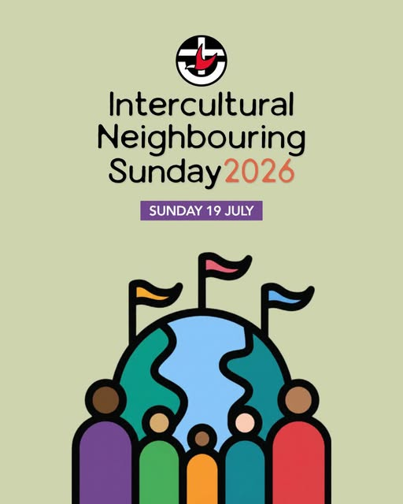
ALL AT LECTERN UNLESS OTHERWISE SHOWN.
Sing-through: 9:30, ends at 9:50 Pre-service music Candles lit –
10.00am Red light displayed: Intro video plays

BT Welcome behind table
Including live stream

BT BT Acknowledgement – Many have gone before who have honoured God by caring for this land in the ways they have lived and the stories they have shared, We give thanks for the Kaurna people, who have held as sacred the duty of protecting the land and living in harmony with it. May God honour and bless them now and forever.

BT Call to Worship – Lectern
We gather together to entrust ourselves
and the world to the Spirit of love and to each other.
To find peace and healing in the joy of music and words,
in the stillness of prayer and in the Spirit's enfolding love

BT Prayer We come God of the journey: a people from different places, different histories, different cultures
We come hoping to find companionship for the journey, solidarity for the struggle.
We gather, God of hospitality, around your welcome table, a table not yet round but rounding.
We gather seeking to become a round table people, welcoming all with no preferred seating,
no firsts and no lasts, and no corners for the "least of these."
We yearn God of diversity, for a new way of living and relating as neighbours not strangers,
as brothers and sisters, not "them and us".
We yearn to live fully celebrating
both the diversity of our human family,
and the unity of our call to peace, love and justice. Amen

BT Song The Bright Wind is blowing TIS 263
1 The bright wind is blowing, the bright wind of heaven,
And where it is going to, no-one can say;
But where it is passing our hearts are awaking
To grope from the darkness and reach for the day.

2 The bright wind is blowing, the bright wind of heaven,
And many old thoughts will be winnowed away;
The husk that is blown is the chaff of our hating,
The seed that is left is the hope for our day.

3 The bright wind is blowing, the bright wind of heaven,
The love that it kindles will never betray;
The fire that it fans is the warmth of our caring,
So lean on the wind - it will show us the way.
Cecily Taylor (1930-2018) Reproduced with permission CCLI License #22260685, all rights reserved

AB Prayer of Confession Lectern
AB For the young at heart

RP Reading Genesis 28:10-19a Jacob’s Dream at Bethel
10 Jacob left Beer-sheba and went towards Haran. 11 He came to a certain place and stayed there for the night, because the sun
had set. Taking one of the stones of the place, he put it under
his head and lay down in that place. 12 And he dreamed that
there was a ladder set up on the earth, the top of it reaching to
heaven; and the angels of God were ascending and descending
on it. 13 And the Lord stood beside him and said, ‘I am the Lord,
the God of Abraham your father and the God of Isaac; the land
on which you lie I will give to you and to your offspring; 14 and
your offspring shall be like the dust of the earth, and you shall
spread abroad to the west and to the east and to the north and
to the south; and all the families of the earth shall be
blessed in you and in your offspring. 15 Know that I am with you
and will keep you wherever you go, and will bring you back to
this land; for I will not leave you until I have done what I have
promised you.’ 16 Then Jacob woke from his sleep and said,
‘Surely the Lord is in this place—and I did not know it!’ 17 And he
was afraid, and said, ‘How awesome is this place! This is none
other than the house of God, and this is the gate of
heaven.’ 18 So Jacob rose early in the morning, and he took the
stone that he had put under his head and set it up for a pillar
and poured oil on the top of it. 19 He called that place
Bethel; but the name of the city was Luz at the first.

RP Reading Matthew 13:24-30 The Parable of Weeds among the Wheat
24 He put before them another parable: ‘The kingdom of heaven may be compared to someone who sowed good seed in his field; 25 but while everybody was asleep, an enemy came and sowed weeds among the wheat, and then went away. 26 So when the plants came up and bore grain, then the weeds appeared as well. 27 And the slaves of the householder came and said to him,
“Master, did you not sow good seed in your field? Where, then,
did these weeds come from?” 28 He answered, “An enemy has
done this.” The slaves said to him, “Then do you want us to go
and gather them?” 29 But he replied, “No; for in gathering the
weeds you would uproot the wheat along with them. 30 Let both of them grow together until the harvest; and at harvest time I will tell the reapers, Collect the weeds first and bind them in bundles to be burned, but gather the wheat into my barn.”’

RP Hear what the Spirit is saying to the Church
Thanks be to God

RP Song When I needed a neighbour were you there? TIS 629.
When I needed a neighbour
Were you there, were you there?
When I needed a neighbour
Were you there?
And the creed and the colour
And the name won't matter
Were you there?
I was hungry and thirsty
Were you there, were you there?
I was hungry and thirsty
Were you there?
And the creed and the colour
And the name won't matter
Were you there?
I was cold, I was naked
Were you there, were you there?
I was cold, I was naked
Were you there?
And the creed and the colour
And the name won't matter
Were you there?
When they put me in prison
Were you there, were you there?
When they put me in prison Were you there?
And the creed and the colour
And the name won't matter
Were you there?
Wherever you travel
I'll be there, I'll be there.
Wherever you travel
I'll be there.
And the creed and the colour
And the name won't matter
I'll be there. Sydney Carter, arr. Rose Reproduced with permission CCLI License #22260685, all rights reserved

AB Message – Who is my neighbour?

AB Song Community of Christ TIS 473
Community of Christ,
who make the Cross your own,
live out your creed and risk your life
for God alone:
the God who wears your face,
to whom all worlds belong,
whose children are of every race
and every song.

Community of Christ,
look past the Church's door
and see the refugee, the hungry,
and the poor.
Take hands with the oppressed,
the jobless in your street,
take towel and water, that you wash
your neighbour's feet.

Community of Christ,
through whom the word must sound --
cry out for justice and for peace
the whole world round:
disarm the powers that war
and all that can destroy,
turn bombs to bread, and tears of anguish
into joy.

When menace melts away,
so shall God's will be done,
the climate of the world be peace
and Christ its Sun;
our currency be love
and kindliness our law,
our food and faith be shared as one
forevermore.
Shirley Erena Murray Reproduced with permission CCLI License #22260685, all rights reserved

BT Offering and prayer- Between table and lectern
We love you God infinite creator of all that is, and we rejoice that we are your children. We come from you.
We are born of your love. You created us as living images of your grace and so now we bring the offering of ourselves
to serve your world through this community. Amen

BT Notices Lectern
BT Prayer for others
Loving God we acknowledge that we are blessed, in this land you have given us peace and freedom.
In this country we have a society with a rich variety of people who have come from many lands.
We thank you for the church in Australia. Inspire us to promote the unity of your church as we pray
for all its congregations and its clergy.
We pray for the Federal and State governments of this country and for all who are in positions
of authority. We pray that they may govern wisely so that all may live in peace and safety.
Today we pray for Margaret and her family as they prepare to say good bye to Roger. Comfort them and uphold them in your loving care.

BT Gathering our prayers and praises into one, let us say the Lord’s
Prayer together.
Our Father in heaven,
Reveal who you are.
Set the world right;
Do what is best— as above, so below.
Keep us alive with three square meals.
Keep us forgiven with you and forgiving others.
Keep us safe from ourselves and evil.
You're in charge of us!
You can do anything you want!
You're ablaze in beauty!
Yes. Yes. Yes.
Matthew 6 The Message E Petersen

BT Song As a fire is meant for burning Tune Blaenwern 590
- As a fire is meant for burning
with a bright and warming flame,
so the church is meant for mission,
giving glory to God’s name.
Not to preach our creeds or customs,
but to build a bridge of care,
we join hands across the nations,
finding neighbours everywhere.

- We are learners; we are teachers;
we are pilgrims on the way.
We are seekers; we are givers;
we are vessels made of clay.
By our gentle, loving actions,
we would show that Christ is light.
In a humble, listening Spirit,
we would live to God’s delight.

- As a green bud in the springtime
is the sign of life renewed,
so may we be signs of oneness
’mid earth’s peoples, many hued.
As a rainbow lights the heavens
when a storm is past and gone,
may our lives reflect the radiance
of God’s new and glorious dawn.
Ruth Duck Reproduced with permission under ONE LICENSE #A- 604530. All rights reserved.

AB Commissioning in front of table

AB Blessing song TIS 629
God, make us good neighbours
To be there, to be there! We’ll help all our neighbours
We’ll be there!
And the creed and the colour
And the name won't matter
We’ll be there!

