Morialta and Marion UCs on Sunday 28 June 2026: UnitingWorld Sunday

Minister: Rev. Dr Paul Goh
Worship Leaders: Margaret Cargill and Peter Vawser
Bible Reader: Wendy Pearce
Piano: from Marion Singers: Lyn Vawser et al.
MorialtaAudio: John Drew MorialtaProjection: John Thornton
MarionAudio: John Mayfield MarionProjection:John Mayfield
Welcome: Judith Purling Camera 6: Colin Cargill
Camera 8: Ray Clogg Vision Director: Chris Ayles
Vision Switcher: John Secombe Video editor: John Drew
Vision at Marion: Andrew Pill

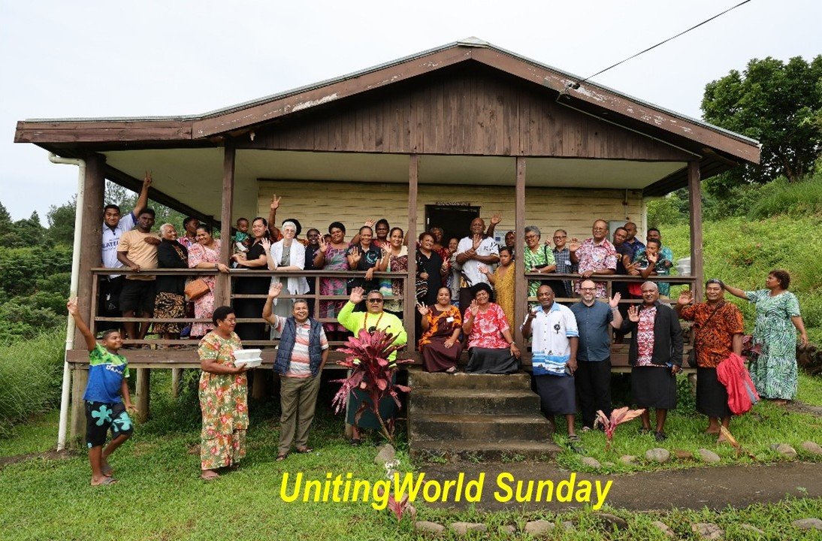

ALL AT LECTERN UNLESS OTHERWISE SHOWN.
Candles lit, Bible open, Water poured.

Pre-service music – live from Marion from 9:50

10.00am Red light displayed: Intro video plays from Morialta

MC Introduction and welcomes Behind table at Morialta
Welcome to worship in this inaugural shared service between Morialta and Marion Uniting Churches – welcome to those of us in the Morialta church, those of us in the Marion church and all those joining us online, now or at any time. You are all highly important members of our gathered congregation. And a special welcome to Rev Dr Paul Goh, our guest preacher for today.

Some words from Marion …

PV: at Marion
Words of welcome from Marion. Friends, today is a special service to focus our attention to the work of Christ in our world through UnitingWorld.
As part of the Uniting Church in Australia, we are connected in partnership with churches across the Pacific, Asia and Africa; one body, gathered across borders. Our partners are vibrant, inspiring and faithful people of God who bear witness to hope, dignity and transformation across their local communities.
Many of our overseas church relationships stretch back more than 150 years, shaping lives across generations and testifying to God’s enduring faithfulness.
Through these relationships, we seek to act as one body of Christ in the world. UnitingWorld nurtures these relationships on behalf of the wider Uniting Church in Australia and today we hear more about this work so we can celebrate our global neighbours together.
And from Morialta:

MC: behind table at Morialta
It is a special joy for me to be a Worship Leader today, bringing back memories of the 4 years Colin, Tom, Helen and I spent working with UnitingWorld in Tonga in the 1980s, and reminding me of all that we learned during that time and all it has led to for all of us and for the people we have lived and worked with, then and since then.

MC: Candles
The Christ candle is lit at both sites, symbolising Christ, light of the world. At Morialta our peace candle also burns, representing the peace we all long for and pray for, in our world and in our lives. The Bibles are open, stories of God’s people through ages past, and more. The water is poured, reminding us of our own baptism. And at Marion …

PV: Acknowledgement of Land at Marion lectern on LH side
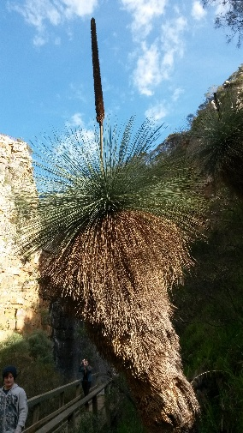
As we look upon the hills and valleys, we see the love poured out on this land by those who have cared for this Land since time beyond measure. We honour those who have gone before and those who are yet to come. May we be mindful of the calling God places on humanity to care for Creation. May we take the lead from the Kaurna People whose stories are entwined with the stewarding of this place, and from the First nations people of all places where this service is shared. May we learn from them and walk with them in God’s Covenant.

MC: Call to worship (Lectern at Morialta)
Our call to worship has responses:

We gather today as people who know the Shepherd's voice.
We come to listen, to follow, to be led.
We gather with family across Asia, the Pacific and Africa. One flock, one Shepherd.
We come as part of a family larger than we can imagine.
Jesus said, I came that you might have life, life in all its fullness.
We come hungry for that life and ready to share it.
Let us worship the Good Shepherd, who calls us each by name.
Come, let us follow where He leads. Amen

MC: Opening Prayer
Let us pray.
Good Shepherd, we come to you now, hungry for life in abundance.
You have called us together across every border and tongue, one flock, gathered in your name, dreaming with you of a world made whole.
We bring before you our partners across Asia, the Pacific and Africa, those longing for hope, dignity, and a future made new. Meet them in their need, as only you can.
May our ears be open to hear your voice above all others. May our eyes be open to see your abundance at work in the world. May our hands be filled to join your work of healing and making whole.
May we be led into your wide and generous pastures, where there is more than enough for all. May a hope be planted in us that will not shrink until every person, in every place, knows the abundant life you came to give.
Together in Christ, may we be true partners. Amen

MC: Introduces Song: We come by ones ATW 418
Let us sing together, standing or seated as we each prefer, as will be the case for all our songs today, and we will be led by the musicians and singers at Marion

Words projected at Marion, but printed here for those accessing the OOS online

1. We come by ones, we come in pairs,
We come in groups of three,
We come all shapes and sizes,
We come in families.

2. We come to grow in love of life,
To hear a word of grace,
For bread and wine and wisdom,
And love for coming days.

Chorus: We come to pray for people’s needs,
For strength to carry on,
For the needs we have each morning,
For love of everyone.

3. We come in hope, we come in pain,
We come with broken dreams.
We weary ones in weakness,
We lose our self-esteem.

4. For we alone are fragile things,
We need community;
We come here for each other
To be the strength we need.

Chorus

5. And we confess our love of God,
Confess we've gone astray,
For love is here beside us
And redirects our way.

6. We come by ones, we come in pairs
And worship God again
For life is found in circles
We're dancing 'til the end.
For life is found in circles
We're dancing 'til the end
Leigh Newton. Reproduced with permission under CCLI License #22260685, all rights reserved.

One second pause

PG: Prayer of Confession at lectern at Morialta
Let us come honestly before the Good Shepherd.
Shepherd of us all,
you call us into one flock,
yet we so often fence ourselves into one paddock.
We grow comfortable with abundance close to home,
and grow deaf to the bleating of the flock in other fields.
Forgive us, when we have loved security more than partnership.
Forgive us, when we have hoarded what was meant to be shared.
Forgive us, when we have called distant voices "other,"
instead of hearing in them the one Shepherd's call.
You ask us to fall like a grain into the earth,
to lose our life that we might find it,
but we cling tightly to what is ours,
and call that clinging wisdom.
Silence is kept. (Count to 5)

God of mercy,
unbind what we have bound too tightly.
Open our hands, our borders, our hearts,
that we might walk together with our sisters and brothers
across Asia, the Pacific, Africa, the Middle East and all over the world,
as one body, one flock, one family in Christ.

Lord, in your mercy,
hear our prayer.

PG: Assurance of Pardon and Renewal

Hear this good news:
The Lord who provides on the mountain
is the same Lord who provides for us still.
God did not withhold the only Son from us,
so that we might not perish, but have life — life in all its fullness.

Friends, in Jesus Christ, we are forgiven.
Thanks be to God.

So let us be renewed —
not to hold our lives more tightly,
but to lose them for love's sake;
not to guard our abundance,
but to let it flow out like a river to dry places;
not to stand at a distance from our global family,
but to walk on, together, as one.
Go in peace, and live as people of abundant life.
Amen.

PG: As we come to the reading of scripture set in the lectionary for today, we first sing together a reminder of our approach, and then Wendy will bring us the readings.

Spirit Lead Us Words projected at Marion, but printed here for those accessing the OOS online

Fire of prophet, cool wisdom of sage,
sacred encounters across every age,
searching these pages, the journey goes on
into the beautiful mystery of God.

Spirit, lead us,
light up the truth in these tales we retell.
Spirit, lead us,
as we become the next chapter ourselves.

Fire of prophet, cool wisdom of sage,
sacred encounters across every age,
searching these pages, the journey goes on
into the beautiful mystery of God.

Spirit, lead us,
light up the truth in these tales we retell.
Spirit, lead us,
as we become the next chapter ourselves.
Words and music: Paul Somerville Â© 2012
Wattleseed Publishing. cmla.org.au

WP: Scripture Reading Genesis 22:1–14 at Marion

22 After these things God tested Abraham. He said to him, “Abraham!” And he said, “Here I am.” 2 He said, “Take your son, your only son Isaac, whom you love, and go to the land of Moriah and offer him there as a burnt offering on one of the mountains that I shall show you.” 3 So Abraham rose early in the morning, saddled his donkey, and took two of his young men with him and his son Isaac; he cut the wood for the burnt offering and set out and went to the place in the distance that God had shown him. 4 On the third day Abraham looked up and saw the place far away. 5 Then Abraham said to his young men, “Stay here with the donkey; the boy and I will go over there; we will worship, and then we will come back to you.” 6 Abraham took the wood of the burnt offering and laid it on his son Isaac, and he himself carried the fire and the knife. And the two of them walked on together. 7 Isaac said to his father Abraham, “Father!” And he said, “Here I am, my son.” He said, “The fire and the wood are here, but where is the lamb for a burnt offering?” 8 Abraham said, “God himself will provide the lamb for a burnt offering, my son.” And the two of them walked on together.

9 When they came to the place that God had shown him, Abraham built an altar there and laid the wood in order. He bound his son Isaac and laid him on the altar on top of the wood. 10 Then Abraham reached out his hand and took the knife to kill[a] his son. 11 But the angel of the Lord called to him from heaven and said, “Abraham, Abraham!” And he said, “Here I am.” 12 He said, “Do not lay your hand on the boy or do anything to him, for now I know that you fear God, since you have not withheld your son, your only son, from me.” 13 And Abraham looked up and saw a ram, caught in a thicket by its horns. Abraham went and took the ram and offered it up as a burnt offering instead of his son. 14 So Abraham called that place “The Lord will provide,”[b] as it is said to this day, “On the mount of the Lord it shall be provided.

John 3:16
“For God so loved the world that he gave his only Son, so that everyone who believes in him may not perish but may have eternal life.

John 12:24–26,
Very truly, I tell you, unless a grain of wheat falls into the earth and dies, it remains just a single grain, but if it dies it bears much fruit. 25 Those who love their life lose it, and those who hate their life in this world will keep it for eternal life. 26 Whoever serves me must follow me, and where I am, there will my servant be also. Whoever serves me, the Father will honor.

In these ancient words the Spirit finds meaning for today. Thanks be to God

WP: Song Projected at Marion but printed here for those accessing the OOS online

Follow Me (ATOK 401)
Anyone who wants to come with me,
deny yourself, take up your cross
and follow me, follow me,
follow me, follow me.

Follow me to the ugly edges,
leave your comfortable zone;
follow me to the broken borders -
where I am is your home.
You’ll never walk alone.

Anyone who wants to come with me,
deny yourself, take up your cross
and follow me, follow me,
follow me, follow me.

Jesus, lead me to where you want me,
help me hear what you say;
take my fear of the unfamiliar,
build my trust every day.
I want to go your way.

Anyone who wants to come with me,
deny yourself, take up your cross
and follow me, follow me,
follow me, follow me.

Lose your life and save it, give it up and get it back. (x4)
© Words & music: Robin Mann. Reproduced with permission under ONE LICENSE #A- 604530. All rights reserved.

PG: Message with ppt slides as provided, from Morialta lectern

PG: Song (TiS 690) Projected at Marion
Beauty for brokenness,
hope for despair,
Lord, in the suffering,
this is our prayer.
Bread for the children,
justice, joy, peace,
sunrise to sunset
your kingdom increase.
Shelter for fragile lives,
cures for their ills,
work for the craftsmen,
trade for their skills;
land for the dispossessed,
rights for the weak;
voices to plead the cause
of those who can't speak.
God of the poor,
friend of the weak,
give us compassion we pray;
melt our cold hearts,
let tears fall like rain.
Come change our love
from a spark to a flame.
Refuge from cruel wars,
havens from fear,
cities for sanctuary,
freedoms to share,
peace to the killing-fields,
scorched earth to green;
Christ for the bitterness,
his cross for the pain.
Rest for the ravaged earth,
oceans and streams,
plundered and poisoned,
our future, our dreams.
Lord, end our madness,
carelessness, greed;
make us content with
the things that we need.
God of the poor,
friend of the weak,
give us compassion we pray;
melt our cold hearts,
let tears fall like rain.
Come change our love
from a spark to a flame.
Lighten our darkness,
breathe on this flame
until your justice
burns brightly again;
until the nations
learn of your ways,
seek your salvation
and bring you their praise.
God of the poor, Bowl brought forward at Morialta
friend of the weak, normal practice at Marion
give us compassion we pray;
melt our cold hearts,
let tears fall like rain.
Come change our love
from a spark to a flame
Words and music Graham Kendrick 1950 - Reproduced with permission under
OneLicense # 604530. All rights reserved
One second pause

MC: Offering Prayer (Between lectern and table at Morialta)
God of mercy and grace,
You came that we may have life.
And that we may have it in all its fullness.
We trust in your unfailing love and thank you for life in abundance.
We offer our gifts to you in grateful thanks
Grow these gifts in your love, God of all creation.
Bless our offerings, our hearts and our hopes in your love
to make us worthy of your work in this world.
Fill these gifts and each of us with your goodness.
Amen.

MC: Notices Celebrating the shared stream, how to donate to UnitingWorld, Amy-Jill Levine talk on 5 July, …

And we cross to Peter at Marion for their notices, and our prayers of intercession

PV: Notices at Marion lectern

PV: Prayers
Remember us, Lord, in your mercy
and hide not your face from us.
May our minds be free from distraction,
our hearts of sorrow transformed to joy.

In the household of God,
May we work to thwart the powers of destruction,
Walking with those who suffer,
Witnessing to your truth.

May the works be defeated of those who steal from the poor ,
Creating scarcity with violence,
Misusing the beauty of your creation.

Where there is poverty, help us to share your abundance of life.
Where there is isolation, help us to weave communities of hope.
Where there is greed, may we be filled to overflowing with your generous Spirit.

May we see your land, sea and all living things
As held in sacred relationship,
By the breath of your life-giving Spirit,
Help us to sing in harmony, glory to you.

Guide us, Good Shepherd,
Through the narrow gate,
That leads to abundance of joy in relationship with you.

Lord, hear us.
Lord, hear our prayer, Amen

We close with the Lord’s prayer, led by Lyn

LV: Our Father in heaven, Projected at Marion
hallowed be your name,
your kingdom come,
your will be done,
on earth as in heaven.
Give us today our daily bread.
Forgive us our sins,
as we forgive those who sin against us.
Save us from the time of trial
and deliver us from evil.
For the kingdom, the power, and the glory are yours
now and for ever. Amen.

LV: Song Now thank we all our God (TiS 106(i)) Projected at Marion

1. Now thank we all our God,
with heart and hands and voices,
who wondrous things has done,
in whom this world rejoices;
who from our mothers' arms
has blessed us on our way
with countless gifts of love,
and still is ours today.

2. O may this bounteous God
through all our life be near us,
with ever joyful hearts
and blessed peace to cheer us;
and keep us still in grace,
and guide us when perplexed;
and free us from all ills,
in this world and the next.

3. All praise and thanks to God
who reigns in highest heaven;
to Father and to Son
and Spirit now be given:
the one eternal God,
whom earth and heaven adore;
for thus it was, is now,
and shall be evermore.
Catherine Winkworth, Public Domain

One second pause

PG: Blessing From in front of Morialta table

Go from this place embracing Christ’s vision of abundance.
An abundance where bellies are full and thirst is quenched.
An abundance where children laugh
and creativity is celebrated.
An abundance where the forests sing
and the earth is renewed.
May the blessing of God; Creator, Christ, and Spirit
be with you and remain with you, now and always.
Amen

PG: Passing the peace Invite the congregations to pass the peace to each other and then wave to the indicated camera (Camera 8 at Morialta; as arranged by Andrew at Marion) so the other congregation can see the greeting.

The peace of Christ be with you.
And also with you

Post-service music Live from Marion

[This is the link to provide for people to donate directly:
https://donate.unitingworld.org.au/sunday/sunday-donate]

