May 31 2026 Trinity Sunday
Minister: Anne Butler Welcome : Bruce Ind
Worship Leader: June Searle Piano: Eunice Sullivan Bible Reader: Ruth Pitt Guitar: Austin Phoenix
Camera 6:Jenny Swanbury Singers Rhonda Amber Anne Ind Camera 8 : Colin Cargill Audio: Ray Clogg
Vision Editor: John Drew Projection: John Thornton Vision Reader: Margaret Cargill Vision Switcher: John Secombe

PICTURE ON SCREEN FIRST - 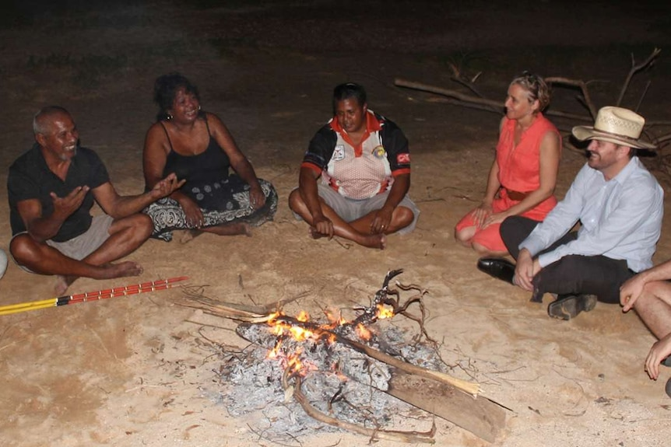Larrakia Nation teamed up with the Universities of Sydney and Tasmania to investigate race relations in the Top End. ABC News
ALL AT LECTERN UNLESS OTHERWISE SHOWN.
Sing-through: 9:30, ends at 9:50 Pre-service music
10.00am Red light displayed: Intro video plays
Candles already lit
JS Welcome behind table
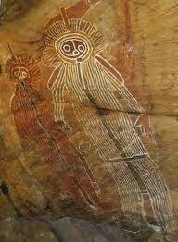

JS Acknowledgement – behind table
As the Holy Spirit spoke in many languages on the day of Pentecost, we also lift up the language of this land.
Marni ngadlu tampinthi ngadlu Kaurna yartangka inparrinthi. (We
acknowledge that we are meeting on Kaurna land).
We acknowledge the Kaurna people as the traditional custodians of
the Adelaide Plains, and honour their spiritual and cultural
stewardship of this Country, and pray that the Holy Spirit unites us all
in mutual respect and reconciliation.
JS Candle acknowledgement behind table Look, the light of a thousand campfires continues in the Christ candle and the peace candle, the words of ancient memory are recorded in the Word, and the Water that gives life, and the people who gather here, physically or virtually.
JS Video Clip This was prepared for reconciliation week by Aunty Denise Champion and Jenny Hughes – a call to worship in Adnyamathanha language of the Flinders Ranges
https://youtu.be/FHrhmgmb2t0?si=6xKId-blfzx5uTKp
JS Call to Worship lectern Creator Spirit, Lord God, from ocean to ocean, from mountain to desert, from river to lake.
Your people gather across these lands now known as Australia.
In the spirit of the Covenant, we bring our shared history, our grief, and our hope.
We gather to worship God, to listen, and to walk together as First and Second Peoples.
Let us open our hearts to the land, its First Peoples, and the quiet ways God is present.
Amen.
JS Prayer Reconciling God, you meet us where we are, in all our faults, troubles and disappointments. You comfort us, and encourage us forward, leaving the mess of the past, into a new future of peace. Help us to speak up for those whose voices have been silenced. Help us to be reconciled to those we have harmed, and be reconciled to those who have harmed us. Living God, make us people of Community, longing for and lifting those trapped by our current system, leading to a commonwealth of peace and justice throughout the world. We believe it can be achieved only through your love, Amen.
JS Song Creator God, you made every race Tune Living Lord, TiS 526
Creator God,
you made every race
giving each your law,
good and true.
We are to worship you, O God,
care for creation in your name,
love and forgive as you love us,
Holy God.

Lord Jesus Christ,
you have made us one,
binding each to you,
making peace;
healing the wounds our hands have made;
asking for truth and grace to rule,
justice, respect and loyalty,
Covenant Lord.

Spirit of Christ,
present from all time,
guiding, shedding light,
giving life;
Counsellor, make us strong to fight,
Free as the wind to do the right,
ready to follow all the way
yet untrod.

One God in three,
bonded strong in love,
reaching out to all,
giving God!
Build in this land community –
black, white and brown, one family
serving the world your love has made,
God of grace.
© John P. Brown Permission is given to copy for free distribution with these words attached.

AB Prayer of Confession
Loving God, we cry to you – when will reconciliation come?
Show us the way of humility in our humanity,
How to walk with those who hear a different drum
How to sit with those made bitter by the great losses of their people,
How to find a common path to walk forward.
When will the truth be told?
When will we look upon the land with loving eyes?
When will we embrace the First People as true Australians?
God of mercy, you call us to be reconciling people.
Holy Spirit, come and help us.
God of justice, you call us to confront injustice wherever we see it.
All: Holy Spirit, come and help us.
God of love, you call us to heal brokenness and walk gently upon these lands together.
May your kingdom come May your will be done. Amen.
AB Intro to readings
RP Reading Matthew 28:16-20 he Commissioning of the Disciples
¹⁶ Now the eleven disciples went to Galilee, to the mountain to which Jesus had directed them. ¹⁷ When they saw him, they worshipped him; but some doubted. ¹⁸ And Jesus came and said to them, ‘All authority in heaven and on earth has been given to me. ¹⁹ Go therefore and make disciples of all nations, baptizing them in the name of the Father and of the Son and of the Holy Spirit, ²⁰ and teaching them to obey everything that I have commanded you. And remember, I am with you always, to the end of the age.’

RP Reading 2 Corinthians 5:17-20
New Revised Standard Version, Anglicised
¹⁷ So if anyone is in Christ, they are a new creation: everything old has passed away; see, everything has become new! ¹⁸ All this is from God, who reconciled us to himself through Christ, and has given us the ministry of reconciliation; ¹⁹ that is, in Christ God was reconciling the world to himself, not counting their trespasses against them, and entrusting the message of reconciliation to us. ²⁰ So we are ambassadors for Christ, since God is making his appeal through us; we entreat you on behalf of Christ, be reconciled to God.
RP The Spirit speaks through ancient words
And we respond in love

RP Song Where wide sky rolls down TiS 188
- Where wide sky rolls down and touches red sand,
where sun turns to gold the grass of the land,
let spinifex, mulga and waterhole tell
their joy in the One who made everything well.

- Where rain-forest calm meets reef, tide and storm, where green things grow lush and oceans are warm,
let every sea-creature and tropical bird
exult in the light of the life-giving Word.

- Where red gum and creek cross hillside and plain,
where cool tree-ferns rise to welcome the rain,
let bushland, farm, mountain-top, all of their days
delight in the Spirit who formed them for praise.
- Now, people of faith, come gather around
with songs to be shared, for blessings abound! Australians, whatever your culture or race,
come, lift up your hearts to the Giver of grace.
Elizabeth J. Smith b1956 © Reproduced with permission under ONE LICENSE #A- 604530. All rights reserved.
JS Poem Truth acceptance basket of reconciliation By Alison Overeem, Uniting Aboriginal and Islander Christian Congress Tasmania
More now than ever
Reflecting and discerning
On the ”re” in all that this nation needs to be
and is called to be
Called to:
All that sits in creation
And in the layers of unpacking reconciliation
More now than ever
A relationship with history before 1788
A relationship with the impacts of invasion
A relationship with the impacts of Colonial power
A relationship with the traditional owners
A relationship with the layers of lands we
Live
Work
Pray on
For the truth-telling and truth knowing that sits on with and through the layers of awareness, the layers of appreciation, the layers of invaded, colonised, westernised
Failed referendum
You don’t matter
Mind chatter
Embedded change
Time rearrange
More now than ever
Time for transformation.
More now than ever
Callen
Fallen
Chosen
Speaking to truth,
Knowing truth, being truth advocates
More now than ever
Feel the call of the creator
Walk as Jesus did, on the fringes
The centrality of the relationship with the creator God
Calling each to a Reconciling tirrina
It’s our cloud of truth-telling witnesses
More now than ever
Hear the spirit of the creator calling
Caller to all before and after 1788

Message - Reconciled to whom, by whom? I will need the laser pointer Banner recognition – picture
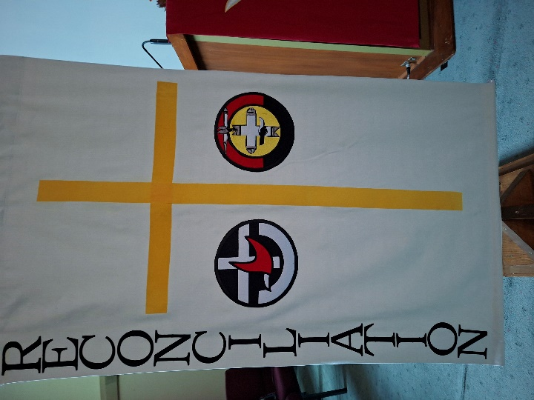
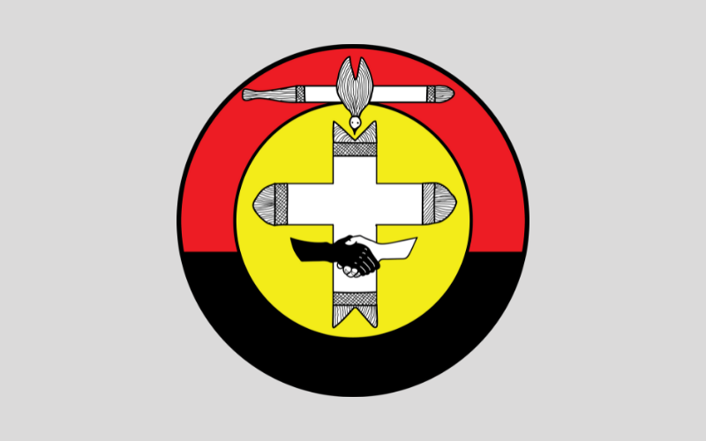
(these are just my notes -The symbol of the Uniting Aboriginal and Islander Christian Congress (UAICC) represents unity, peace, and the holistic faith of First Peoples within the Uniting Church in Australia.
Designed by Aboriginal Christian leaders, the five key elements in the emblem symbolize:
- The Black & White Hands: Symbolize unity, racial non-discrimination, and the belief that all people belong in the body of Christ.
- The Fighting Stick: An Aboriginal symbol used by important leaders to stop fighting, representing peace, reconciliation, and friendship.
- The Message Stick Cross: Formed by two traditional message sticks, it represents the passing of the "message" of the Gospel and the Word of God that brings life.
- The Dove: Represents the Holy Spirit and tongues of fire, depicted in an Aboriginal cultural context.
- The Colours & Shapes: The use of red, black, and yellow reflects the Aboriginal flag, while the wide "U" border incorporates the symbol of the Uniting Church in Australia)

AB Song God of Reconciliation Tune Tis 587 Intercessor

Where is our God of reconciliation,
Our fount of life, the source of all our peace?
To deal with discord, strife and separation?
To heal division, make our conflict cease?

We look within, for God is surely active
When humans care, forgive, apologise;
When others are aggressive and offensive;
“Forgive” – We hear the call of Christ arise.

We look at Jesus and we find the essence
Of reconciling and of healing grace;
He taught be word and deed to hold no grievance;
Revenge and spite, for Jesus, held no place.

But when he faced oppression and injustice,
No reconciliation was pursued;
Uncompromising, Jesus fought quite fearless,
To conquer wrong. He would not be subdued.

Our reconciling God is not defeated Bowl brought forward
By wilfulness or hate or bitterness;
The life and love of Jesus is repeated
When we re-live his strength and tenderness.
© George Stuart used with permission

JS Offering and prayer between lectern and table
Who we are we share.
What we have, we share,
Our hope for the future, we share.
Please let our money and our good intentions
Make a more reconciled world. Amen

JS Notices Lectern
JS Prayers of the People Steph Evans, Wiradjuri woman, shares a prayer for National Reconciliation Week.
Loving Father, Creator Spirit,
Thank you that you created all people. That you knit us together in our mother's womb and placed a purpose on each person's life. Thank you that there were no mistakes in your creation. Thank you, God, that we have weeks like these where we can turn our focus to reconciliation. These lands bleed and yearn for your reconciling Spirit, and I pray that this week acts as a reminder of this to us all, a reminder that won't be forgotten in the weeks to come. Yet in this week I come to you with a heavy heart.
God, I pray for all those affected by the Stolen Generation. I pray that your peace will rest with them and that they will know your love and comfort. I pray for all Mob fighting for their land, that they will find strength in you. I pray for the too many Mob who are incarcerated. I pray they will find peace in you, that their families will find peace in you, and that our governments will hear your call for justice as so many fight to stop the increasing incarceration of Aboriginal and Torres Strait Islander children. I pray for the parents of the children who continue to be taken away. I pray that your guiding hand will be over these systems as we stand in your defiant hope asking for change.
I pray that you'll be with these children, that you will be known to them as their loving Father and that, whilst they wait to be reunited with their family, they will continue to be connected to Country, community, and culture. God, I lift up all Mob to you. That you will be there and known in the pain of injustice. Thank you, God, that you are with us in times of injustice. That you are in our citadels. That you stand with us, Mob or not, and lead us towards a just world, a garden world. God, I could not think of anything more powerful in this journey of reconciliation than your love. God, I pray that as we join with you, you will transform us to be people who are more Christlike. People who live out your command to love. I pray God that you will transform all of Australia to love like you love, so that we love so much that there is no longer room for racism. That your love is felt in rooms of decision making so that there is no longer room for injustice. That we love so deeply that we care for Country. That your love is felt in our churches as we truth-tell and welcome Mob through our doors.
God, you have reconciled nations and people before and I so wholly believe that you will do so again, that you are doing so. Thank you, God, that you are working in us to achieve reconciliation. Thank you, God, for the vision of justice, reconciliation, and love that you have for us, that you have for your garden city to be realised on Earth. God help us to have ears that hear as we continue to listen deeply. Help us to hope defiantly for a reconciled Australia.
Help us to love one another and cherish our differences.
May your love be the foundation of Australia's reconciliation.
Let your justice fall on our lands.
In your mighty mighty name, we pray as you taught us…
O Life-Giver at the heart of all Being,
holy is your presence.
May your Empire of grace replace our own,
and your delight be fulfilled,
as this world becomes heaven.
Give us our sustenance, one breath at a time,
and make us completely forgiving of ourselves and others.
Save us from the weakness of our will,
and deliver us from the power of evil.
For all Being is yours; all power is yours; all glory is yours,
in this moment, in eternity. Amen. Unfolding light

JS Song I am Australian
I come from the dream-time
From the dusty red-soil plains
I am the ancient heart
The keeper of the flame
I stood upon the rocky shores
I watched the tall ships come
For sixty thousand years I've been
The first Australian

I come upon the prison ship
Bowed down by iron chains
I fought the land, endured the lash
And waited for the rains
I'm a settler, I'm a farmer's wife
On a dry and barren run
A convict, then a free man
I became Australian

I'm the daughter of a digger
Who sought the mother lode
The girl became a woman
On the long and dusty road
I'm a child of the Depression
I saw the good times come
I'm a bushie, I'm a battler
I am Australian
We are one, but we are many
And from all the lands on earth we come
We'll share a dream and sing with one voice
"I am, you are, we are Australian"
I'm a teller of stories
I'm a singer of songs
I am Albert Namatjira
And I paint the ghostly gums
I'm Clancy on his horse
I'm Ned Kelly on the run
I'm the one who waltzed Matilda
I am Australian

I'm the hot wind from the desert
I'm the black soil of the plains
I'm the mountains and the valleys
I'm the drought and flooding rains
I am the rock, I am the sky
The rivers when they run
The spirit of this great land
I am Australian

We are one, but we are many
And from all the lands on earth we come
We'll share a dream and sing with one voice
"I am, you are, we are Australian"

We are one, but we are many
And from all the lands on earth we come
We'll share a dream and sing with one voice
"I am, you are, we are Australian"
"I am, you are, we are Australian"
Songwriters: Bruce Woodley, David Newton. For non-commercial use only.
AB Commissioning In front of table
In all the world of discord
We have been reconciled
When we were outcast
You reached and brought us in.
When we place others on the outer
Call us anew to your reconciliation.
We ask
Renew our hearts, our wills and our minds;
God of reconciliation.

Blessing song For you, deep stillness of the silent inland (slides)
FOR YOU – DEEP STILLNESS Words for order when needed
For you, deep stillness of the silent inland
For you, deep blue of the desert skies
For you, flame red of the rocks and stones
For you, sweet water from hidden springs.
From the edges seek the heartlands
and when you're burnt by the journey
may the cool winds of the hovering Spirit
soothe and replenish you.
In the name of Christ, In the name of Christ
© 1997 Robin Mann. Words: Julie Perrin Reproduced with permission CCLI License #22260685, all rights reserved

