May 17 2026 Easter 7
Minister: Anne Butler Welcome : Jan Sillett
Worship Leader: Pam Ayles Piano: Eunice Sullivan Bible Reader: Joan Wagner Guitar:
Camera 6:Carole Lyons Singers Rhonda Amber, Anne Ind
Camera 8: Ray Clogg Audio: John Drew
Vision Editor: John Drew Projection: Leonie Brown Vision Director: Margaret Cargill Vision Switcher: Chris Ayles

PICTURE ON SCREEN FIRST - 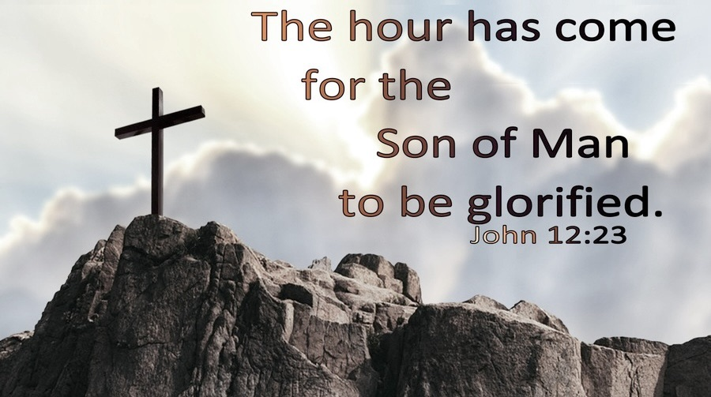
ALL AT LECTERN UNLESS OTHERWISE SHOWN.
Sing-through: 9:30, ends at 9:50 Pre-service music
10.00am Red light displayed: Intro video plays
PA Welcome behind table
A warm welcome to everyone here today and to those online now or joining us later. It is a pleasure to share worship with you.

PA Acknowledgement of land behind table
We acknowledge the Kaurna people on whose land we at Morialta are worshipping and first nations people everywhere this service in seen. They have lived in harmony with the land for millennia. May we share with them, walking gently and respectfully.

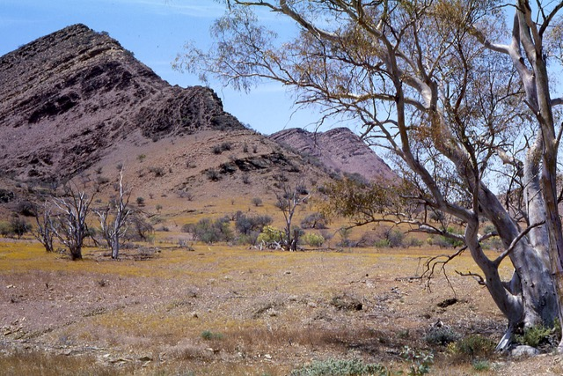
PA Candle lighting behind table
The Symbols
The peace candle is lit.
The Christ candle is lit. A light to the world.
The Bible is open. Stories of the relationship between God and humanity.
The water has been poured. A reminder of our baptism.

AB Call to Worship lectern
What time is it?
The hour has come
Who needs to be here?
The Body of Christ
Why are we here?
Love, always love.
Who meets us here?
The Lord, the Almighty, the Lamb of the universe, the Spirit and Wisdom of God, the holy one.
We come to bend the knee, to learn and to share our burdens,
We come to worship.

AB Prayer
Christ is risen!
He is risen indeed!
Ascended Lord Jesus, we adore You!
Once you lived a human life, subject to limitations of time:
Now you are the same yesterday, today and forever!
Once you were limited to one particular place:
Now you are present wherever people turn to you!
Once only those who met you face to face knew you:
Now your divine love extends throughout all the world!
Ascended Jesus, Lord of time and space, love as wide as life,
we adore You. Amen!

AB Song The love of God is greater far Tis 151
The love of God is greater far
Than tongue or pen can ever tell;
It goes beyond the furthest star,
And reaches to the lowest hell;
Those caught in guilt, bowed down with care,
God gave his love to win;
His erring child He reconciled,
And pardoned every sin
Oh, love of God, how rich and pure!
How measureless and strong!
It shall for evermore endure—
The saints’ and angels’ song.
When years of time shall pass away,
And earthly thrones and kingdoms fall,
When those who here refuse to pray,
On rocks and hills and mountains call,
God’s love so sure, shall still endure,
All measureless and strong;
Redeeming grace to Adam’s race—
The saints’ and angels’ song.
Oh, love of God, how rich and pure!
How measureless and strong!
It shall for evermore endure—
The saints’ and angels’ song.
Could we with ink the ocean fill,
And were the skies of parchment made,
Were every stalk on earth a quill,
And every one a scribe by trade;
To write the love of God above
Would drain the ocean dry;
Nor could the scroll contain the whole,
Though stretched from sky to sky.
Oh, love of God, how rich and pure!
How measureless and strong!
It shall for evermore endure—
The saints’ and angels’ song. Frederick Martin Lehman, Meir Ben Isaac Nehorai Public Domain
AB Prayer of Confession
When we trust our own experience of a too small god
Forgive.
When we worry about of future, and feel we are running out of time
Understand.
When we think that the young people of today are not our future, the caretakers of our world
Remind.
Whisper again your words of love,
and we will give our hearts anew. Amen.

AB Intro to readings
JW Reading Psalm 85 The Message
¹⁻³ God, you smiled on your good earth!
You brought good times back to Jacob!
You lifted the cloud of guilt from your people,
you put their sins far out of sight.
You took back your sin-provoked threats,
you cooled your hot, righteous anger.
⁴⁻⁷ Help us again, God of our help;
don’t hold a grudge against us forever.
You aren’t going to keep this up, are you?
scowling and angry, year after year?
Why not help us make a fresh start—a resurrection life?
Then your people will laugh and sing!
Show us how much you love us, God!
Give us the salvation we need!
⁸⁻⁹ I can’t wait to hear what he’ll say.
God’s about to pronounce his people well,
The holy people he loves so much,
so they’ll never again live like fools.
See how close his salvation is to those who fear him?
Our land is home base for Glory!
¹⁰⁻¹³ Love and Truth meet in the street,
Right Living and Whole Living embrace and kiss!
Truth sprouts green from the ground,
Right Living pours down from the skies!
Oh yes! God gives Goodness and Beauty;
our land responds with Bounty and Blessing.
Right Living strides out before him,
and clears a path for his passage.

JW Reading - Jesus Prays for His Disciples John 17:1-11
17 After Jesus had spoken these words, he looked up to heaven and said, ‘Father, the hour has come; glorify your Son so that the Son may glorify you, ² since you have given him authority over all people,^{[a]} to give eternal life to all whom you have given him. ³ And this is eternal life, that they may know you, the only true God, and Jesus Christ whom you have sent. ⁴ I glorified you on earth by finishing the work that you gave me to do. ⁵ So now, Father, glorify me in your own presence with the glory that I had in your presence before the world existed.
⁶ ‘I have made your name known to those whom you gave me from the world. They were yours, and you gave them to me, and they have kept your word. ⁷ Now they know that everything you have given me is from you; ⁸ for the words that you gave to me I have given to them, and they have received them and know in truth that I came from you; and they have believed that you sent me. ⁹ I am asking on their behalf; I am not asking on behalf of the world, but on behalf of those whom you gave me, because they are yours. ¹⁰ All mine are yours, and yours are mine; and I have been glorified in them. ¹¹ And now I am no longer in the world, but they are in the world, and I am coming to you. Holy Father, protect them in your name that you have given me, so that they may be one, as we are one.
JW Song Like the murmur of the dove’s song TIS 419
Like the murmur of the dove’s song,
Like the challenge of her flight,
Like the vigor of the wind’s rush,
Like the new flame’s eager might:
Come, Holy Spirit, come.
To the members of Christ’s body,
To the branches of the vine,
To the church in faith assembled,
To her midst as gift and sign:
Come, Holy Spirit, come.
With the healing of division,
With the ceaseless voice of prayer,
With the power to love and witness,
With the peace beyond compare:
Come, Holy Spirit, come.
Carl P. Daw Jr., Peter Warwick Cutts Reproduced with permission CCLI License #22260685, all rights reserved

AB Message What time is it?
AB Song Lord Jesus we belong to you TiS 686
- Lord Jesus, we belong to you,
you live in us, we live in you;
we live and work for you —
because we bear your name.

- Help us receive each other,
Lord, for you receive the least of us
and come to us in them —
because we bear your name.

- Bless those who give us any gift,
because they know that we are yours;
reward them with your grace —
because we bear your name.

- Let us acknowledge those as friends
who use your name to right a wrong
but have not joined us yet —
because we bear your name.

- Let nothing that we do or say
offend the weak so that they fall
and lose their faith in you —
because we bear your name.

- Keep us from missing out on life; Bowl brought forward give hands that help, and single sight, and feet that walk your way — because we bear your name.

- You are the salt that cleanses us,
so clean us out, and make us fit
for common life with you —
because we bear your name.
Robin Mann Reproduced with permission CCLI License #22260685, all rights reserved

PA Offering and prayer between lectern and table
We give thanks for the gifts we have been given. Gifts of love, abilities, time and money. May we share them with those where they are most needed, bringing hope and healing.
Amen

PA Notices lectern
PA Prayers of the People
Loving God, we bring our prayers and concerns to you.
You have shown your love for us by giving us Jesus to show us the way. As the disciples needed to pass on what they had been taught, it is up to us to pass it on too.
We pray for people in areas of the world where conflict has caused many innocent victims to die or be injured and has caused millions of refugees to flee their homes. May we find ways to help.
We pray for leader in all countries, including our own. Give them wisdom and courage to do what is right, to build a world of justice, freedom and truth.
We pray that we may be aware of the needs of those around us, that they may feel loved and valued. Give us patience and understanding if they have different ideas and ways to us.
We pray for the sick and those who care for them. Those who have lost loved ones and who have tragedy in their lives.
We pray we can show kindness, empathy and thoughtfulness as Jesus showed us. May we do everything we can to make this world a better place. Amen
PA Lord’s Prayer
Abba Father, we praise your name!
Forgive us for yesterday’s sins,
grant us the needs we have today,
fortify us to resist tomorrow’s temptations. Amen.

PA Song Lord of all hopefulness TIS 613
Lord of all hopefulness, Lord of all joy,
Whose trust, ever child-like, no cares could destroy,
Be there at our waking, and give us, we pray,
Your bliss in our hearts, Lord, at the break of the day.
Lord of all eagerness, Lord of all joy,
Whose strong hands were skilled at the plane and the lathe,
Be there at our labours, and give us, we pray,
Your strength in our hearts, Lord, at the noon of the day.
Lord of all kindliness, Lord of all grace,
Your hands swift to welcome, your arms to embrace,
Be there at our homing, and give us, we pray,
Your love in our hearts, Lord, at the eve of the day.
Lord of all gentleness, Lord of all calm,
Whose voice is contentment, whose presence is balm,
Be there at our sleeping, and give us, we pray,
Your peace in our hearts, Lord, at the end of the day.
Jan Struther Public Domain

AB Commissioning In front of table
What is the time?
There is today.
There is this hour
There is this minute.
This day will not come again
What shall we do?
Let us live to bless,
And be a blessing to all that live.

AB Blessing song (sung twice) TIS 781 Father bless us as we go Jesus walk beside us Holy Spirit guide us.
Robin Mann Reproduced with permission CCLI License #22260685, all rights reserved

