Mother’s day May 10 2026 Easter 6
Minister: Anne Butler Welcome : Bruce Ind
Worship Leader: Jan Sillett Piano: Jey Edwin Bible Reader: Ruth Wise Guitar:
Camera 6: Pam Ayles Singers Rhonda Amber Eunice Camera 8 : Peter Thornley Audio: June Searle Vision Editor: John Secombe Projection: John Thornton Vision Director: John Secombe Vision Switcher: Chris Ayles

PICTURE ON SCREEN FIRST –

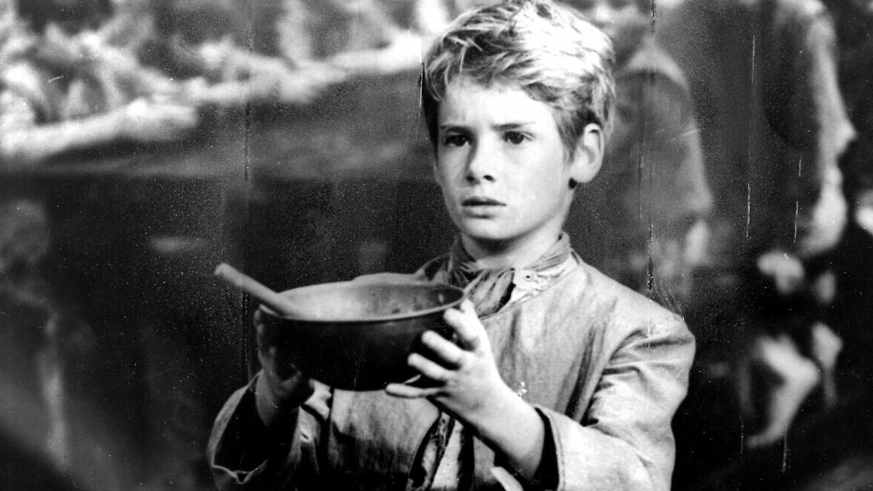
ALL AT LECTERN UNLESS OTHERWISE SHOWN.
Sing-through: 9:30, ends at 9:50 Pre-service music
10.00am Red light displayed: Intro video plays
Welcome behind the table
The spirit of God calls us from many places;
some of us come from busy homes with many people
some of us live alone.
We are a part of the family.

This week has been different for each of us;
some of us have had happy news we want to celebrate
some of us have faced grief and need to cry.
We are members of God’s family.
Yet we all come to this same place;
all of us seeking God’s presence in our lives
all of us seeking God’s presence with each other.
Together we become God’s family.(1994, Liturgy Outside)
It is my pleasure to welcome you to our Mother’s day service

Jan S.Acknowledgement –
– 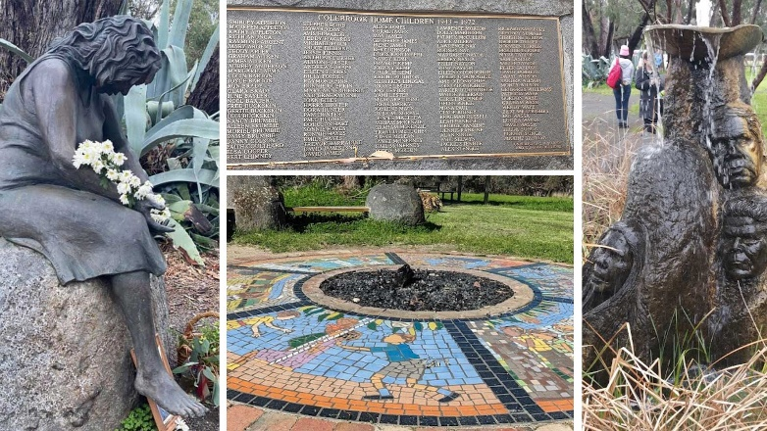
Memorials at Colebrook Home Blackwood.
We acknowledge the sovereign First Peoples of these lands where
we meet, the Kaurna Peoples of the Adelaide Plains. We pay our
respects to their elders past and present and to all descendants of
this Nation who have cared for this place since creation.
Today we pay special respect to mothers of the stolen generation.
May their pain be recognised and their children find reconciliation.
We also remember the family of Kumanjayi Little Baby and hold
them in our hearts and prayers.

JS Candle lighting In the love of families we light the Christ candle to bring love to all families.
In the pain of families torn apart we pour the water of our baptism to
bring new beginnings
In the hope of change we look to the Word to nourish and inform our
lives.
Jan S. Call to Worship
The words of Jesus in the gospel of John 16:16-24 invite us to
explore how sorrow and joy are often connected and of how pain can
be the sign of immanent birth for the individual and the community
and even for the age in which we live. “When a woman is in labour,
she has pain, because her hour has come. But when the child is
born, she no longer remembers the anguish because of the joy of
having brought a human being in to the world. So you have pain
now; but I will see you again, and your hearts will rejoice, and no one
will take your joy from you.”
As we begin our worship let us remember that whatever pain we
know at this time is part of our great birthing. What a wonderful
image for anyone celebrating Mother’s Day – a woman in labour
whose pain turns into joy. Mother’s Day is the day in which we give
thanks for those who bore labour pains so that we might live, and for
some of us we are mindful of those who we gave birth to.
Let us Worship God!
Call to Worship lectern
AB Prayer Ode to love
Our first love – the woman who bore us, who held space for us in joy or fear, our birth mother.
Those who cared for us in the early years, feeding, changing, jiggling, patting – adapting to the rapid changes and gently guiding, our early caregiver mother.
Those who taught us, how to be kind people, how to discover the world, new skills and new ideas, our teaching mother.
Those who in later years became dependent on our care, who looked to us for what they had given us, and those who have no one to care.
Our mothers in the faith, who showed us the way of love, even to strangers, who opened to us the possibilities, and steered us in the right direction, our mothers in Christ
Inventor of love, we praise you for your greatest gift, and all those wh were the village who raised us, and love us still.
AB Song Now thank we all our God TIS 106
1 Now thank we all our God
with heart and hands and voices,
who wondrous things has done,
in whom this world rejoices;
who from our mothers' arms
has blessed us on our way
with countless gifts of love,
and still is ours today.
2 O may this bounteous God
through all our life be near us,
with ever joyful hearts
and blessed peace to cheer us,
to keep us in his grace,
and guide us when perplexed,
and free us from all ills
of this world in the next.
3 All praise and thanks to God
the Father now be given,
the Son and Spirit blest,
who reign in highest heaven
the one eternal God,
whom heaven and earth adore;
for thus it was, is now,
and shall be evermore.

AB Prayer of Confession
Loving God,
We ask for your compassion upon every mother who has knowingly or unknowingly caused pain and suffering. And so, we lift to you our mothers, imperfect but also so wounded by the world. Pour out your healing mercy upon our mothers this day, no matter what they have done or left undone. Help us be forgiving.

Where we have failed because we did not know better, help us to forgive ourselves. Where our mothering has been impatient, or we have created rivals in our families. Help us be forgiving.

We lift to you the broken heart of every mother who has watched her child die of hunger, or drugs, or car accidents.
Where we have been judgemental about the choices of some people to remain childless, or the way they are bringing up their children.
Help us be forgiving

Where we have made the suffering worse for the women whose dreams of motherhood went unfulfilled. Help us be understanding.

We lift to you the prayer of every mother who has ever loved and lost, along with the prayer of every one who feels like they have no one to love. Help us be understanding.
We pray in the name of Jesus, our brother, to the Great God who is Father and Mother of us all. Amen.

AB Intro to reading

RW Reading Acts 17:22-31
²² Then Paul stood in front of the Areopagus and said, ‘Athenians, I see how extremely religious you are in every way. ²³ For as I went through the city and looked carefully at the objects of your worship, I found among them an altar with the inscription, “To an unknown god.” What therefore you worship as unknown, this I proclaim to you. ²⁴ The God who made the world and everything in it, he who is Lord of heaven and earth, does not live in shrines made by human hands, ²⁵ nor is he served by human hands, as though he needed anything, since he himself gives to all mortals life and breath and all things. ²⁶ From one ancestor^{[a]} he made all nations to inhabit the whole earth, and he allotted the times of their existence and the boundaries of the places where they would live, ²⁷ so that they would search for God^{[b]} and perhaps grope for him and find him—though indeed he is not far from each one of us. ²⁸ For “In him we live and move and have our being”; as even some of your own poets have said,
“For we too are his offspring.”
²⁹ Since we are God’s offspring, we ought not to think that the deity is like gold, or silver, or stone, an image formed by the art and imagination of mortals. ³⁰ While God has overlooked the times of human ignorance, now he commands all people everywhere to repent, ³¹ because he has fixed a day on which he will have the world judged in righteousness by a man whom he has appointed, and of this he has given assurance to all by raising him from the dead.’

Reading - The Promise of the Holy Spirit John 14:15-21
¹⁵ ‘If you love me, you will keep my commandments. ¹⁶ And I will ask the Father, and he will give you another Advocate, to be with you for ever. ¹⁷ This is the Spirit of truth, whom the world cannot receive, because it neither sees him nor knows him. You know him, because he abides with you, and he will be in you.
¹⁸ ‘I will not leave you orphaned; I am coming to you. ¹⁹ In a little while the world will no longer see me, but you will see me; because I live, you also will live. ²⁰ On that day you will know that I am in my Father, and you in me, and I in you. ²¹ They who have my commandments and keep them are those who love me; and those who love me will be loved by my Father, and I will love them and reveal myself to them.’
RW Song Mothering God, you gave me birth Tune TiS 443 Tallis Canon
Mothering God, you gave me birth
in the bright morning of this world.
Creator, source of ev’ry breath,
you are my rain, my wind, my sun.
Mothering Christ, you took my form,
offering me your food of light,
grain of new life, and grape of love,
your very body for my peace.
Mothering Spirit, nurt’ring one,
in arms of patience hold me close,
so that in faith I root and grow
until I flow’r, until I know.
AB Message- No longer orphaned
Blank https://www.facebook.com/share/v/1Ayo4vcTwd/ Blank
AB Song God is love, let heaven adore her TIS 153
God is Love, let heav'n adore her;
God is Love, let earth rejoice;
Let creation sing before her
And exalt her with one voice.
God who laid the earth's foundation,
God who spread the heav'ns above,
God who breathes through all creation:
God is Love, eternal Love.
God is Love; and love enfolds us,
All the world in one embrace:
With unfailing grasp God hold us,
Ev'ry child of ev'ry race.
And when human hearts are breaking
Under sorrow's iron rod,
Then we find that selfsame aching
Deep within the heart of God.
God is Love; and though with blindness Bowl brought forward Sin afflicts all human life,
God's eternal loving kindness
Guides us through our earthly strife.
Sin and death and hell shall never
O'er us final triumph gain;
God is Love, so Love for ever
O'er the universe must reign.
JS Offering and prayer Between table and lectern
Loving God,
we give you thanks for all who care for us,
who have encouraged us and helped us grow,
who have forgiven us,
and cared for us when we are unwell,
who have supported us when times were hard,
who have challenged us,
Who have loved us
With grateful hearts we bring our offerings of money, time and skills.
We say Thank you. Amen

Jan S. Notices lectern

Jan S . Prayers of the People
Let us Pray
To those who gave birth this year to their first child—
we celebrate with you
To those who have lost a child–
we mourn with you
To those who are in the trenches with little ones every day and wear
the badge of food stain–
we appreciate you

To those who experienced loss through miscarriage, failed
adoptions, or running away— we mourn with you
To those who walk the hard path of infertility, fraught with pokes,
prods, tears, and disappointment—
we walk with you.
Forgive us when we say foolish things. We don’t mean to make this
harder than it is
To those who are foster moms, mentor moms, and spiritual moms–
we need you
To those who have warm and close relationships with your children–
we celebrate with you
To those who have disappointment, heart ache, and distance with
your children–
we sit with you
To those who lost their mothers this year–
we grieve with you
To those who experienced abuse at the hands of your own mother–
we acknowledge your experience
To those who lived through driving tests, medical tests, and the
overall testing of motherhood–
we are better for having you in our midst
To those who have aborted children–
we remember them and you on this day
To those who are single and long to be married and mothering your
own children–
we mourn that life has not turned out the way
you longed for it to be
To those who stepparent or foster
we walk with you on these complex paths
To those who envisioned lavishing love on grandchildren, yet that
dream is not to be–
we grieve with you
To those who will have emptier nests in the upcoming year–
we grieve and rejoice with you
To those who placed children up for adoption–
we commend you for your selflessness
and remember how you hold that child in your heart
And to those who are pregnant with new life, both expected and
surprising–
we anticipate with you
This Mother’s Day, we walk with you. Mothering is not for the faint of
heart and we have real warriors in our midst.
We remember you. (Source: By Amy Young, Messy Middle )
Amen
JS Lord’s Prayer Let us join together in the Lord’s prayer
Eternal Spirit, Earth-maker, Pain-bearer, Life-giver,
Source of all that is and that shall be,
Father and Mother of us all,
Loving God, in whom is heaven:
The hallowing of your name echo through the universe!
The way of your justice be followed by the peoples of the world!
Your heavenly will be done by all created beings!
Your commonwealth of peace and freedom
sustain our hope and come on earth.
With the bread we need for today, feed us.
In the hurts we absorb from one another, forgive us.
In times of temptation and test, strengthen us.
From trials too great to endure, spare us.
From the grip of all that is evil, free us.
For you reign in the glory of the power that is love,
Now and for ever. Amen

JS Song Fold to your heart your sister and your brother TIS 587 tune TiS 603
1 Fold to your heart your sister and your brother:
where pity dwells, the peace of God is there;
to worship rightly and to love each other,
each smile a hymn, each kindly deed a prayer.
2 For he whom Jesus loved has truly spoken:
the holier worship which he deigns to bless
restores the lost, and binds the spirit broken,
and feeds the widow and the fatherless.
3 Follow with reverent steps the great example
of him whose holy work was doing good:
so shall the wide earth seem our father's temple,
each loving life a psalm of gratitude.
4 Then shall all shackles fall: the stormy clangour
of wild war music o'er the earth shall cease;
love shall tread out the baleful fire of anger,
and in its ashes plant the tree of peace.
AB Commissioning In front of table
"Love is patient, love is kind. It does not envy, it does not boast, it is not proud. It does not dishonor others, it is not self-seeking, it is not easily angered, it keeps no record of wrongs. Love does not delight in evil but rejoices with the truth. It always protects, always trusts, always hopes, always perseveres." 1 Corinthians 13:4-7 God is love -Be love
AB Blessing song on video What a wonderful world with lyrics?
https://youtu.be/rBrd_3VMC3c?si=L__xcbiAOlVCP-FF

