April 3 2026 Good Friday Encounter with Persecution
Minister: Anne Butler Welcome: Bruce Ind
Worship Leader: Pam Ayles Piano: Gil Sullivan Bible Reader: Craig Mackenzie Guitar: Singers. Eunice Sullivan Anne Ind
Camera 6: Carole Lyons Audio: John Drew
Camera 8 Jenny Swanbury Projection: Colin Cargill
Vision Director: Chris Ayles Vision Switcher: John Secombe

PICTURE ON SCREEN FIRST – 
ALL AT LECTERN UNLESS OTHERWISE SHOWN.
Sing-through: 9:30, ends at 9:50 Pre-service music

10.00am Red light displayed: Intro video plays
PA Welcome behind table
A warm welcome to everyone joining us, here and online, for this Good Friday worship service.

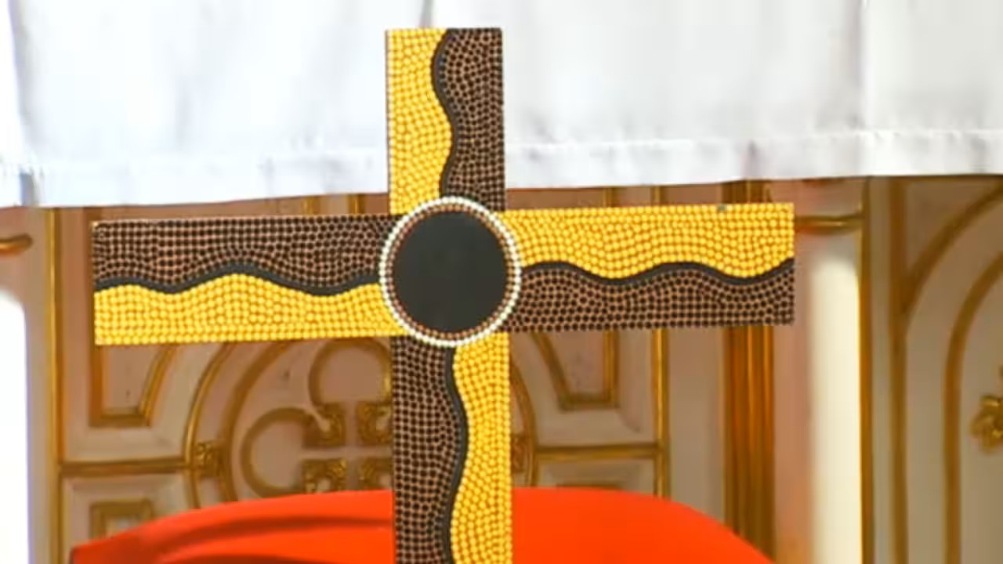
Aboriginal Painted Cross St John’s Sydney
PA Acknowledgement – We acknowledge the Sovereign First Peoples of this land on which we gather today. We honour their Elders—past and present—and those emerging as leaders among their people. We give thanks for their enduring custodianship of land, waters, and culture. As followers of Christ, we commit ourselves anew to the journey of truth-telling, justice, healing, and reconciliation.
PA Call to Worship – Lectern
We gather on this most solemn of days to worship what we can barely comprehend. To be grateful for a love beyond our understanding. To acknowledge a sacrifice and pain grossly undeserved. To see a resolute commitment to living God’s way, even to the bitter end.
May we accept the inheritance of that courageous love.

PA Song O come and mourn with me awhile AHB 267

1 O come and mourn with me awhile;
O come now to the Saviour's side;
O come, together let us mourn:
Jesus, our Love, is crucified.

2 Have we no tears to shed for him,
while soldiers scoff and foes deride?
Ah! Look how patiently he hangs:
Jesus, our Love, is crucified.

3 Seven times he spoke, seven words of love;
and all three hours his silence cried
for mercy on the souls of all;
Jesus, our Love, is crucified.

4 O love of God! O sin-filled world!
In this dread act your strength is tried;
and victory remains with love:
Jesus, our Love, is crucified.

5 A broken heart a fount of tears
Ask and they will not be denied
A broken heart love's cradle is
Jesus our Lord is crucified.
Frederick William Faber Reproduced with permission CCLI License #22260685, all rights reserved
AB Prayer of Lament and Hope
Response Our God, hear us, Hear our prayer
Divine Friend, Saviour of the world, Forgive us that in spite of the cross, we have somehow managed to turn Christianity into a bland, easy-going way of life. Our God, hear us, Hear our prayer
Forgive us that our preference runs to Easter bunnies, buttered buns, and massive amounts of sweet chocolate, rather than Golgotha with its rough wood and cruel nails. Our God, hear us, Hear our prayer
Forgive us that even on the most poignant, holy days we are more inclined to be resting than we are to be following. Our God, hear us, Hear our prayer
Grant that we may never be casual before that awesome love which has overtaxed the skills of even our finest poets and musicians, and left all preachers floundering. Make us, saving God, reachable and teachable, more responsive to your saving grace and willing captives of the love which grants perfect liberty. Our God, hear us, Hear our prayer
By your cross deliver us from every corrupting thought, every weight which pulls us down, and set our face towards the light which comes not to condemn but to save, Through this same Christ Jesus our brother and Saviour. Amen!
AB FORGIVENESS
My sisters and brothers in the faith, take your courage from this holy Cross. Here is real love, not that we loved God, but that God loved us and suffered and died rather than give up on us. Through him we are forgiven and renewed.
We thank our God for this mystery of faith.
The peace of the Christ be always with you. And also with you.
AB For the young at heart
CM Reading Isaiah 52:13 – 53:3 The suffering servant
¹³ See, my servant shall prosper;
he shall be exalted and lifted up,
and shall be very high.
¹⁴ Just as there were many who were astonished at him
—so marred was his appearance, beyond human semblance,
and his form beyond that of mortals—
¹⁵ so he shall startle many nations;
kings shall shut their mouths because of him;
for that which had not been told them they shall see,
and that which they had not heard they shall contemplate.
53 Who has believed what we have heard?
And to whom has the arm of the Lord been revealed?
² For he grew up before him like a young plant,
and like a root out of dry ground;
he had no form or majesty that we should look at him,
nothing in his appearance that we should desire him.
³ He was despised and rejected by others;
a man of suffering and acquainted with grief;
and as one from whom others hide their faces
he was despised, and we held him of no account.
CM Hear what the Spirit is saying to the World We thank our God for this mystery of faith.
CM Song Like autumn leaves upon the ground ATN 38
Like autumn leaves upon the ground
We know not where we should be bound.
The rain comes hard, the night rolls in;
The sky is black, and its cold within,
And one by one You call us home.
Bright is the sun, and pale the moon,
With winking stars they sing Your tune.
The sunset comes, You paint the sky
The darkness falls like a lullaby,
And one by one you call us home.
You do not sit and take Your ease;
You wash our feet upon Your knees,
Shoulder the load that holds us down,
Untie the ropes that have kept us bound.
And one by one You call us home.
Come walk with me, both old and young,
No other way can take you home.
Here’s bread and wine to keep you strong
Until we meet for the final song,
And one by one You call us home.
Copyright: 1977 Robin Mann Reproduced with permission CCLI License #22260685, all rights reserved

AB Message The wife of Simon of Cyrene – monologue in front of Table
Finishing with
AT GOLGOTHA – Based on a poem by Bruce Prewer
Today I dared to step closer
to the man on Skull Hill.

I elbowed past the curious crowd,
beyond the high priest’s mob,
and stood near Mary and John.

The soldiers
leered at me and one said:
“Take a good look darl,
it may be you tomorrow.”

Determined
I went and stood about five
paces from that cross
and looked up.

It was hideous;
smell of blood, sweat and urine.
I wanted to throw up;
the soldiers guffawed.

Then I braced myself
and took a long searching look
at the crucified son of Mary
in his agony.

O his eyes! The agony!
His cry - Why have you abandoned me?

PA Song Wait for the Lord, whose day is near stay seated sung about six times

Wait for the Lord, whose day is near
Wait for the Lord, keep watch, take heart.
Reproduced with permission under ONE LICENSE #A- 604530. All rights reserved.

PA Prayers of the People – the prayer is read slowly from lectern , while AB writes words on the cross in front of table

We give thanks for the non-violent resisters,
the peaceful protesters, the prophets
who show us where you stand, O God:
the falsely accused – ‘do you hear their many
accusations against you?’
‘what evil has he done?
the abandoned – ‘then what should I do
with this Jesus, your Messiah?’
‘let him be crucified!’
the beaten – they stripped him, spat
on him, struck him on the head;
they twisted a crown of thorns
and put it on his head

the commandeered – like Simon, who bear someone’s cross,
or shoulder their own
the mocked – they taunted him, ‘King
of the Jews’, mixed gall with his wine,
cast lots for his clothes; ‘you Son of God,
save yourself!’
the executed – ‘My God, my God,
why have you forsaken me?’
he cried out again, then breathed
his last.
We give thanks for the non-violent resisters,
the peaceful protesters, the prophets
who show us where you stand, O God. Sarah Agnew

PA Gathering our prayers and praises into one, let us say the Lord’s
Prayer together.
Our Father in heaven,
hallowed be your name,
your kingdom come,
your will be done,
on earth as in heaven.
give us today our daily bread.
Forgive us our sins
as we forgive those who sin against us.
Save us from the time of trial
and deliver us from evil.
For the kingdom, the power,
and the glory are yours
now and for ever.
Amen.

PA Song Take up your cross TIS 583
“Take up your cross”, the Saviour said,
“If you would my disciple be;
Deny yourself, the world forsake,
And humbly follow after me.
Take up your cross; let not its weight
Fill your weak spirit with alarm
His strength shall bear your spirit up
And brace your heart and nerve your arm.

Take up your cross, be not ashamed!
and let your foolish pride be still!
For God himself endured to die
Upon a cross, on Calvary's hill.
Take up your cross, which gives you strength,
Which makes your trembling spirit brave;
It guides you to a better life
And leads to vict'ry o'er the grave.
Take up your cross, and follow Christ,
Nor think till death to lay it down;
For only they who bear the cross
May hope to wear the glorious crown.
Charles William Everest Public Domain
AB Commissioning in front of table Go now into the world as bearers of Christ’s light. Celebrate the richness of our diversity. Stand alongside those who suffer injustice: the falsely accused, the abandoned, the beaten, the mocked, the executed.
The service is not over. We must wait, for the dawning of the new day. We must meet again, to anoint his body, to join in grief and pain. On Sunday we will experience all our God has in store for us. Go in peace and in silence

