April 26 2026 Easter 4
Minister: Anne Butler Welcome : Margaret Clogg Worship Leader: Margaret Cargill Piano: Jey Edwin Bible Reader: June Searle Guitar: Austin Phoenix Singers Rhonda Amber Eunice Camera 6: Colin Cargill Audio: Ray Clogg Camera 8 : Peter Thornley Projection: John Thornton Vision Director: John Secombe Vision Switcher: Andrew Pill

PICTURE ON SCREEN FIRST – 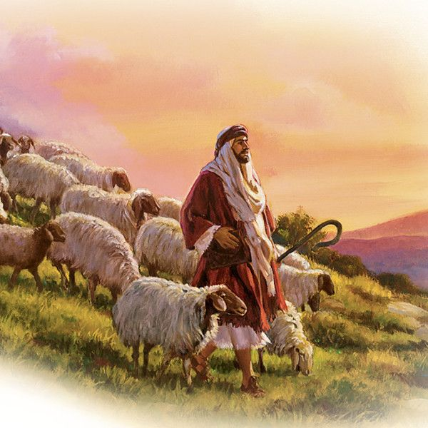

ALL AT LECTERN UNLESS OTHERWISE SHOWN.
Sing-through: 9:30, ends at 9:50 Pre-service music
10.00am Red light displayed: Intro video plays
MC: Welcome Lectern
MC: Acknowledgement – (image please)
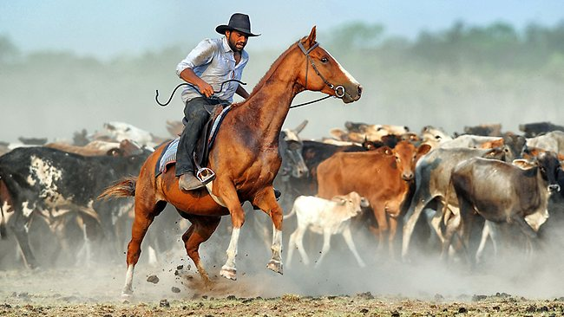
As we look upon the hills and valleys, we see the love poured out on this land by those who have cared for this Land since time beyond measure. We honour those who have gone before and those who are yet to come. May we be mindful of the calling God places on humanity to care for Creation. May we take the lead from the Kaurna People whose stories are entwined with the stewarding of this place, and from the First nations people of all places where this service is shared. May we learn from them and walk with them in God’s Covenant.
MC: Candle lighting We see the Christ Candle and the Peace candle still alight with Easter fire, the Scriptures open to all, and the waters of baptism uniting us as one.
MC: Call to Worship
As the Good Shepherd of every flock, we come to worship you today.
God of infinite love: we come in response to your warm tenderness to us.
As the Compassionate Carer of all vulnerable people, we give you our thanks.
God of limitless mercy: we come to respond to your gentle nurturing of us.
As the Leader, Guide and Protector of every flock of “sheep” and “goats” – we revere and praise you for your generous and gracious mercy to us all.
God of all peoples: we come to praise you in response to your welcoming and generous care of all your people, which overflows with love and understanding. Amen.
(Source: Joan Stott, The Timeless Psalms)

MC: Prayer: The psalm for today is 23, familiar to many as ‘The Lord is my shepherd’. Please join as I pray in words of Steve Garnass-Holmes:
Praying Psalm 23
Loving One, I will let you shepherd me
to where you choose, not I.
You are what I need.
Transform my desires.
My heart as still as the waters,
I wait.
I am grateful for these green pastures;
deepen my gratitude.
Lead me in the way of justice
even through the shadow of death.
Along your via dolorosa
comfort me.
To this rich table of your grace
invite my enemies.
I accept your anointing.
I drink of your cup.
Goodness and mercy are mine;
mine, your presence.
(Source: Steve Garnaas-Holmes, Unfolding Light)
MC: Song: Let us join to sing; please stand or remain seated to sing, as works for you, and this request applies to all the songs we sing today.
Jesus calls us here to meet him TIS 477
Jesus calls us here to meet him
as, through word and song and prayer,
we affirm God’s promised presence
where his people live and care.
Praise the God who keeps his promise ;
praise the Son who calls us friends ;
praise the Spirit who, among us,
to our hopes and fears attends.

Jesus calls us to confess him
Word of life and Lord of all,
sharer of our flesh and frailness,
saving all who fail or fall.
Tell his holy human story ;
tell his tales that all may hear ;
tell the world that Christ in glory
came to earth to meet us here.

Jesus calls us to each other,
vastly different though we are ;
creed and colour, class and gender
neither limit nor debar.
Join the hand of friend and stranger ;
join the hands of age and youth ;
join the faithful and the doubter
in their common search for truth.
John L. Bell (b. 1949) and Graham Maule (b. 1958) Reproduced with permission CCLI License #22260685, all rights reserved
AB Prayer of Confession
AB Intro to readings
JS: Reading 1 Peter 2:19-25 NRSV.

¹⁹ For it is to your credit if, being aware of God, you endure pain while suffering unjustly. ²⁰ If you endure when you are beaten for doing wrong, where is the credit in that? But if you endure when you do right and suffer for it, you have God’s approval. ²¹ For to this you have been called, because Christ also suffered for you, leaving you an example, so that you should follow in his steps.
²² ‘He committed no sin,
and no deceit was found in his mouth.’
²³ When he was abused, he did not return abuse; when he suffered, he did not threaten; but he entrusted himself to the one who judges justly. ²⁴ He himself bore our sins in his body on the cross, so that, free from sins, we might live for righteousness; by his wound you have been healed. ²⁵ For you were going astray like sheep, but now you have returned to the shepherd and guardian of your souls.

JS: Reading - Jesus the Good Shepherd John 10:1-10
‘Very truly, I tell you, anyone who does not enter the sheepfold by the gate but climbs in by another way is a thief and a bandit. 2 The one who enters by the gate is the shepherd of the sheep. 3 The gatekeeper opens the gate for him, and the sheep hear his voice. He calls his own sheep by name and leads them out. 4 When he has brought out all his own, he goes ahead of them, and the sheep follow him because they know his voice. 5 They will not follow a stranger, but they will run from him because they do not know the voice of strangers.’ 6 Jesus used this figure of speech with them, but they did not understand what he was saying to them.
7 So again Jesus said to them, ‘Very truly, I tell you, I am the gate for the sheep. 8 All who came before me are thieves and bandits; but the sheep did not listen to them. 9 I am the gate. Whoever enters by me will be saved, and will come in and go out and find pasture. 10 The thief comes only to steal and kill and destroy. I came that they may have life, and have it abundantly.
JS We hear these ancient words, Loving God, help us apply them to our lives.
JS Song You Lord are both Lamb and Shepherd tune Picardy TIS 497
You, Lord, are both Lamb and Shepherd.
You, Lord, are both prince and slave.
You, peacemaker and swordbringer
Of the way you took and gave.
You the everlasting instant;
You, whom we both scorn and crave.
Clothed in light upon the mountain,
Stripped of might upon the cross,
Shining in eternal glory,
Beggar’d by a soldier’s toss,
You, the everlasting instant;
You, who are both gift and cost.
You, who walk each day beside us,
Sit in power at God’s side.
You, who preach a way that’s narrow,
Have a love that reaches wide.
You, the everlasting instant;
You, who are our pilgrim guide.
Worthy is our earthly Jesus!
Worthy is our cosmic Christ!
Worthy your defeat and vict’ry.
Worthy still your peace and strife.
You, the everlasting instant;
You, who are our death and life.
Alleluia. Alleluia. Alleluia.
You, who are our death and our life.
Sylvia Dunstan (1955-1993) Reproduced with permission under ONE LICENSE #A- 604530. All rights reserved.
AB: Message How Sheepish?
Video Clip from the Sheep Detectives
https://youtu.be/JSsGiEabHPY?si=E7zF2Yq-h5wuVnXk
AB: Song Father, hear the prayer we offer: Tune Aust Hymn Book 510
Father, hear the prayer we offer:
not for ease that prayer shall be,
but for strength that we may ever
live our lives courageously.
2 Not for ever in green pastures
do we ask our way to be;
but the steep and rugged pathway
may we tread rejoicingly.
3 Not for ever by still waters
would we idly rest and stay;
but would smite the living fountains
from the rocks along our way.
4 Be our strength in hours of weakness, Bowl brought forward
in our wanderings be our guide;
through endeavour, failure, danger,
Father, be thou at our side. Love Maria Willis, Tom Bell Reproduced with permission CCLI License #22260685, all rights reserved
MC: Offering prayer: Between table and lectern
God of love,
you abide with us;
you provide for all our needs
and guide us in your ways.
Out of gratitude for your care,
we bring our gifts before you.
Use them for your work of caring,
that all may feast at the table of abundance,
walk without fear, and drink deeply
from the cup of compassion. Amen.
(Words: Mary Petrina Boyd, Ministry Matters)

MC: Notices Lectern
MC: Prayers of the People
The shepherd goes ahead of them, and the sheep follow (John 10.4)
Even though I walk through the valley of the shadow of deathl I fear no evil (Psalm 23.4)

(Intro) _ Usually when we pray “The Lord is my shepherd” we have in mind that God provides for us and protects us. When we pray about the valley of the shadow of death we mean an unfortunate place we’ve unwillingly found ourselves.
But what if you, the Loving Shepherd, lead us intentionally through the dark valley? What if Psalm 23 is not only about our comfort, but our courage? We can imagine that the “paths of righteousness” include the arduous road of working and even sacrificing for justice and compassion. That you, the shepherd, restores our soul because we’ve poured it out. That the table prepared for us is not in our safe sanctum but among our enemies, those who would see us destroyed? That You are leading us to be with those who dwell in the shadow of death, not from a distance, but there in the valley with them. That You are leading us to do justice despite persecution, to enter into the world’s wounds, to be in solidarity with those who suffer. Is that not what it means to take up our cross and follow You, to follow you into the shadow of death?
“It’s just consequences to suffer for our bad choices,” says 1 Peter 2.20, “but it opens us to your grace to suffer for doing good.” The one prize we hold most dear is to be near you, the Beloved. So we don’t beg for the easy path, the still waters and green pastures. We pray for the grace to listen, draw near and follow, even if the shepherd is marching into the valley of shadows. We pray for more than our own comfort. We pray for the healing of the world. So we pray to follow you, the Beloved, even into dark places, knowing that even there we are led, we are blessed, we are renewed.
MC Breath prayer: Following you … I fear not (Source: Steve Garnaas-Holmes, Unfolding Light adapted)
MC: Lord’s Prayer Joining our prayers into one, we say together the words taught to us:
Our Father in heaven,
hallowed be your name,
your kingdom come,
your will be done,
on earth as in heaven.
give us today our daily bread.
Forgive us our sins
as we forgive those who sin against us.
Save us from the time of trial
and deliver us from evil.
For the kingdom, the power,
and the glory are yours
now and for ever.
Amen.

MC: Song The king of love my Shepherd is TIS 145
The King of love my shepherd is,
whose goodness fails me never.
I nothing lack if I am His,
and He is mine forever.
Where streams of living water flow,
with gentle care He leads me,
and where the verdant pastures grow,
with heav'nly food He feeds me.
Perverse and foolish, I have strayed,
but yet in love He sought me;
and on His shoulder gently laid,
and home, rejoicing, brought me.
In death's dark vale I fear no ill,
with you, dear Lord, beside me;
Your rod and staff my comfort still,
your cross before to guide me.
You spread a table in my sight;
your saving grace bestowing;
and oh, what joy and true delight
from your pure chalice flowing!
And so through all the length of days your goodness fails me never;
Good Shepherd, may I sing your praise
within your house forever.
Henry Williams Baker Reproduced with permission CCLI License #22260685, all rights reserved
Commissioning In front of table Follow with reverent steps the great example,
of him whose holy work was doing good
So shall the wide earth be our Father's temple
Each loving life a psalm of gratitude.

Blessing song TIS 781 (sung twice
Father bless us as we go
Jesus walk beside us
Holy Spirit guide us

