March 8 2026 Lent 3
Minister: Anne Butler Welcome: Margaret Clogg
Worship Leader: Pam Ayles Piano: Eunice Sullivan
Bible Reader: John Thornton Guitar: Austin Phoenix
Singers: Anne Ind Rhonda Amber
Projection: Leonie Brown Audio: Ray Clogg
Camera 6: Carole Lyons Camera 8: Peter Thornley
Reader: John Secombe Vision Switcher: Chris Ayles

Encounter with the Woman at the well

PICTURE ON SCREEN FIRST – 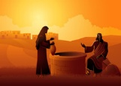
ALL AT LECTERN UNLESS OTHERWISE SHOWN.
Sing-through: 9:30, ends at 9:50 Pre-service music
Candles lit, Bible open
10.00am Red light displayed: Intro video plays

PA Welcome Behind table
A warm welcome to all of you joining us today, wherever you are, here or online.
PA Acknowledgement
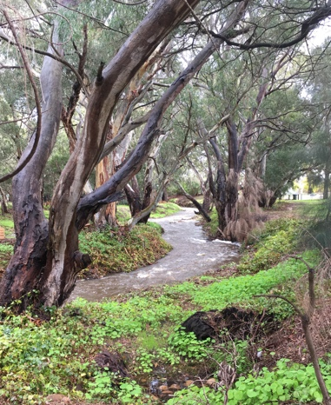
Here in this place, we worship on the land of the Kaurna People, the traditional custodians of the Adelaide Plains. We acknowledge them and First Nations People everywhere this service is seen. May we walk together in peace with respect and care.
PA Call to Worship Lectern
Children of God, it’s time to take off your shoes,
Let go of the anxieties and worries, and
Wade with trust into the stream of God’s compassionate grace.
We come to be still for a moment,
to gather in holy time and space.
Let the healing waters wash your heart.
Take a deep breath as Love soaks into your soul.
We come to know again that we belong,
We are treasured by God,
Listen to the whispering of God
Let the conversations with God begin
We come with our questions
And with our deep desires
To re-orientate our lives in God.
(Source: St Martins Presbyterian Church, Christchurch, NZ)
AB Prayer

AB Song Worship the Lord in the beauty of holiness TIS 454
1 Worship the Lord in the beauty of holiness,
bow down before God, his glory proclaim;
gold of obedience and incense of lowliness
bring, and adore him: the Lord is his name.
2 Low at his feet lay your burden of carefulness,
high on his heart he will bear it for you,
comfort your sorrows, and answer your prayerfulness,
guiding your steps in the way best for you.
3 Fear not to enter his courts in the slenderness
of the poor wealth you would reckon to own:
truth in its beauty and love in its tenderness,
these are the offerings to bring to his throne.
4 These, though we bring them in trembling and fearfulness,
he will accept for the name that is dear,
mornings of joy give for evenings of tearfulness,
trust for our trembling and hope for our fear.
5 Worship the Lord in the beauty of holiness,
bow down before him, his glory proclaim;
gold of obedience and incense of lowliness,
bring, and adore him: the Lord is his name.
John Samuel Bewley Monsell Reproduced with permission CCLI License #22260685, all rights reserved

AB Prayer of Confession
AB Intro to readings
JT Reading Exodus 17:1-7 17 From the wilderness of Sin the whole congregation of the Israelites journeyed by stages, as the Lord commanded. They camped at Rephidim, but there was no water for the people to drink. ² The people quarrelled with Moses, and said, ‘Give us water to drink.’ Moses said to them, ‘Why do you quarrel with me? Why do you test the Lord?’ ³ But the people thirsted there for water; and the people complained against Moses and said, ‘Why did you bring us out of Egypt, to kill us and our children and livestock with thirst?’ ⁴ So Moses cried out to the Lord, ‘What shall I do with this people? They are almost ready to stone me.’ ⁵ The Lord said to Moses, ‘Go on ahead of the people, and take some of the elders of Israel with you; take in your hand the staff with which you struck the Nile, and go. ⁶ I will be standing there in front of you on the rock at Horeb. Strike the rock, and water will come out of it, so that the people may drink.’ Moses did so, in the sight of the elders of Israel. ⁷ He called the place Massah and Meribah, because the Israelites quarrelled and tested the Lord, saying, ‘Is the Lord among us or not?’

Dramatic Reading – The Message John 4:3b-42 In front of table
June: So Jesus left the Judean countryside and went back to Galilee.
⁴⁻⁶ To get there, he had to pass through Samaria. He came into Sychar, a Samaritan village that bordered the field Jacob had given his son Joseph. Jacob’s well was still there. Jesus, worn out by the trip, sat down at the well. It was noon.
⁷⁻⁸ A woman, a Samaritan, came to draw water. Jesus said,
John: “Would you give me a drink of water?”
June: (His disciples had gone to the village to buy food for lunch.)
⁹ The Samaritan woman, taken aback, asked,
Anne “How come you, a Jew, are asking me, a Samaritan woman, for a drink?”
June (Jews in those days wouldn’t be caught dead talking to Samaritans.)
¹⁰ Jesus answered,
John: “If you knew the generosity of God and who I am, you would be asking me for a drink, and I would give you fresh, living water.”
¹¹⁻¹² Anne: “Sir, you don’t even have a bucket to draw with, and this well is deep. So how are you going to get this ‘living water’? Are you a better man than our ancestor Jacob, who dug this well and drank from it, he and his sons and livestock, and passed it down to us?”
¹³⁻¹⁴ “Everyone who drinks this water will get thirsty again and again. Anyone who drinks the water I give will never thirst—not ever. The water I give will be an artesian spring within, gushing fountains of endless life.”
¹⁵ Anne: “Sir, give me this water so I won’t ever get thirsty, won’t ever have to come back to this well again!”
¹⁶ John: “Go call your husband and then come back.”
¹⁷⁻¹⁸ Anne:”I have no husband,”
John: “That’s nicely put: ‘I have no husband.’ You’ve had five husbands, and the man you’re living with now isn’t even your husband. You spoke the truth there, sure enough.”
¹⁹⁻²⁰ Anne:”Oh, so you’re a prophet! Well, tell me this: Our ancestors worshiped God at this mountain, but you Jews insist that Jerusalem is the only place for worship, right?”
²¹⁻²³ John:”Believe me, woman, the time is coming when you Samaritans will worship the Father neither here at this mountain nor there in Jerusalem. You worship guessing in the dark; we Jews worship in the clear light of day. God’s way of salvation is made available through the Jews. But the time is coming—it has, in fact, come—when what you’re called will not matter and where you go to worship will not matter.
²³⁻²⁴ “It’s who you are and the way you live that count before God. Your worship must engage your spirit in the pursuit of truth. That’s the kind of people the Father is out looking for: those who are simply and honestly themselves before him in their worship. God is sheer being itself—Spirit. Those who worship him must do it out of their very being, their spirits, their true selves, in adoration.”
²⁵ June: The woman said
Anne: “I don’t know about that. I do know that the Messiah is coming. When he arrives, we’ll get the whole story.”
²⁶ John: “I am he, You don’t have to wait any longer or look any further.”
²⁷ June: Just then his disciples came back. They were shocked. They couldn’t believe he was talking with that kind of a woman. No one said what they were all thinking, but their faces showed it.
²⁸⁻³⁰ The woman took the hint and left. In her confusion she left her water pot. Back in the village she told the people,
Anne: “Come see a man who knew all about the things I did, who knows me inside and out. Do you think this could be the Messiah?”
On the screen
June:And they went out to see for themselves.
³¹ In the meantime, the disciples pressed him,
All: “Rabbi, eat. Aren’t you going to eat?”
³² June: He told them,
John: “I have food to eat you know nothing about.”
³³ The disciples were puzzled.
All: “Who could have brought him food?”
³⁴⁻³⁵ June: Jesus said,
John: “The food that keeps me going is that I do the will of the One who sent me, finishing the work he started. As you look around right now, wouldn’t you say that in about four months it will be time to harvest? Well, I’m telling you to open your eyes and take a good look at what’s right in front of you. These Samaritan fields are ripe. It’s harvest time!
³⁶⁻³⁸ “The Harvester isn’t waiting. He’s taking his pay, gathering in this grain that’s ripe for eternal life. Now the Sower is arm in arm with the Harvester, triumphant. That’s the truth of the saying, ‘This one sows, that one harvests.’ I sent you to harvest a field you never worked. Without lifting a finger, you have walked in on a field worked long and hard by others.”
³⁹⁻⁴² June: Many of the Samaritans from that village committed themselves to him because of the woman’s witness:
Anne: “He knew all about the things I did. He knows me inside and out!”
June: They asked him to stay on, so Jesus stayed two days.
On the Screen
June: A lot more people entrusted their lives to him when they heard what he had to say. They said to the woman,
All: “We’re no longer taking this on your say-so. We’ve heard it for ourselves and know it for sure. He’s the Saviour of the world!
JT Song Lord I come to you Power of your love TIS 685
Lord, I come to you, let my heart be changed, renewed
Flowing from the grace that I found in You
Lord, I've come to know the weaknesses I see in me
Will be stripped away by the power of Your love
Hold me close, let Your love surround me
Bring me near, draw me to Your side
And as I wait I'll rise up like the eagle
And I will soar with You your Spirit leads me on
In the power of Your love

Lord, unveil my eyes, let me see You face to face
The knowledge of Your love as You live in me
Lord, renew my mind as Your will unfolds in my life
In living every day by the power of Your love
Hold me close, let Your love surround me
Bring me near, draw me to Your side
And as I wait I'll rise up like the eagle
And I will soar with You your Spirit leads me on
In the power of Your love. Bowl brought forward

Hold me close, let Your love surround me
Bring me near, draw me to Your side
And as I wait I'll rise up like the eagle
And I will soar with You your Spirit leads me on
In the power of Your love
Geoff Bullock Reproduced with permission CCLI License #22260685, all rights reserved

AB Message Learning from the Woman
Slide for Message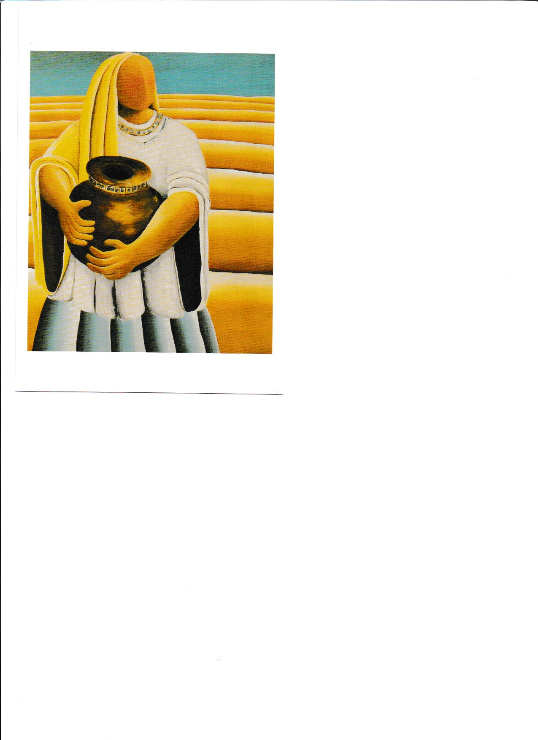

AB Song Jesus, brother and giver of life
Jesus, brother and giver of life,
you fell with the leaves in the autumn wind
broken and bleeding, lost to the cold
that your seed might be tall in me.

Give me courage to know your word
Help me to follow the peaceful road
Plough my weapons back to the earth
So that I might rely on you.

Give me wisdom to know your ways
To thank you for freedom when I’m in chains
To sing of your glory when death seems to reign
That your hope might be part of me.

Give me strength to be gentle and kind
To see you the victim in suffering ones
Turn my senses to know your pain
That you love might be seen in me.

Give me patience to know your plan
To see over all things your loving hand
To work for you kingdom as part of your love
That your peace be alive in me.

Jesus, brother and giver of life, Offering brought forward
you fell with the leaves in the autumn wind
broken and bleeding, lost to the cold
that your seed might be tall in me.
Leigh Newton Reproduced with permission CCLI License #22260685, all rights reserved

PA Offering and prayer (Between lectern and table)
God of great gifts you have given us much, accept these gifts from our hands, our faithful response to your abundant grace. Amen

PA Notices lectern
Lent Event

PA Prayers of the People
Let us pray.
Thank you God for the different experiences we have had this week.
The future is always evolving; help us to create and find solutions,
And be joyfully thankful in happy times.

There are many things happening in our world –
Waring nations – We pray for those who are caught in the crossfire. May they help and care for each other. And we here in Australia, find ways to help.

We pray for passionate leaders who are prepared to use passive means to speak out and confront injustices.

We pray for those searching for meaning and purpose in their lives.
We pray for those suffering from grief and other challenging situations.
May we surround those we meet with kindness, comfort and hope, creating a world where we care. Love and respect each other.
Where justice and peace are possible.
We pray in the name of Jesus who encourages us to say:-
Eternal Spirit, Earth-maker, Pain-bearer, Life-giver,
Source of all that is and that shall be,
Father and Mother of us all,
Loving God, in whom is heaven:
The hallowing of your name
echo through the universe!
The way of your justice
be followed by the peoples of the world!
Your heavenly will be done by all created beings!
Your commonwealth of peace and freedom
sustain our hope and come on earth.
With the bread we need for today, feed us.
In the hurts we absorb from one another, forgive us.
In times of temptation and test, strengthen us.
From trials too great to endure, spare us.
From the grip of all that is evil, free us.
For you reign in the glory of the power that is love,
now and for ever. Amen NZ Anglican prayer book
PA Song I heard the voice of Jesus say TIS 585

I heard the voice of Jesus say, “Come unto Me and rest;
Lay down, O weary one, lay down your head upon my breast.”
I came to Jesus as I was, weary, worn, and sad;
I found in Him a resting place, and He has made me glad.

I heard the voice of Jesus say, “Behold I freely give
The living water; thirsty one, stoop down and drink, and live.”
I came to Jesus, and I drank of that life-giving stream;
My thirst was quenched, my soul revived, and now I live in Him.

I heard the voice of Jesus say, “I am this dark world's Light;”
Look unto Me, your morn shall rise, and all your day be bright.”
I looked to Jesus, and I found in Him my star, my sun;
and in that Light of life I'll walk ‘til traveling days are done.
Horatius Bonar Reproduced with permission CCLI License #22260685, all rights reserved

AB: Commissioning front of table
Blessing song: Powerpoint ATW 494 on Morialta List Sung to piano x2 For you, deep stillness of the silent inland
For you, deep stillness of the silent inland
For you, deep blue of the desert skies
For you, flame red of the rocks and stones
For you, sweet water from hidden springs.
From the edges seek the heartlands
and when you're burnt by the journey
may the cool winds of the hovering Spirit
soothe and replenish you.
In the name of Christ, In the name of Christ.
© 1997 Robin Mann. Words: Julie Perrin Reproduced with permission CCLI License #22260685, all rights reserved

