March 15 2026 Lent 4 - Encounter with disability
Minister: Anne Butler Welcome: Carole Lyons
Worship Leader: Leonie Brown Piano: Gil Sullivan
Bible Reader: Dawn Colegrove Guitar:
Singers: Anne Ind Rhonda Amber
Projection: John Thornton Audio: John Drew/June Searle
Camera 6: Jenny Swanbury Camera 8: Ray Clogg
Reader: Joan Morrison Vision Switcher: John Secombe
PICTURE ON SCREEN FIRST – 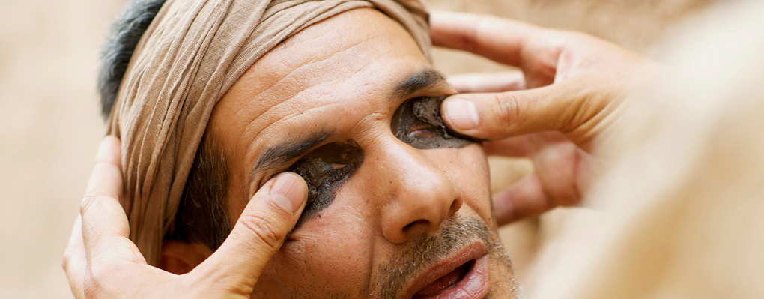
This Photo by Unknown Author is licensed under CC BY-NC-ND
ALL AT LECTERN UNLESS OTHERWISE SHOWN.
Sing-through: 9:30, ends at 9:50 Pre-service music
Candles lit, Bible open
10.00am Red light displayed: Intro video plays
LB Welcome Behind table
LB Acknowledgement We meet on the lands of the Kaurna People of the Adelaide Plains, and where ever you are worshipping, we acknowledge First People’s care for the lands and waters. May our eyes and hearts be opened to reconciliation possibilities so that we may walk together in peace.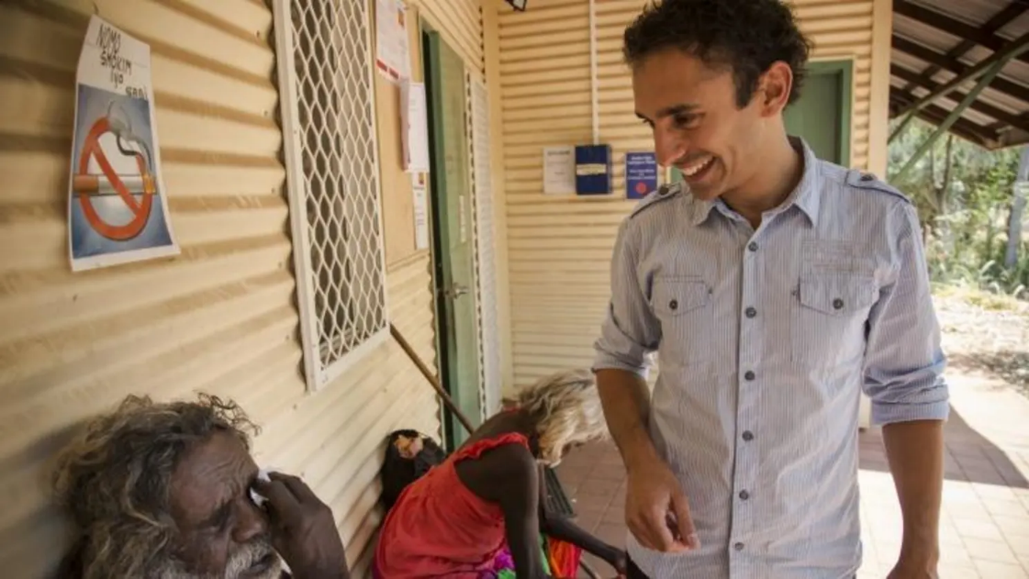The first First Nations Ophthalmologist restoring sight
AB Call to Worship Lectern
When God appeared on earth in the person of Jesus,
most of the world did not recognise him
and therefore did not worship him.
Today we ask for faith that will open our eyes
to see Jesus for who he is,
that we might worship him in truth.
People of God, behold your God!
We open our eyes to see his glory.
We open our ears to hear his wisdom.
We open our hands to offer him gifts.
We open our mouths to sing his praise.
We open our hearts to offer him our love. He is the Eternal One! (Source: Reformed Worship)
AB Prayer
Discerner of hearts,
you look beneath our outward appearance
and see your image in each of us.
Banish in us the blindness
that prevents us from recognizing truth,
so we may see the world through your eyes
and with the compassion of Jesus Christ who reconciles us. Amen.

AB Song Praise the God who changes places TIS178
Praise the God who changes places
leaves the lofty seat,
welcomes us with warm embraces,
stoops to wash our feet.
Friends, be strong!
Hold your heads high!
Freedom is our song! Alleluia!

Praise the Rabbi, speaking, doing
all that God intends,
dying, rising, faith renewing,
calling us his friends.
Friends, be strong!
Hold your heads high!
Freedom is our song! Alleluia!

Praise the Breath of Love, whose freedom
spreads our waking wings,
lifting every blight and burden
till our spirit sings:
Friends, be strong!
Hold your heads high!
Freedom is our song! Alleluia!

Praise, until we join the singing
far beyond our sight,
with the Ending-and-Beginning,
dancing in the light.
Friends, be strong!
Hold your heads high!
Freedom is our song! Alleluia!
© 1986 Brian Arthur Wren, William Patrick Rowan Reproduced with permission CCLI License #22260685, all rights reserved

AB Prayer of Confession and assurance
God of healing, God of wholeness,
we bring our brokenness,
our fears and tendency to despair,
and lay them at your feet.
God of healing, God of wholeness,
we hold out hearts and hands, minds and souls
to feel your touch, and know the peace
that only you can bring.
God of healing, God of wholeness,
this precious moment in your presence and power
grant us faith and confidence that here broken lives are made whole.
Our healing God desires our wholeness, so I say to you, we are still becoming the people we are meant to be. Thanks be to God!
AB Message to the young in heart In front of table

Dramatic Reading John 9:1-41
DC: As he walked along, he saw a man blind from birth. ² His disciples asked him,
Left: ‘Rabbi, who sinned, this man or his parents, that he was born blind?’
DC: ³ Jesus answered,
AB ‘Neither this man nor his parents sinned; he was born blind so that God’s works might be revealed in him. ⁴ We must work the works of him who sent me while it is day; night is coming when no one can work. ⁵ As long as I am in the world, I am the light of the world.’
DC: ⁶ When he had said this, he spat on the ground and made mud with the saliva and spread the mud on the man’s eyes, ⁷ saying to him,
AB: ‘Go, wash in the pool of Siloam’
DC: (which means Sent). Then he went and washed and came back able to see. ⁸ The neighbours and those who had seen him before as a beggar began to ask,
Right: ‘Is this not the man who used to sit and beg?’
DC: ⁹ Some were saying,
Left: ‘It is he.’
DC: Others were saying,
Right: ‘No, but it is someone like him.’
DC: He kept saying,
‘I am the man.’
DC: ¹⁰ But they kept asking him,
Left: ‘Then how were your eyes opened?’
¹¹ ‘The man called Jesus made mud, spread it on my eyes, and said to me, “Go to Siloam and wash.” Then I went and washed and received my sight.’
DC: ¹² They said to him,
Left: ‘Where is he?’
‘I do not know.’
DC: ¹³ They brought to the Pharisees the man who had formerly been blind. ¹⁴ Now it was a sabbath day when Jesus made the mud and opened his eyes. ¹⁵ Then the Pharisees also began to ask him how he had received his sight. He said to them,
‘He put mud on my eyes. Then I washed, and now I see.’
DC: ¹⁶ Some of the Pharisees said,
Right: ‘This man is not from God, for he does not observe the sabbath.’ DC: But others said,
Left: ‘How can a man who is a sinner perform such signs?’
DC: And they were divided. ¹⁷ So they said again to the blind man,
Right: ‘What do you say about him? It was your eyes he opened.’
He said, ‘He is a prophet.’
DC: ¹⁸ The Jews did not believe that he had been blind and had received his sight until they called the parents of the man who had received his sight ¹⁹ and asked them,
Left: ‘Is this your son, who you say was born blind? How then does he now see?’
DC: ²⁰ His parents answered,
‘We know that this is our son, and that he was born blind; ²¹ but we do not know how it is that now he sees, nor do we know who opened his eyes. Ask him; he is of age. He will speak for himself.’
²² His parents said this because they were afraid of the Jews; for the Jews had already agreed that anyone who confessed Jesus to be the Messiah would be put out of the synagogue. ²³ Therefore his parents said, ‘He is of age; ask him.’
²⁴ So for the second time they called the man who had been blind, and they said to him,
Right: ‘Give glory to God! We know that this man is a sinner.’
²⁵ He answered, ‘I do not know whether he is a sinner. One thing I do know, that though I was blind, now I see.’
Right: ‘What did he do to you? How did he open your eyes?’
²⁷ ‘I have told you already, and you would not listen. Why do you want to hear it again? Do you also want to become his disciples?’
DC: ²⁸ Then they reviled him, saying,
Right: ‘You are his disciple, but we are disciples of Moses. ²⁹ We know that God has spoken to Moses, but as for this man, we do not know where he comes from.’
³⁰ ‘Here is an astonishing thing! You do not know where he comes from, and yet he opened my eyes. ³¹ We know that God does not listen to sinners, but he does listen to one who worships him and obeys his will. ³² Never since the world began has it been heard that anyone opened the eyes of a person born blind. ³³ If this man were not from God, he could do nothing.’
³⁴ Right: You were born entirely in sins, and are you trying to teach us?’ DC: And they drove him out. ³⁵ Jesus heard that they had driven him out, and when he found him, he said,
AB ‘Do you believe in the Son of Man?’
‘And who is he, sir? Tell me, so that I may believe in him.’
³⁷ ‘You have seen him, and the one speaking with you is he.’
³⁸ ‘Lord, I believe.’
DC: And he worshipped him. ³⁹ Jesus said,
AB: ‘I came into this world for judgement so that those who do not see may see, and those who do see may become blind.’
DC: ⁴⁰ Some of the Pharisees near him heard this and said to him,
Left: ‘Surely we are not blind, are we?’
DC: ⁴¹ Jesus said to them,
AB: ‘If you were blind, you would not have sin.
But now that you say, “We see”, your sin remains.

DC Song Amazing grace! TIS 129
Amazing grace! how sweet the sound,
That saved and strengthened me!
I once was lost, but now am found,
Was blind, but now I see.

2.As grace first taught my heart to fear,
So grace my fears relieved;
How precious did that grace appear
whenever I believed!

3. Through many dangers, toils and snares
We have already come
God’s grace has brought us safe thus far
And grace will lead us home

4 The Lord has promised good to us,
God’s word our hope secures;
God will our shield and portion be
As long as life endures.

5.When we’ve been there ten thousand years,
Bright shining as the sun,
We’ve no less days to sing God’s praise
Than when we first begun.
John Newton Public Domain

AB Message Encounter with disability
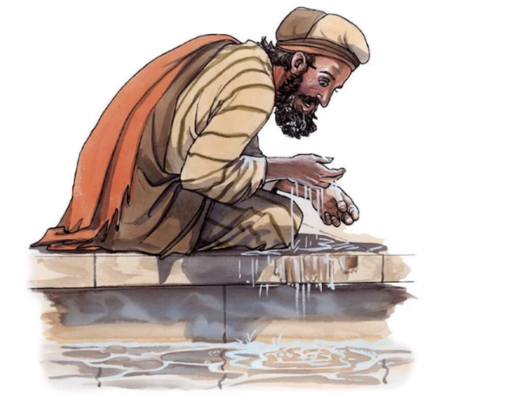
AB Song When pain and terror strike by chance TIS 262
When pain and terror strike by chance,
with causes unexplained,
when God seems absent or asleep,
and evil unrestrained,
we crave an all-controlling force,
ready to rule and warn,
but find, far-shadowed by a cross,
a child in weakness born.

We marvel at God's nakedness
and sense the play of chance
in Herod's anger, Peter's growth,
and Pilate's troubled glance.
Our Saviour's tempted, tested way
never was cut and dried,
but costly, risking life and love,
betrayed and crucified.

How deep the Wisdom of our God,
how weak, but truly wise,
to risk, to sacrifice, to die,
and from the grave arise,
to shed the shroud of death and fate,
freeing our hearts for good.
We breathe the ample air of hope
and take our chance with God.

Since Wisdom took her chance on earth, Bowl brought forward
to show God's living way,
we'll trust that fear and force will fail,
and Wisdom win the day.
Then, come, dear Christ, and hold us fast
when faith and hope are torn,
and bring us, in your loving arms,
to resurrection morn.
Words © 1993 Hope Publishing Company Brian Wren Reproduced with permission CCLI License #22260685, all rights reserved

LB Offering and prayer (Between lectern and table)
We see the generosity of your grace and mercy and we bring to you something a small part of all you have given us, give to us a generous heart and spirit as we dedicate both our offerings and our hearts that we may serve you, your church and your world.
LB Notices
LB Lent Event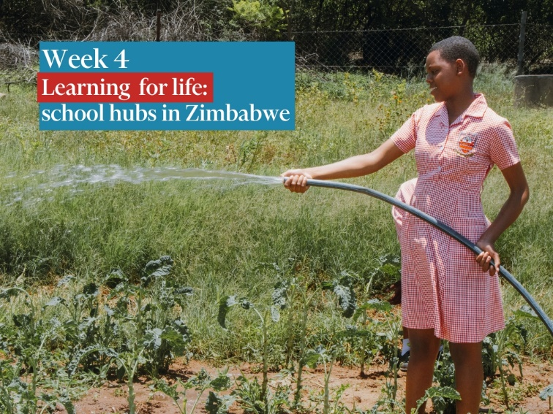
This week, as we learn and pray for our global Church partners, we’re in Zimbabwe, where school hubs are an innovative way of creating change in the whole community. Children and students everywhere face huge challenges in our complex and ever-changing world. In rural Zimbabwe, schools face these issues on top of even more urgent challenges: children come to school hungry or malnourished. They may drop out because they’re needed at home to look after younger children and animals. When rains fail, they may have to walk long distances for water instead of attending school. Changing weather patterns have created unseasonal drought, failed crops and widespread hunger in these communities. Previous gains made against poverty and hunger have slid backwards in the face of these challenges. UnitingWorld’s partner, the Methodist Church in Zimbabwe, realised that one of the best ways to reach whole communities to create change is through school hubs. The Church is turning dry land into school vegetable gardens, installing solar powered water systems and training students and their families in climate-smart farming. Parents know their children are eating well at school, and using the solar powered water systems, they can also access enough water to improve their own vegetable gardens. This means they have enough to feed their families and also create some income. The projects show people that the Church is responsive to their most urgent challenges – how to feed themselves, get clean water and provide an income in the face of a changing climate. Children are learning to care for their land in a climate-crisis, and members of the community are stepping up to advocate for better environmental policies.

AB Prayers of the People
Slide for the whole prayer
Response Jesus, Light of the world,
lighten our darkness.
My brothers and sisters:
reconciled to God by the mercy of Christ,
we pray with confidence for the needs of the church and the world. Today we heard of the healing of blindness and the intransigent blindness of the Pharisees.
Rather than feeling superior that we are not like them we know there are times when we close our eyes rather than see clearly what is around us.
When self-centredness blinds us to the wreckage of human problems and stubbornness blinds us to the troubles of our brothers and sisters;
Jesus, Light of the world, lighten our darkness.
When we turn away so we cannot see the inequalities where we have so much while others live in poverty, Jesus Light of the world, lighten our darkness.
There are many people blind around the world that with funds available could be healed, blindness caused by dirty water and malnutrition, and cataract removal operations which quickly and easily and cheaply restore sight. Jesus Light of the world, lighten our darkness.
Areas where the light of Christ is being extinguished by persecution and violence, senseless dropping of bombs on schools and hospitals. Jesus, Light of the world, lighten our darkness.
Help those who live in the darkness of unbelief, disillusionment and hopelessness to turn to the light of Christ.
As you touched the eyes of the man born blind you bless us with your love that we may bless others. Bless our families and our homes and any we name before you in the silence of our hearts… Brief silence Gracious and loving God, through Christ you make us a new creation, O God, for with him we pass from sin and self reliance to the new life of grace.
Accept our prayers in the warm embrace of your compassion,
and welcome all people to the festive banquet of your table,
where we may rejoice in your love
and celebrate the inheritance you have given to us.
Jesus, Light of the world, lighten our darkness.
We join in our Family Prayer Eternal Spirit, Earth-maker, Pain-bearer, Life-giver,
Source of all that is and that shall be,
Father and Mother of us all,
Loving God, in whom is heaven:
The hallowing of your name
echo through the universe!
The way of your justice
be followed by the peoples of the world!
Your heavenly will be done by all created beings!
Your commonwealth of peace and freedom
sustain our hope and come on earth.
With the bread we need for today, feed us.
In the hurts we absorb from one another, forgive us.
In times of temptation and test, strengthen us.
From trials too great to endure, spare us.
From the grip of all that is evil, free us.
For you reign in the glory of the power that is love,
now and for ever. Amen A prayer book for New Zealand

AB Song Jesus, brother and giver of life
Jesus, brother and giver of life,
you fell with the leaves in the autumn wind
broken and bleeding, lost to the cold
that your seed might be tall in me.

Give me courage to know your word
Help me to follow the peaceful road
Plough my weapons back to the earth
So that I might rely on you.

Give me wisdom to know your ways
To thank you for freedom when I’m in chains
To sing of your glory when death seems to reign
That your hope might be part of me.

Give me strength to be gentle and kind
To see you the victim in suffering ones
Turn my senses to know your pain
That you love might be seen in me.

Give me patience to know your plan
To see over all things your loving hand
To work for you kingdom as part of your love
That your peace be alive in me.

Jesus, brother and giver of life,
you fell with the leaves in the autumn wind
broken and bleeding, lost to the cold
that your seed might be tall in me.
Leigh Newton Reproduced with permission CCLI License #22260685, all rights reserved
AB: Commissioning front of table
Blessing song: Tune TIS 536
Let others call my faith a lie
Or try to stir up doubt in me
Look at me now! None can deny
I once was blind and now I see.
Ask me not how! But I know who
has opened up new worlds to me
This Jesus does what none can do
I once was blind and now I see

