Fifth Sunday after the Epiphany - February 8, 2026
Minister: Anne Butler Welcome: Christine Garner
Worship Leader: Leonie Brown Piano: Jey Edwin Bible Reader: June Searle Guitar: Austin Phoenix Singers Eunice S. Rhonda Amber
Camera 6: Pam Ayles Audio: Ray Clogg
Camera 8 : Peter Thornley Projection: Colin Cargill
Vision Director: Margaret Cargill Vision Switcher: John Secombe

PICTURE ON SCREEN FIRST – 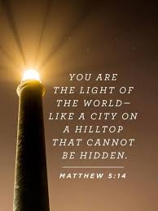

ALL AT LECTERN UNLESS OTHERWISE SHOWN.
Sing-through: 9:30, ends at 9:50 Pre-service music
10.00am Red light displayed: Intro video plays
LB Welcome behind table

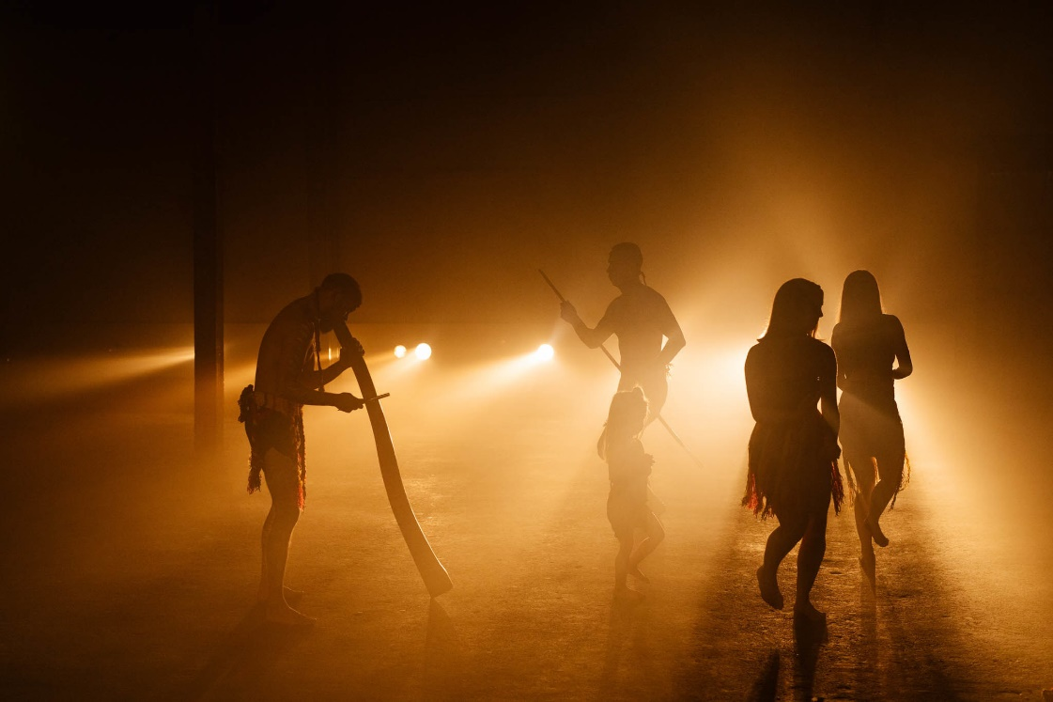
LB Acknowledgement – We acknowledge the Kaurna people as the traditional custodians of the country on which we gather in worship and fellowship. We pay our respects to them for their care of the land on which we meet. We are mindful of those gone before us, and those present and those to come, that we share this land.

LB Candle lighting – We light the Peace candle to pray continually for peace in our world, the Christ candle to remind us we are filled with the light of Christ, the open Word- the revelation of God in human experience, and the flowing water which unites us in baptism.
LB Call to Worship - Lectern
We worship the God who inhabits our world through nature and who
also dwells in our lives. To find God, we can look around at the
wonders of creation; but we can also look within ourselves and into
the eyes of others.

LB Prayer
As we gather here today, may the Holy Spirit surprise us with grace.
May we experience the presence of the risen Christ among us as we
sing, listen and pray.
Let our ears be open to hear the message of God’s love and our
eyes be open to the new insights.
We give thanks for stories of grace that carry us into new depths of
love.
We give thanks that those who followed Jesus and looked into his
face and could see your love personified in him.
It is an endless gift of grace to us. Amen

LB Song Let there be light TIS 447
1 God, your almighty word
chaos and darkness heard,
and took their flight:
hear us, we humbly pray,
and where the gospel day
sheds not its glorious ray,
let there be light.
2 Jesus, who came to give
those who in darkness live
healing and sight,
health to the sick in mind,
sight to the inly blind,
now to all humankind
let there be light.
3 Spirit of truth and love,
life-giving holy dove,
speed forth your flight;
move on the waters' face
bearing the lamp of grace,
and in earth's darkest place
let there be light.
4 Holy and blessèd Three,
glorious Trinity,
Wisdom, Love, Might,
boundless as ocean's tide
rolling in fullest pride,
through the earth far and wide,
let there be light. John Marriott Public Domain.
AB Prayer of Confession
When we doubt the difference we make in the world
Remind us of your love
When we are critical of others, but blind to our own failings
Remind us of your love
When we believe the time for change has passed
Call us again your Salt and Light,
and give us your hope and peace.

AB Assurance –
No matter how we have failed in the past, our apathy or wilful disobedience, God still loves us and believes in us, and depends on us to work for the Kingdom. So I say to you, our sins are forgiven,
Thanks be to God.

AB Intro to readings
JS Reading 1 Corinthians 2:1-12
When I came to you, brothers and sisters, I did not come proclaiming the mystery of God to you in lofty words or wisdom. ² For I decided to know nothing among you except Jesus Christ, and him crucified. ³ And I came to you in weakness and in fear and in much trembling. ⁴ My speech and my proclamation were not with plausible words of wisdom, but with a demonstration of the Spirit and of power, ⁵ so that your faith might rest not on human wisdom but on the power of God.
⁶ Yet among the mature we do speak wisdom, though it is not a wisdom of this age or of the rulers of this age, who are doomed to perish. ⁷ But we speak God’s wisdom, secret and hidden, which God decreed before the ages for our glory. ⁸ None of the rulers of this age understood this; for if they had, they would not have crucified the Lord of glory. ⁹ But, as it is written,
‘What no eye has seen, nor ear heard,
nor the human heart conceived,
what God has prepared for those who love him’—
¹⁰ these things God has revealed to us through the Spirit; for the Spirit searches everything, even the depths of God. ¹¹ For what human being knows what is truly human except the human spirit that is within? So also no one comprehends what is truly God’s except the Spirit of God. ¹² Now we have received not the spirit of the world, but the Spirit that is from God, so that we may understand the gifts bestowed on us by God.
JS Reading - Matthew 5:13-20 - Salt and Light
13 ‘You are the salt of the earth; but if salt has lost its taste, how can its saltiness be restored? It is no longer good for anything, but is thrown out and trampled under foot.
14 ‘You are the light of the world. A city built on a hill cannot be hidden. 15 No one after lighting a lamp puts it under the bushel basket, but on the lampstand, and it gives light to all in the house. 16 In the same way, let your light shine before others, so that they may see your good works and give glory to your Father in heaven.
The Law and the Prophets
17 ‘Do not think that I have come to abolish the law or the prophets; I have come not to abolish but to fulfil. 18 For truly I tell you, until heaven and earth pass away, not one letter, not one stroke of a letter, will pass from the law until all is accomplished. 19 Therefore, whoever breaks one of the least of these commandments, and teaches others to do the same, will be called least in the kingdom of heaven; but whoever does them and teaches them will be called great in the kingdom of heaven. 20 For I tell you, unless your righteousness exceeds that of the scribes and Pharisees, you will never enter the kingdom of heaven.
JS Hear what the Spirit is saying to the Church Thanks be to God
JS Song This little light of mine – Video the Harvard Krokodiloes
https://youtu.be/wBwJik2FKW0?si=jJhQmuxSlSVet6O_
Reproduced with permission CCLI License #22260685, all rights reserved
AB Message Salt and Light
AB Song Christ is the world's true light TIS 238 tune 106(i)
1 Christ is the world's true light,
its Captain of salvation,
the Daystar clear and bright
of every land and nation;
new life, new hope awakes,
for all who own his sway:
freedom her bondage breaks,
and night is turned to day.
2 In Christ all races meet,
their ancient feuds forgetting,
the whole round world complete,
from sunrise to its setting:
when Christ is throned as Lord,
all shall forsake their fear,
to plough-share beat the sword,
to pruning hook the spear.
3 One Lord, in one great name Christine brings bowl forward unite us all who own you;
cast out our pride and shame
that hinder to enthrone thee;
the world has waited long,
has travailed long in pain;
to heal its ancient wrong, come, Prince of Peace, and reign.
George Wallace Briggs Reproduced with permission CCLI License #22260685, all rights reserved
LB Offering and prayer- Between table and lectern
May these gifts represent also the offering of our lives as we live
them day to day, both different ways of seeking to be part of bringing
the kingdom of God in the world. May our gifts and our lives be
blessed in God’s service. Amen.

LB Notices - Lectern
AB explanation of Ash Wednesday and Lenten studies

AB Prayers of the People
Loving God, we hold the Earth and her peoples before you.
You know where children cry in hunger or fear,
Where parents despair,
Where older folk are ignored,
Where the earth groans from neglect or abuse.
You know already the places that cause us concern –
Ukraine, Gaza, Iran, Greenland, Taiwan.
We care about global warming, famines, pollution, plastics, the loss of habitat and forests, exploitation of women, children and men through modern slavery, the sex and drug trades and child marriage.
You call us to be salt
You call us to be light.
To change our world with our presence,
With our peace and with our hope,
To bring your very self into places of pain and anguish.
Make us workers of a better tomorrow.
Keep us close that our attitudes may mirror yours
And we be true to our calling.

Gathering our prayers and praises into one, let us say the Lord’s
Prayer together.
Our Father in heaven,
hallowed be your name,
your kingdom come,
your will be done,
on earth as in heaven.
give us today our daily bread.
Forgive us our sins
as we forgive those who sin against us.
Save us from the time of trial
and deliver us from evil.
For the kingdom, the power,
and the glory are yours
now and for ever.
Amen.

AB Song Christ, be our light
Longing for light, we wait in darkness
Longing for truth, we turn to You
Make us Your own, Your holy people
Light for the world to see
Christ, be our light
Shine in our hearts
Shine through the darkness
Christ, be our light
Shine in Your church gathered today

Longing for shelter, many are homeless
Longing for warmth, many are cold
Make us Your building, sheltering others
Walls made of living stone

Christ, be our light
Shine in our hearts
Shine through the darkness
Christ, be our light
Shine in Your church gathered today

Many the gifts, many the people
Many the hearts that yearn to belong
Let us be servants to one another
Making Your kingdom come

Christ, be our light
Shine in our hearts
Shine through the darkness
Christ, be our light
Shine in Your church gathered today
Bernadette Farrell Reproduced with permission under ONE LICENSE #A- 604530. All rights reserved.
AB Commissioning in front of table
AB Blessing song Christ be our light
Christ, be our light
Shine in our hearts
Shine through the darkness
Christ, be our light
Shine in Your church gathered today.

