Sixth Sunday after the Epiphany - February 15, 2026
Minister: Anne Butler Welcome: Judith Purling
Worship Leader: Craig Mackenzie Piano: Anne Ind Bible Reader: Joan Wagner Guitar: Austin Phoenix Singers: Rhonda Amber Chris Ayles
Camera 6: Jenny Swanbury Audio: John Drew
Camera 8 : Carole Lyons Projection: Colin Cargill
Vision Director: John Secombe Vision Switcher: Margaret Cargill

PICTURE ON SCREEN FIRST – 

ALL AT LECTERN UNLESS OTHERWISE SHOWN.
Sing-through: 9:30, ends at 9:50 Pre-service music
10.00am Red light displayed: Intro video plays
Peace candle already lit.
CM Welcome behind table

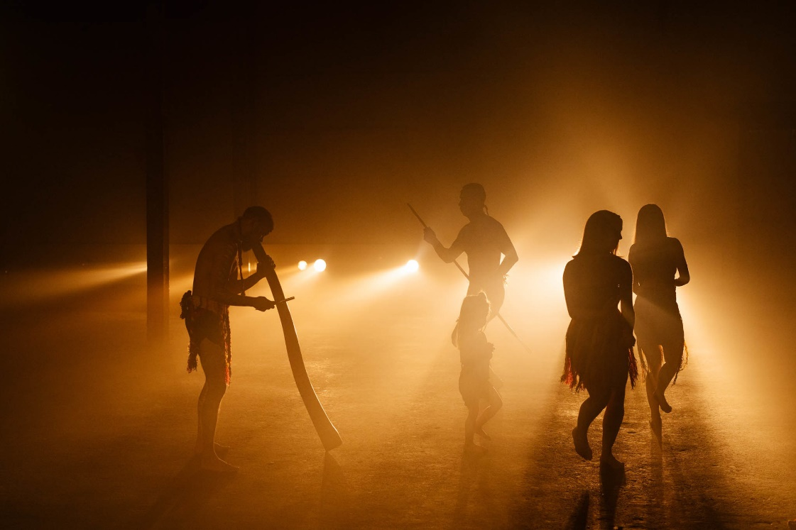
CM Acknowledgement –
As we gather to behold the glory of God in the face of Jesus Christ, we acknowledge the Kaurna people as the custodians of the lands and waters where we meet. We pay our respects to their elders past and present. As this land is transformed by the changing seasons, we thank the Traditional Custodians for their care of this place since creation. May we be light-bearers for justice in this community
CM Candle lighting –
We light this candle to represent the divine splendour of Jesus Christ, our Lord, which shone forth before his chosen witnesses.
Just as the light of the sun illuminates the world, may this light shine in our hearts, bringing hope and understanding.
We gather to behold his glory—the light that darkness cannot overcome.

CM Call to Worship - Lectern
Today we are celebrating the holy light that illuminated Jesus.
We celebrate his transfiguration on the mountain.
Light of light: transfusing and transforming light.
Divine light flooding out the shadows.
Light of love, light of delight.
Light that turns doubters into followers.
It is the same God who at the beginning said:
“Let there be light,”
who has shone in our hearts with an understanding
of the glory of God in the face of Jesus Christ.
The mightiest One of all, God the Eternal,
speaks and summons the whole earth
from the rising of the sun to its setting.
From God’s holy mountain, God’s light,
the perfection of beauty, shines out.

CM Prayer
Christ,
God,
Son of the Father,
The pleased one of God,
Transfigure us.
Transfigure our comprehension of who you are.
Grant us that greatest of epiphanies,
The insight of the fullness of your nature.
May we find and hold you in awe that we might not take you for granted.
Continually humble our understandings of you,
That we might not presume in arrogance to define who you might be,
Or get stuck in the moment of an understanding of one aspect of your being.
Transfigure how we see you,
That we might, in relationship and friendship, be inspired to come to know you better.
Transfigure us,
That in knowing you better we come to know your call to us better.
Transfigure us,
So that in following you and embodying your way,
Our living and being might be transfigured,
As you redeem and transform us through your love and grace.
Transfigure us, Christ,
Now and always may it be so.
Amen
(Source: Jon Humphries, Prayers that unite)

CM Song Here in this place, new light is streaming TIS 474
Here in this place new light is streaming
Now is the darkness vanished away
See in this space our fears and our dreamings
Brought here to you in the light of this day
Gather us in, the lost and forsaken
Gather us in, the blind and the lame
Call to us now and we shall awaken
We shall arise at the sound of our name
We are the young, our lives are a mystery
We are the old who yearn for your face
We have been sung throughout all of history
Called to be light to the whole human race
Gather us in, the rich and the haughty
Gather us in, the proud and the strong
Give us a heart so meek and so lowly
Give us the courage to enter the song
Here we will take the wine and the water
Here we will take the bread of new birth
Here you shall call your sons and your daughters
Call us anew to be salt for the earth
Give us to drink the wine of compassion
Give us to eat the bread that is you
Nourish us well and teach us to fashion
Lives that are holy and hearts that are true
Not in the dark of buildings confining
Not in some heaven light years away
But here in this place the new light is shining
Now is the kingdom, now is the day
Gather us in and hold us forever
Gather us in and make us your own
Gather us in, all peoples together
Fire of love in our flesh and our bones
Reproduced with permission under ONE LICENSE #A- 604530. All rights reserved.
AB Prayer of Confession
As we come to the end of the season after Epiphany,
May we remember we are people enlightened.
When we fall back into the petty ways of darkness
Send the light of your Spirit to show us the way
When we fail the see the light in others
Remind us again that we are all loved by you.
As we begin the season of Lent,
May we give up all that holds us back,
Doing without our pleasures and luxuries
And take up all that brings light,
To our world, to your people and our own souls.
Amen

AB Intro to readings

JW Reading 2 Peter 1:16-21
¹⁶ For we did not follow cleverly devised myths when we made known to you the power and coming of our Lord Jesus Christ, but we had been eyewitnesses of his majesty. ¹⁷ For he received honour and glory from God the Father when that voice was conveyed to him by the Majestic Glory, saying, ‘This is my Son, my Beloved, with whom I am well pleased.’ ¹⁸ We ourselves heard this voice come from heaven, while we were with him on the holy mountain.
¹⁹ So we have the prophetic message more fully confirmed. You will do well to be attentive to this as to a lamp shining in a dark place, until the day dawns and the morning star rises in your hearts. ²⁰ First of all you must understand this, that no prophecy of scripture is a matter of one’s own interpretation, ²¹ because no prophecy ever came by human will, but men and women moved by the Holy Spirit spoke from God.
JW Reading - Matthew 17:1-9 - The Transfiguration
¹⁷ Six days later, Jesus took with him Peter and James and his brother John and led them up a high mountain, by themselves. ² And he was transfigured before them, and his face shone like the sun, and his clothes became dazzling white. ³ Suddenly there appeared to them Moses and Elijah, talking with him. ⁴ Then Peter said to Jesus, ‘Lord, it is good for us to be here; if you wish, I will make three dwellings here, one for you, one for Moses, and one for Elijah.’ ⁵ While he was still speaking, suddenly a bright cloud overshadowed them, and from the cloud a voice said, ‘This is my Son, the Beloved; with him I am well pleased; listen to him!’ ⁶ When the disciples heard this, they fell to the ground and were overcome by fear. ⁷ But Jesus came and touched them, saying, ‘Get up and do not be afraid.’ ⁸ And when they looked up, they saw no one except Jesus himself alone.
⁹ As they were coming down the mountain, Jesus ordered them, ‘Tell no one about the vision until after the Son of Man has been raised from the dead.’
JW Hear what the Spirit is saying to the Church Thanks be to God
JW Song Christus Paradox tune TIS 497
You, Lord, are both Lamb and Shepherd.
You, Lord, are both prince and slave.
You, peacemaker and sword-bringer
Of the way you took and gave.
You the everlasting instant;
You, whom we both scorn and crave.
Clothed in light upon the mountain,
Stripped of might upon the cross,
Shining in eternal glory,
Beggared by a soldier’s toss,
You, the everlasting instant;
You, who are both gift and cost.
You, who walk each day beside us,
Sit in power at God’s side.
You, who preach a way that’s narrow,
Have a love that reaches wide.
You, the everlasting instant;
You, who are our pilgrim guide.
Worthy is our earthly Jesus!
Worthy is our cosmic Christ!
Worthy your defeat and victory.
Worthy still your peace and strife. You, the everlasting instant;
You, who are our death and life.
Alleluia. Alleluia. Alleluia.
You, who are our death and our life.
Sylvia Dunstan (1955-1993) Reproduced with permission under ONE LICENSE #A- 604530. All rights reserved.
AB Message - Mountain top experience
AB Song We have come at Christ's own bidding tune TIS 217(i)

We have come at Christ's own bidding
to this high and holy place,
where we wait with hope and longing
for some token of God's grace.
Here we pray for new assurance
that our faith is not in vain,
searching like those first disciples
for a sign both clear and plain.

Light breaks in upon our darkness,
splendour bathes the flesh-joined Word,
Moses and Elijah marvel
as the heavenly voice is heard.
Eyes and hearts behold with wonder
how the Law and Prophets meet:
Christ, with garments drenched in brightness,
stands transfigured and complete.

Strengthened by this glimpse of glory, Judith brings bowl forward
fearful lest our faith decline,
we like Peter find it tempting
to remain and build a shrine.
But true worship gives us courage
to proclaim what we profess,
that our daily lives may prove us
people of the God we bless.
Carl P. Daw Jr., Rowland Hugh Prichard Reproduced with permission CCLI License #22260685, all rights reserved
CM Offering and prayer- Between table and lectern
O God, the mystery of your being, is never separated from the earthly obligations which you give to us,
To share what we have with others,
Receive our offerings this day we pray,
Amen.

CM Notices

CM Prayers of the People
Lord, there are times when we are so concerned about ourselves that we don’t think of others.
We ask for the gift of your Spirit that we may grow in awareness and sensitivity towards others:
Noticing when someone is unhappy,
Sensing when there’s something wrong for somebody,
Seeing when someone feels cut off or isolated,
Knowing when to say the right word,
Expressing thanks and compliments,
Being thoughtful when someone is ill,
Giving words of encouragement,
Helping someone to feel welcome,
Realising when someone needs the opportunity to talk.
May we grow in sensitivity towards others.
Help us to live in ways which show by our deeds the words of Jesus, who was friend of the outcast and the poor.
May we be moved to think of ways of helping the vulnerable, to bring the compassion of Jesus to those who suffer, to bind up the lonely and the broken hearted.
In these ways may we experience your presence with us in the common tasks of life, showing us how our lives may be transfigured by your presence, so that the radiance of Jesus would shine through to the dark places of our world.
Amen.

Gathering our prayers and praises into one, let us say the Lord’s
Prayer together.
Our Father in heaven,
hallowed be your name,
your kingdom come,
your will be done,
on earth as in heaven.
give us today our daily bread.
Forgive us our sins
as we forgive those who sin against us.
Save us from the time of trial
and deliver us from evil.
For the kingdom, the power,
and the glory are yours
now and for ever.
Amen.

CM Song Christ be our light
Longing for light, we wait in darkness
Longing for truth, we turn to You
Make us Your own, Your holy people
Light for the world to see
Christ, be our light
Shine in our hearts
Shine through the darkness
Christ, be our light
Shine in Your church gathered today

Longing for shelter, many are homeless
Longing for warmth, many are cold
Make us Your building, sheltering others
Walls made of living stone
Christ, be our light
Shine in our hearts
Shine through the darkness
Christ, be our light
Shine in Your church gathered today

Many the gifts, many the people
Many the hearts that yearn to belong
Let us be servants to one another
Making Your kingdom come
Christ, be our light
Shine in our hearts
Shine through the darkness
Christ, be our light
Shine in Your church gathered today
Bernadette Farrell Reproduced with permission under ONE LICENSE #A- 604530. All rights reserved.

AB Commissioning in front of table
AB Blessing song
Christ, be our light
Shine in our hearts
Shine through the darkness
Christ, be our light
Shine in Your church gathered today

