Third Sunday after the Epiphany - January 25, 2026 Day of Mourning
Minister: Anne Butler Piano: Eunice Sullivan Worship Leader: Carole Lyons Guitar: Austin Phoenix Bible Reader: Bev Tredrea Singers Anne Ind Rhonda Amber Camera 6: Colin Cargill Audio: Ray Clogg Camera 8 : Peter Thornley Projection: John Thornton Vision Director: Joan Morrison Vision Switcher: Margaret Cargill
PICTURE ON SCREEN FIRST -
ALL AT LECTERN UNLESS OTHERWISE SHOWN.
Sing-through: 9:30, ends at 9:50 Pre-service music
Candles lit
10.00am Red light displayed: Intro video plays
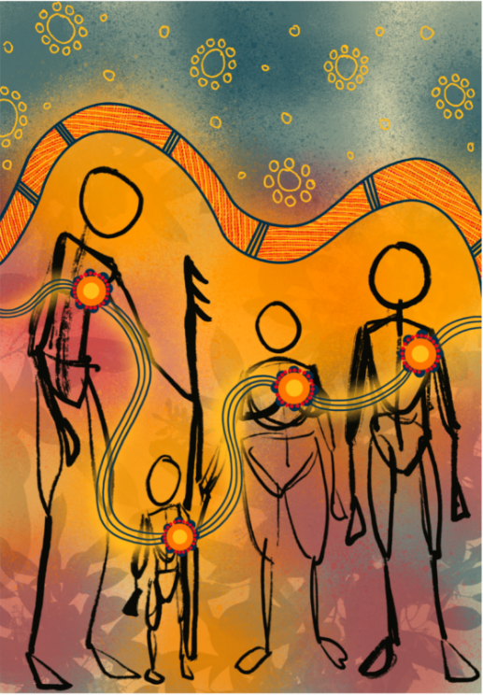
CL Welcome lectern Picture up until call to worship bold
CL Acknowledgement –We acknowledge that God has been present in these lands for thousands of generations, and we can claim the promises of Jesus to write a new story of a walking together in faith, hope, justice and love.
CL and AB Call to Worship Both with mics in front of table
Our Lord is alive amongst all things of creation.
(Lift your hand to your ears)
The sounds of the rivers in motion, the waves of the seas.
(Make a motion of the waves with your hands)
The scents of the gum trees and native flowers on the winds.
(Stand still with your legs firmly planted, take some deep breathes, stretch up both arms and sway like a tree in the breezes.)
that we find a place to retreat and walk alongside you in whispering conversation.
(Rub hands together to make the sound of a whispering conversation) Today we come together, and we bring our full voices,
to lift them in praise of our triune God.
(Lift arms wide to praise God together)
We ask for forgiveness for not always being the givers of love and hospitality. (Bring hands together in prayerful pose)
And, we look to have our hearts made clean. (Use your right hand to catch the love of Christ and rub it onto your chest over your heart)

Lord, our Father of unconditional love, Still in front of table
we come in repentance and hope.
Jesus, son of guiding and teaching love,
we come to listen, learn and act with courage.
Holy Spirit of multiplying love,
we come with humble awe and wonder
of what you might move within our hearts
and the hearts of those with whom we share life.

CL Prayer Lectern
God of all wonder,
We pause in the busyness of our days to listen deeply to the wisdom of this land and those who belong to it.
May our minds be open to dialogue,
May our hearts be open to transformation and
May our hands do the work of reconciliation.
We ask that the Spirit accompany us on our journey of healing on these lands, seas and waterways; We also ask the Spirit of peace be with all those who are living a life of fear, dispossession and distress. We make this prayer in the name of Jesus our brother and friend. Amen.

CL Song Praise with joy the world’s creator TIS 179
Praise with joy the world's creator,
God of justice, love and peace,
Source and end of human knowledge,
Force of goodness without cease.
Celebrate the Maker's glory,
Power to rescue and release.
Praise the Son who feeds the hungry,
Frees the captive, finds the lost,
Heals the sick, upsets religion,
Fearless both of fate and cost.
Celebrate Christ's constant presence -
Friend and Stranger, Guest and Host.
Praise the Spirit sent among us
Liberating truth from pride,
Forging bonds where race or gender,
Age or nation dare divide.
Celebrate the Spirit's treasure -
Foolishness none dare deride.
Praise the Maker, Son and Spirit,
One God in Community,
Calling Christians to embody
Oneness and diversity.
Thus the world shall yet believe
When shown Christ's vibrant unity.
Graham Maule John Bell Reproduced with permission CCLI License #22260685, all rights reserved
AB Prayer of Confession Lectern

Merciful God, we, the Second Peoples of this land,
acknowledge with sorrow the injustice and abuse
that has so often marked the treatment
of the First Peoples of this land.

Light of the world, please guide each of us
Through every hour and moment of the days that are to come.

Enable us to see your image
In the faces of friends,
And to recognise your wounds
in all who suffer disease or injustice.

Give us the grace required
To do the boring things cheerfully,
Enjoy the pleasant things gratefully,
And attempt the difficult things hopefully;

That many may see something of the light
That shines from these vessels of clay
And give glory to the incomparable Light
Who was found in Christ Jesus,
Amen.

AB Intro to readings

BT Reading 1 Corinthians 1:10-18 Divisions in the Church
¹⁰ Now I appeal to you, brothers and sisters, by the name of our Lord Jesus Christ, that all of you should be in agreement and that there should be no divisions among you, but that you should be united in the same mind and the same purpose. ¹¹ For it has been reported to me by Chloe’s people that there are quarrels among you, my brothers and sisters. ¹² What I mean is that each of you says, ‘I belong to Paul’, or ‘I belong to Apollos’, or ‘I belong to Cephas’, or ‘I belong to Christ.’ ¹³ Has Christ been divided? Was Paul crucified for you? Or were you baptized in the name of Paul? ¹⁴ I thank God that I baptized none of you except Crispus and Gaius, ¹⁵ so that no one can say that you were baptized in my name. ¹⁶ (I did baptize also the household of Stephanas; beyond that, I do not know whether I baptized anyone else.) ¹⁷ For Christ did not send me to baptize but to proclaim the gospel, and not with eloquent wisdom, so that the cross of Christ might not be emptied of its power.
¹⁸ For the message about the cross is foolishness to those who are perishing, but to us who are being saved it is the power of God.
BT Reading - Matthew 4:12-23 - Jesus Begins His Ministry in Galilee
12 Now when Jesus heard that John had been arrested, he withdrew to Galilee. 13 He left Nazareth and made his home in Capernaum by the lake, in the territory of Zebulun and Naphtali, 14 so that what had been spoken through the prophet Isaiah might be fulfilled: 15 ‘Land of Zebulun, land of Naphtali, on the road by the sea, across the Jordan, Galilee of the Gentiles— 16 the people who sat in darkness have seen a great light and for those who sat in the region and shadow of death light has dawned.’ 17 From that time Jesus began to proclaim, ‘Repent, for the kingdom of heaven has come near.’
As he walked by the Sea of Galilee, he saw two brothers, Simon, who is called Peter, and Andrew his brother, casting a net into the lake—for they were fishermen. 19 And he said to them, ‘Follow me, and I will make you fish for people.’ 20 Immediately they left their nets and followed him. 21 As he went from there, he saw two other brothers, James son of Zebedee and his brother John, in the boat with their father Zebedee, mending their nets, and he called them. 22 Immediately they left the boat and their father, and followed him.
23 Jesus went throughout Galilee, teaching in their synagogues and proclaiming the good news of the kingdom and curing every disease and every sickness among the people.
BT The Spirit is speaking to the church through these ancient words Our ears and hearts are listening
BT Song You were in this place AT 433
- At the dawn of the ages, you pulled land from the sea.
With your word you invented all we know, all we see:
creek and desert and forest, red and grey kangaroo.
You were in this place— but we never knew.

- Paintings seen on the rock face, footprints left in the sand,
campfire next to the river, songs that rise from the land:
signs that seem so elusive, shadows just out of view.
You were in this place— but we never knew.

- Do we take after Jacob, blind to what lies at hand,
needing dreams to inform us God is here in this land?
See him suffering and dying, bread and wine tell the news. You were in this place— but we never knew.

- Jesus, open our senses, help us see you today
in the person beside us, as we work, as we play.
While we love you and serve you, may it never be true:
you were in this place— but we never knew.
Robin Mann © 1987 Reproduced with permission CCLI License #22260685, all rights reserved

AB Message Humility Slide up for Message
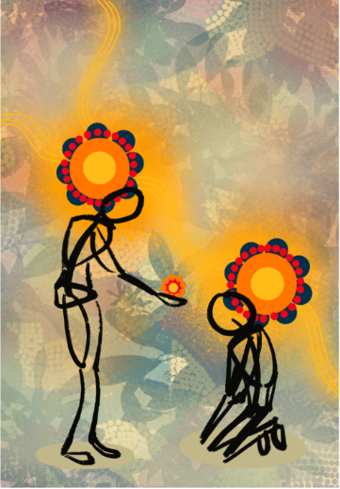
AB Song Lord of earth and all creation TIS 672(ii)
Lord of earth and all creation,
let your love possess our land:
wealth, and freedom, far horizons,
mountain, forest, shining sand:
may we share, in faith and friendship,
gifts unmeasured from your hand.

People of the ancient Dreamtime,
they who found this country first,
ask with those, the later comers,
will our dream be blessed or cursed?
Grant us, Lord, new birth, new living,
hope for which our children thirst.

Lord, life-giving healing Spirit, Bowl brought forward
on our hurts your mercy shower;
lead us by your inward dwelling,
guiding, guarding, every hour.
Bless and keep our land Australia:
in your will her peace and power.
Michael Rayner Thwaites 1915- and Honor Mary Thwaites 1914-93 Reproduced with permission under ONE LICENSE #A- 604530. All rights reserved.
CL Offering and prayer Between table and lectern
The time of sharing is upon us. We bring our gifts, and ourselves. Help us to be generous to those who cannot pay us back, and remember to pay it forward with grace for all the blessings we have received. Amen
CL Notices
CL Prayers of the People
Response: Father, you are good.
Lord fill our hearts with Love and Compassion
Loving God, on this day of celebration we acknowledge Aboriginal and Torres Strait Islander people throughout Australia. We turn to you in prayer as we commit ourselves to journeying together in the spirit of Faith. Father, you are good.
Lord fill our hearts with Love and Compassion
We pray for all Leaders in this Great Southern Land, that they may respect and accept the Aboriginal and Torres Strait Islander heritage, and provide truth, justice, peace, unity and equity for all. Father you are good.
Lord fill our hearts with Love and Compassion
We ask for your guidance for the youth on their life’s journey, that they come to seek and know you and trust in your love and compassion. Father you are good.
Lord fill our hearts with Love and Compassion
We pray for all Elders, those who are sick, the dying, the imprisoned, those who are lost and suffering – we ask for your protection, healing and mercy for all. Father you are good.
Lord fill our hearts with Love and Compassion
Lord thank you for your Merciful Love which you wash over us. Please help us to be strong in Faith and to love everyone as you taught us. Father you are good.
Lord fill our hearts with Love and Compassion
Let us all take a moment’s silence as we pray for our personal intentions to our God. Father you are good.
Lord fill our hearts with Love and Compassion
God, our loving Father, you reveal your care and compassion to us through the life, words and deeds of your son Jesus. Grant us the gift of your compassion so that all peoples may enjoy your promise of peace. With humble hearts we make our prayer through Christ our Lord. Amen

CL Lord’s Prayer translated into Noongar, then back to English
Our Father, high in your Holy Place,
your name is holy.
We want the day to come
when you reign as King in our land.
We want you to become Boss of our land,
the same way you are Boss of your Holy Place.
Today, give us the food that we eat every day.
Forgive our wrong-doing,
the same way we forgive the wrong-doing that people do to us.
Do not take us on the path that goes to wrong-doing,
but hold us so the Devil cannot get us.
You hold the land.
You hold the power.
You hold the light.
Forever and forever.
Amen.
CL Song Comfort, comfort all my people TIS 647 changed words
Comfort, comfort all my people
with the comfort of my word.
Speak it tender to my people:
All your sins are taken away.

1 Though we build strong walls for prisons,
though we feast while others starve,
though we fill this world with weapons: comfort, comfort.
Every prisoner will be rescued,
every hungry mouth be filled,
every gun will rust, forgotten: comfort, comfort.

Comfort, comfort all my people
with the comfort of my word.
Speak it tender to my people:
All your sins are taken away.
2. Though we fracture God's creation,
though we stand so far apart,
though we fail to love each other: comfort, comfort.
Every wall will crack and crumble,
every stranger will be friend,
every one embrace another: comfort, comfort.

Comfort, comfort all my people
with the comfort of my word.
Speak it tender to my people:
All your sins are taken away.
Robin Mann Reproduced with permission CCLI License #22260685, all rights reserved

AB Blessing
May the God of all wonder who set the stars in the sky, bless you with relentless unsettledness that drives you to seek truth.
May the God of all justice who gave motion to the rivers, bless you with righteous anger that drives you to seek freedom for all.
May the God of all love who placed laughter in the kookaburra, bless you with the friendship that looks like the love where one lays down their life for another.
May the God of all comfort who determined the height of the mountains, bless you with tears from shared pain and mourning that shows you hope.
Now with wonder, righteous anger, sacrifice, and lament
Go in truth, justice, love, and hope to Change the Heart of Australia. Brooke Prentis
AB Blessing song For you, deep stillness of the silent inland AT 494 Slides already made
For you, deep stillness of the silent inland
For you, deep blue of the desert skies
For you, flame red of the rocks and stones
For you, sweet water from hidden springs.
From the edges seek the heartlands
and when you're burnt by the journey
may the cool winds of the hovering Spirit
soothe and replenish you.
In the name of Christ, In the name of Christ
Julie Perrin Robin Mann Reproduced with permission CCLI License #22260685, all rights reserved

