Sunday Feb 1 2026 Epiphany 4 - G
Minister: Doug Hosking * Welcome: Leonie Brown Worship Leader: Bev Tredrea* Piano: Eunice Sullivan Bible Reader: Craig Mackenzie* Guitar: Austin Phoenix Communion: Anne Butler* Singers Anne Ind Rhonda Amber
Camera 6: Jenny Swanbury Audio: John Drew
Camera 8 : Ray Clogg Projection: Sharon Mackenzie
Vision Director: John Secombe Vision Switcher: Chris Ayles

PICTURE ON SCREEN FIRST –
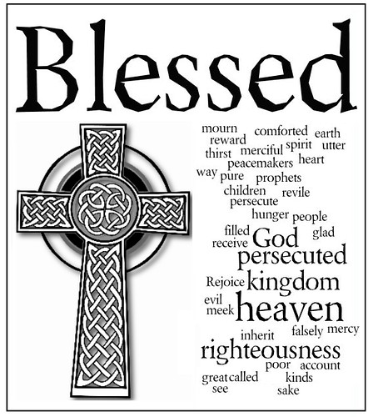
This Photo by Unknown Author is licensed under CC BY-SA-NC
ALL AT LECTERN UNLESS OTHERWISE SHOWN.
Sing-through: 9:30, ends at 9:50 Pre-service music
Candles already lit
10.00am Red light displayed: Intro video plays
BT Welcome behind table

BT.Acknowledgement – behind communion table
For this land
We give thanks
For the Kaurna people
We give thanks
We honour the custodians of sacred stories, of dreamings and the connections with the deep earth. We pay our respects to their Elders both past and present.

BT. Call to Worship - Lectern
When we hunger and thirst for God
God satisfies us.
When we are weak and broken hearted
God comforts and heals us
When we seek to be peacemakers an do justice and despair of our smallness
God empowers us.
God we thank you, we praise you, we worship you.

BT. Prayer
Eternal God, Jesus went up on the mountain and spoke your word. So we gather close and listen, that we might hear and receive the gift of life, and be changed.
Speak to us for we are listening Amen

BT Song Let us sing to the God of salvation TIS 52
1 Let us sing to the God of salvation,
let us sing to the Lord our rock;
let us come to his house with thanksgiving,
let us come before the Lord and sing!
Praise our maker, praise our saviour,
praise the Lord our everlasting king:
every throne must bow before him
God is Lord of everything!

2 In his hand are the earth's deepest places,
and the strength of the hills is his;
all the sea is the Lord's, for he made it
by his hand the solid rock was formed.
Praise our maker, praise our saviour,
praise the Lord our everlasting king:
every throne must bow before him
God is Lord of everything!

3 Let us worship the Lord our maker,
let us kneel to the Lord our God;
for we all are the sheep of his pasture
he will guide us by his powerful hand.
Praise our maker, praise our saviour,
praise the Lord our everlasting king:
every throne must bow before him
God is Lord of everything!

4 Let today be the time when you hear him!
May our hearts not be hard or cold,
lest we stray from the Lord in rebellion
as his people did in time of old.
Praise our maker, praise our saviour,
praise the Lord our everlasting king:
every throne must bow before him
God is Lord of everything!
Norman Leonard Warren, Richard Thomas Bewes Reproduced with permission CCLI License #22260685, all rights reserved
AB Prayer of Confession
When we give in to the expectations of our consumerist society,
Believing money will give us purpose and keep us safe
Lord, show us again your mercy
When we fill our homes, our minds and hearts, with clutter,
Hanging on to outmoded thoughts and feelings,
Christ, show us again your mercy
When we have forgotten that life does not come with guarantees, just another invitation to follow,
Lord, show us again your mercy.
We are blessed with mercy and grace,
And an opportunity to begin again.
The past has gone, wiped clean.
Thanks be to God.
DH Intro to readings
CM Reading Micah 6:1-8
CM Reading Matthew 5:1-12
CM Hear what the Spirit is saying to the Church Thanks be to God
DH Message
Slide for message
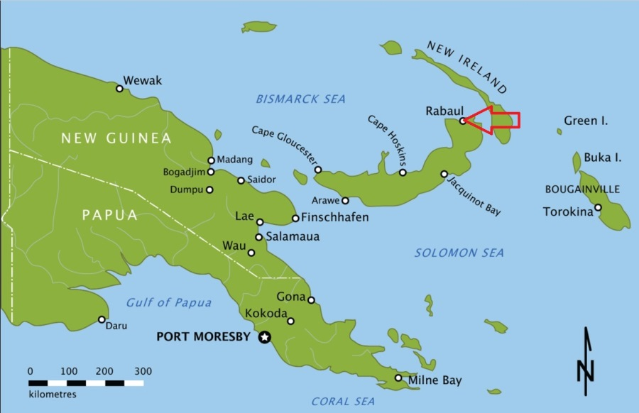
DH Song Will you come and follow me ATOK 413
Will you come and follow me if I but call your name?
Will you go where you don't know and never be the same?
Will you let my love be shown?
Will you let my name be known?
Will you let my life be grown in you and you in me?
Will you leave yourself behind if I but call your name?
Will you care for cruel and kind and never be the same?
Will you risk the hostile stare
Should your life attract or scare?
Will you let me answer prayer in you and you in me?
Will you let the blinded man see if I but call your name?
Will you set the prisoners free and never be the same?
Will you kiss the leper clean
And do such as this unseen?
And admit to what I mean in you and you in me?
Will you love the "you" you hide if I but call your name?
Will you quell that fear inside and never be the same?
Will you use the faith you've found
To reshape the world around
Through my sight and touch and sound in you and you in me?
Leonie brings bowl forward
Lord, your summons echoes true when you but call my name
Let me turn and follow you and never be the same In your company I'll go
Where your love and footsteps show
Thus I'll move and live and grow in you and you in me.
Graham Maule, John L. Bell Reproduced with permission CCLI License #22260685, all rights reserved
BT Offering and prayer- Between table and lectern
Gracious God, we give you our lives , symbolised in the gifts of money presented here or electronically.
Receive them with love , bless them with grace
and use them as you will.
Strengthen our hearts to trust your grace, to be your peacemakers, to do justice, practice kindness and walk humbly with you for the sake of the healing of the world. Amen.

BT Notices Lectern
BT Prayers for Others

Loving God, you are revealed to us in Jesus Christ in whom you became one of us. Remind us of your solidarity with us in all parts of our lives. Strengthen our confidence in you so that we may act with wisdom and grace. Assuage our fears, so that we can be strength and hope for others.
We pray for those who are vulnerable and marginalised, for those whose lives have become difficult and life has brought suffering of body mind and spirit. We pray for those who are grieving the loss of people they love, or their home and properties that have damaged and lost through fire or floods.
We ask your blessing on Doug as he plans for life after his many years of active ministry, May his dedication to preaching and his care of those he served give him give him assurance that he served you and your church with love.
We ask in the name of Jesus.
Amen.

BT Song Let us talents and tongues employ TIS 537
Let us talents and tongues employ,
reaching out with a shout of joy:
bread is broken, the wine is poured,
Christ is spoken and seen and heard.
Jesus lives again; earth can breathe again.
Pass the Word around: loaves abound!
Jesus lives again; earth can breathe again.
Pass the Word around: loaves abound!
Christ is able to make us one,
at His table, He sets the tone,
teaching people to live to bless,
love in word and in deed express.
Jesus lives again; earth can breathe again.
Pass the Word around: loaves abound! Jesus lives again; earth can breathe again.
Pass the Word around: loaves abound!
Jesus calls us in, sends us out,
bearing fruit in a world of doubt,
gives us love to tell, bread to share:
God (Immanuel) everywhere!
Jesus lives again; earth can breathe again.
Pass the Word around: loaves abound! Jesus lives again; earth can breathe again.
Pass the Word around: loaves abound!
Words: Fred Kaan, 1975 Music: Adapt. Doreen Potter, 1975 Reproduced with permission CCLI License #22260685, all rights reserved
AB Invitation

AB THE GREAT THANKSGIVING
God is with us
the Spirit proclaims it.
Lift your hearts.
We lift them up to God.
Let us give thanks to the God we love.
We freely give God thanks and praise.
It is right and meet, beautiful and holy
that we should, in ceaseless joy
Give our thanks and praise to you,
Holy and merciful God,
Through Jesus Christ, our Saviour
And the assurance of the Spirit.
And so, in grateful procession of endless praise
With the church that is, was, and shall be forever,
We glorify you, joining this unending cry:
Holy, holy, holy Lord, God of power and love,
heaven and earth are full of your glory.
Hosanna in the highest.
Blessed is the one who comes in the name of the Lord.
Hosanna in the highest.
Holy are you, Eternal One.
You sit above, through, within the circle of the earth
Setting light into being
Casting the stars in the sky
Founding the evolving earth
And all that dwell within it.
Limitless is your power,
And great is your wisdom.
You look upon the lowly as your most cherished creatures.
You visit upon the downtrodden
With presence, grace, and the promise of eternal justice and mercy.
You came to be with us in Jesus,
Who reached into unexpected places,
Calling women beyond the limits of their times
Equipping men for nurturing love
Welcoming children into your holy embrace.
And so we recall that on the night of betrayal and desertion,
The light of the world took bread, broke and gave it to the disciples, saying: “This is my body, given for you.
Do this for the remembrance of me.” And, in like manner, after supper,
Jesus took the cup and after giving thanks give it to them saying, “This is the cup of the new covenant
poured out for you and for all people
for the forgiveness of sins.
Do this, as often as you drink of it,
for the remembrance of me.”
Dear God, you transform.
all that is before you
So that at the touch of your grace
We are never the same. Dear God, you illumine.
You bring light to all peoples
Light to the nations
Light into our hearts
Light on your Way. Dear God, we pray for your Spirit.
Transform, illumine, bless.
Make these ordinary gifts of bread and cup
Into the extraordinary presence of Christ with us.
For all honour and glory are yours, O God,
Through Jesus Christ,
Who lives and reigns and loves with you and the Holy Spirit in your glorious creation
Both now and forever.
Amen.
Lord’s Prayer
Our Father in heaven
hallowed be your name,
your kingdom come,
your will be done, on earth as in heaven.
Give us today our daily bread.
Forgive us our sins
as we forgive those who sin against us.
Save us from the time of trial
and deliver us from evil.
For the Kingdom, the power
and the glory are yours,
Now and forever, Amen
Distribution – Servers and musicians come forward to be served then the people
AB Post-Communion Prayer
Let us pray:
We have been fed, Holy One, by your presence.
We have been led, Eternal One, by your light.
May we show forth this glow
Now and forevermore. Amen.
DH Song And can it be that I should gain TIS 209
And can it be that I should gain
An interest in the Savior's blood?
Died He for me, who caused His pain?
For me, who Him to death pursued?
Amazing love! how can it be
That Thou, my God, should die for me? Amazing love! how can it be
That Thou, my God, should die for me!

2 'Tis mystery all! The Immortal dies!
Who can explore this strange design?
In vain the firstborn seraph tries
To sound the depths of love divine!
'Tis mercy all! let earth adore,
Let angel minds inquire no more.
'Tis mercy all! let earth adore,
Let angel minds inquire no more.

3 He left His Father's throne above,
So free, so infinite His grace;
Emptied Himself of all but love,
And bled for Adam's helpless race;
'Tis mercy all, immense and free;
For, O my God, it found out me.
'Tis mercy all, immense and free;
For, O my God, it found out me.

4 Long my imprisoned spirit lay
Fast bound in sin and nature's night;
Thine eye diffused a quickening ray,
I woke, the dungeon flamed with light;
My chains fell off, my heart was free;
I rose, went forth and followed Thee.
My chains fell off, my heart was free;
I rose, went forth and followed Thee.

5 No condemnation now I dread;
Jesus, and all in Him is mine!
Alive in Him, my living Head,
And clothed in righteousness divine,
Bold I approach the eternal throne,
And claim the crown, through Christ my own.
Bold I approach the eternal throne,
And claim the crown, through Christ my own.
Charles Wesley Public Domain

AB Special Blessing
DH Commissioning Front of table
Go with us God in all that builds community.
Go with us Christ in all that breaks down barriers.
God with us Spirit in all that reconciles.
Amen!
From Singing while it is still dark (Susan Wickham)
DH Blessing song : May the feet of God walk with you TIS 779
May the feet of God walk with you
and his hand hold you tight.
May the eye of God rest on you
and his ear hear your cry.
May the smile of God be for you
and his breath give you life.
May the Child of God grow in you
and his love bring you home.
Words: Aubrey Podlich; Music: Robin Mann © 1983 Reproduced with permission CCLI License #22260685, all rights reserved AV Team gather at the table for communion

