**Steps to load video files into PowerPoint (2007)**

Select “File” Menu

* From the ribbon select “Movie” (right hand end).
* Select the movie file from dialog box and then click “OK”
* At the next dialog box select “automatic”.
* Ensure the video is that active part of the selected slide choose menu option “Movie Tools”
* Ensure the “play Movie options is Automatic
* Tick the “Play Full Screen” option. (this makes the replay of video full screen regardless of how it is in the edit screen – If the Powerpoint and video are different formats ie one is 4:3 the other 16:9 then manual adjustment of the inserted video will need to be done in the edit screen)

Save your work by clicking the “Office” button.

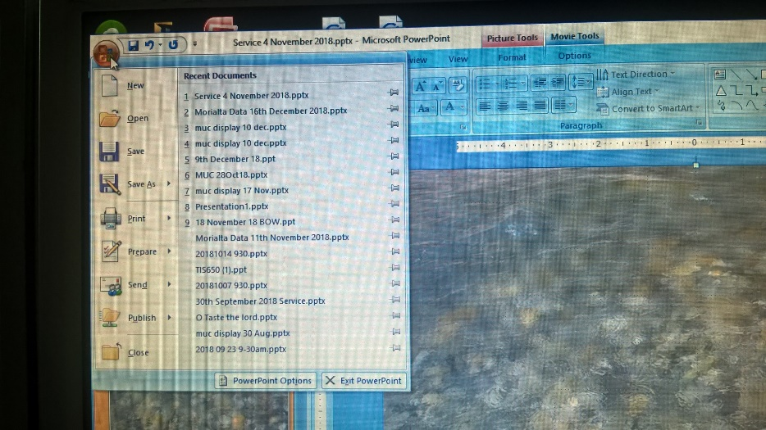

It is best if the Slide before and after the video slide are blank slides.

A note to yourself in the “notes” of the blank slide before the video slide may help you when you are running the PPT (especially if the video starts in black)