Recalling a Scene
When a Scene is recalled all the existing settings will be changed to those contained in the Scene.
At Morialta, a Scene is stored which contains all the latest settings. It is called "Church Master *******" where ******* the date that the scene had been saved. It has probably been saved in location #2. It is to be recalled before the start of every service to ensure that the mixer is set with latest set of mixer parameters.
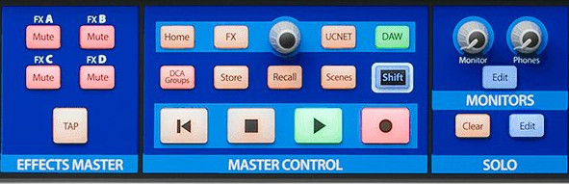
To recall a Scene, press the Scenes button in the Master Control section.
A form containing the stored scenes will open. Use the encoder or the scroll arrows on the touch screen to scroll through the library to the Scene you wish to recall and touch it to select.
Then press the Recall button in the Master Control section.
By default, all the stored parameters (Input Channel Fader levels, Fat Channel settings, channel muting and soloing, aux mixes, and internal effects parameters) will be recalled and the mixer set to these parameters.
Optional Filtering
To the right of the list is a grid of filter buttons. These let you select the parameters you want to be affected when you recall the scene. With the exception of Phantom Power, all filters are enabled by default (blue).
Scene Safe
In some cases, a channel or bus has been protected from being affected when scenes are recalled.
When a channel has been protected from being recalled, a padlock will appear on its scribble strip to alert you that it has been omitted from the Scene that is recalled.

The StudioLive allows you to create and store a library of Scenes. A Scene is a snapshot of your mix. It stores each fader’s position, the aux and effects mixes, channel mutes and solos, all Fat Channel parameter for every input and bus, and so on. Up to 100 Scenes can be saved.

