- Three Preset DCA Groups
Three DCA groups have been established and saved as part of the Church Master scene. They are:
DCA ID | Scribble ID | Input Channel Numbers
DCA 1 | Singers | 11, 12 & 13
DCA 2 | Instrum. | 14, 15, 16, 17, 18, 19 & 20
DCA 3 | Congreg. | 21 & 22
- When the Church Master scene is recalled these three DCA groups will be recalled.
- Input channel faders 11, 12, 15, 16, 17, 21 & 22 are preset to unity gain.
- Input channel faders that are normally (or rarely) used in a service (eg. channels 13, 14, 18, 19 & 20) are set to zero.
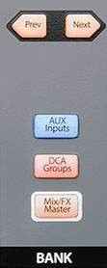
- A white strip of tape has been placed under the input channel fader numbers 11 to 22 to indicate that they are controlled by DCA groups.
- During the pre-service checks
- Press the DCA Groups button in the Bank section to select the DCA Groups layer. This will configure the right eight faders (25 to 32) to be the DCA master faders.
- Move one of the DCA group master faders and check whether any input channel faders move. No input channel fader should move. If some do move it means that the DCA is not in the correct mode and must be reset to "Traditional DCA" mode. To do this see Section 1. on the next page under For the "Advanced" Operators only.
- Lower any input channel faders that will not be used in this service.
- Adjust all the faders that will be used to their initial setting for the service.
- During the service
- Raise the appropriate DCA group master fader as required. Adjust individual input channel faders if necessary to maintain the correct balance.
- Lower the DCA group master fader when no longer required.
- Note that these actions do not alter the position of the actual input channel faders. Leave them at the desired setting.
- How to stop using the DCA Group Faders
If you do not wish to use DCA groups or want to stop using them during the service:
- Set the DCA group master faders to unity gain.
- Then just ignore the master faders and use the actual input channel faders as normal.
- You can remove the DCA Groups layer by pressing the DCA Groups button in the Bank section (be sure that the DCA group master faders at unity gain first).

For the "Advanced" Operators only
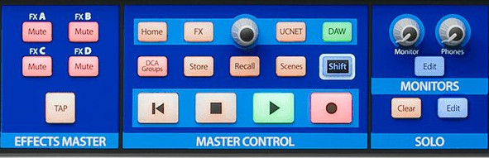
- Setting the "Traditional DCA" mode
- To create a new DCA Group, press the DCA Groups button in the Master Control section.
- This will open the DCA Group edit form.
- If the Traditional DCA button is highlighted then the "Traditional DCA" mode has been set. If not then press the button to set the mode.
- Once set, the DCA Groups will operate in "Traditional" mode. This means that the input channel faders will not move as the DCA group master fader is moved.
- During the pre-service checks
- Check that the DCA groups have been correctly set to the required input channel faders. To do this press each of the DCA master faders Select button in turn and check the input channel faders that are "spilled out" on the left fader bank are correct for that DCA group.
- Add any other faders that may be required for a DCA group.
- Create any new DCA groups that may be required.

See the document "Input Channels & Outputs.doc" for information about the Input Channels Numbers.

