- Receive the order of service from the service organiser. This will usually be by Tuesday or Wednesday before the Sunday service. Please allocate time to prepare the PowerPoint presentation asap. Text to be included on slides will be in bold font. Include only what congregation members need for participation – omit headings and sources.
- Normally you will attend a ‘talk through’ of the details of the service, usually held via Zoom on the Wednesday evening before. If you are unable to attend, liaise with the worship curator (service organiser) to make sure any changes decided on that affect the projection are noted and communicated to you.
- Prepare the Power Point Presentation with these general guidelines (but there will sometimes be exceptions: please consult with the worship curator):
  - Slide size to be set to Widescreen (16:9) (under Slide Size on the Design menu)
  - The background to be black
  - Text colour to be
    - bright yellow and bolded for all text to be read or sung by the congregation (we have many members with vision limitations), and
    - white plain (un-bolded) for text read or spoken by a worship leader that needs to be projected, including bible passages where these are in bold in the service order (these can fill the full slide area, as they are not livestreamed).
  - Font: Arial Narrow
  - Font size: Minimum 36, Preferred 40 or 44
  - Justification: Left justification is conventional for readability, but centre justified may be used. Full justification should not be used.
  - No text must appear within 7% of the edges of a slide: top, bottom or sides; aim to keep all content well away from the edges of the slides so they will project fully on both our projectors.
    - The intro video has this 7% automatically included, so can be inserted as full screen. Other videos and images should be considered on a case-by-case-basis: generally, insert them as full screen and check in Slide Show if any crucial material is located in the margin spaces – if so, reduce the image size to allow a margin all round.
  - Insert a black slide at every logical break point. Do not place a black slide between the title slide and the introductory video.
  - Do not place text over graphics / pictures etc. unless you have first checked in the church environment.
  - Liaise with the rostered Video Editor for the week re obtaining and inserting the required video segments.
- Title slide: Please include the following wording, or similar, at the bottom of the slide: “If you do not wish your image to be included in the livestreamed video, please sit in the rows on the Western side, in front of the projection desk.”
- Guidelines for preparing text for responsive reading:
  - Easy discrimination between leader and ‘people’ is essential and can be achieved by using white / yellow text as above.
  - Maximum lines per slide: 5, placed on the lower half of the slide only, to allow for ‘Picture in Picture’ presentation in the livestream video.
  - Ensure the last line of leader text and the first line of response text are on the same slide.
  - Where the leader’s text is lengthy, omit the bulk of it and only show the last line or so. Make it clear that there is text missing using three dots only:
e.g. … and the blessing of the Lord be with you.
Amen
- Guidelines for preparing text for hymns / songs
  - Preferred practice is to copy and paste hymn/song words directly from the Order of Service onto the slides. If the full words of the songs are not included in the Order of Service you receive, you may wish to use our song library. PowerPoint files of songs that we have used in the past are stored at http://www.morialtauca.org.au/songs/
    - Note that this data resource has been developed over several years and contains a number of errors of spelling, text, punctuation. Songs copied into your presentation MUST be checked for accuracy.
    - Do not use the first title slide from the songs in the library; use the words only, plus a small-print acknowledgement of authorship and copyright status, as below.
  - Maximum lines per slide: 5, placed on the lower half of the slide only, to allow for ‘Picture in Picture’ presentation in the livestream video.
  - On the final slide for each hymn/song, insert a text box of a suitable size/orientation and present in very small font (readability is not an issue here) authorship details for words and music and the license information. Follow this example: TiS 648. Words: Frederik Herman Kaan, © Stainer & Bell Ltd, London; Music: Brian Hoare, © Jubilate Hymns, Southampton UK. Reprinted with permission under ONE LICENSE #A- 604530. All rights reserved. (The highlighted information is very important to include.)
  - Hymn text is written specifically to portray the poetry and break points for breathing in singing. Therefore, punctuation is important.
  - Left justification is more important in the presentation of hymns / songs.
  - Wherever possible, present a line of print from the book/service order in one line on the screen. (Adjust the font size for the whole hymn if necessary)
  - When it is essential to wrap around a line, start a new line for the next line.
  - Choruses can be distinguished by using italic font style.
  - Make a repeat slide for every time the chorus is sung so that you do not have to back track in the presentation.
  - Check that the chorus is/is not repeated after every verse.
  - Watch out for complex repeats. Where there is any doubt about how many repeats (of say, the last line), check during your compilation with the rostered pianist.
  - Where selected verses of a song are used, check that the correct verses have been copied for the slides.
  - Check, check, check.
Read through your text with a hymnbook or the order of service.
Run your presentation and ensure that all the verses are in order, any choruses are in the right place, and any repeats are included (and the correct number of them).
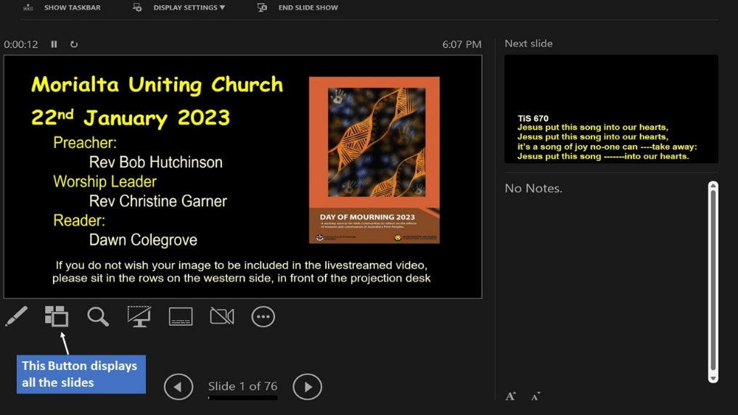
  - To make it easier to find a required slide quickly, during the sing-through (see final section of this document) or at other times, we recommend that you write, on a printed copy of the order of service, the slide number for the first verse of each song. Then, once you are in Slide Show mode, type the slide number and hit Enter to display the desired slide. (Alternatively, click the ’Show all slides’ icon on the Slide Show management page on the church computer – identified by the blue box in the picture. This will show all the slides and enable you to click on the one you want. However, the screen will then revert to the management page, not to the all-slides view.)
- Send a copy of your PowerPoint file to the Vision Director for co-ordination with the vision script: For ease of sending, make a version with the videos removed and replaced by a marker slide.

- Loading PowerPoint file onto the projection computer and turning on projectors
  - If the power has not already been turned on by others, follow this procedure. "AV power" is turned on by three power switches in the Control Room, to the left of the door as you go in.
  - Note: Do not turn all three on together as the current surge may trip a circuit breaker. Turn on the middle power switch first. Then wait a few seconds. Then turn on the other two switches.
  - Then switch on the computer you will use and load your file to the desktop – either the church computer (switch under the projection desk), OR your own laptop, which must be connected by the red cable and the switch on the red box set to position 2. Make sure the computer is on, PowerPoint is running your file and in Slide Show mode before turning on the projectors.
  - When you open your PowerPoint file, go first to the Slide Show top menu and ensure that the box labelled Show media controls (in the central section) is un-ticked. Then proceed as usual.
  - Play your file in Slide Show mode and check whether the transition from the title slide to the Intro Video requires one click or two – remember this for later use! Do the same check for any other videos in the service slide-set.
  - The projectors are turned on via remote controls left on the desk (grey for front projector, white for rear one). After you turn on the rear projector, turn on the SDI to HDMI converter (located on the projector shelf) with the extra remote provided; its red on-light will be visible. Point the remotes to the relevant projector when turning on/off.
  - A remote to control the front curtains is also on the desk.
- Checks that need to be performed including the sing-through with musicians and singers 9:00 – 9:20 am Sunday
  - At about 8:50 the audio operator will ask you to play all the videos to check the sound levels and audio quality.
  - At about 8:55 the Vision Director will ask you to display any slides that will be streamed alongside live camera shots (e.g. for Acknowledgement of land).
  - At 9:00 am on Sunday you will be needed for a rehearsal session organised by Rev. Bob or someone he delegates.
  - From 9:00, you will be asked to display all song words screen by screen so the musicians/singers can play and sing through each verse.
  - Once all checks are completed, display the title slide.
  - When the light on the desk (green) illuminates to indicate the service is ready to start, wait till the pianist stops playing. Then advance the slideshow to the Introductory Video and proceed through the service as prepared.

