Resetting Morialta’s lighting control system (Church)

- Start Light factory with LightFactory.exe (Icon should be on desk top) and wait for it to open etc may take a minute or so.

- Run lfib.exe (this should also be an icon on the desk top) if not it will be in the program files - lightfactory

- This will open 2 windows – they may be on top of each other

- Separate the 2 windows 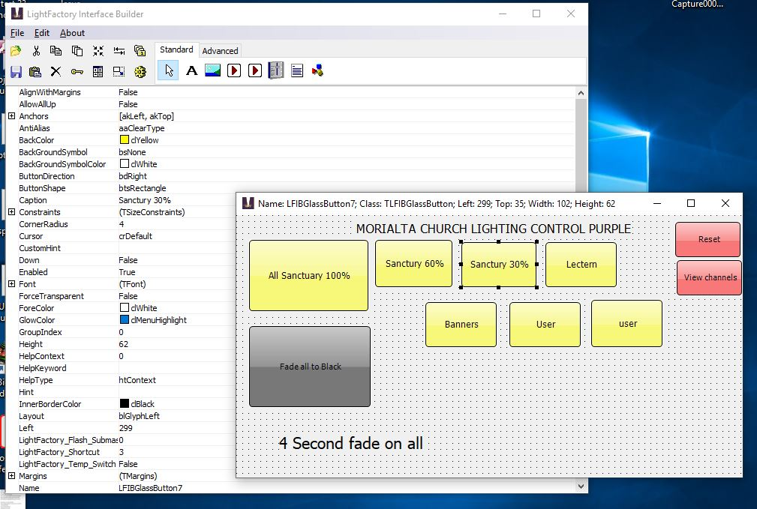

- On the window with “file”option click to open file and open the required ****.lfi File

- On the same window click a cog looking symbol called “Run/Test”
- In server box type “Local Host” (it may come up as the default) 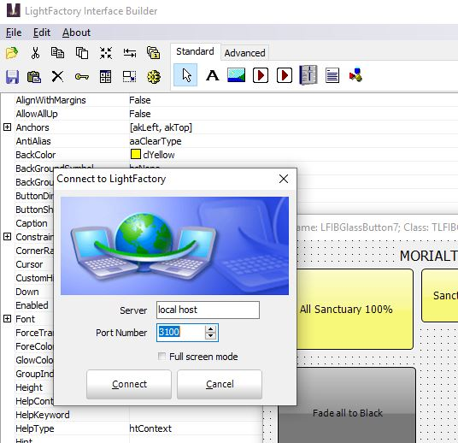

- Click connect box 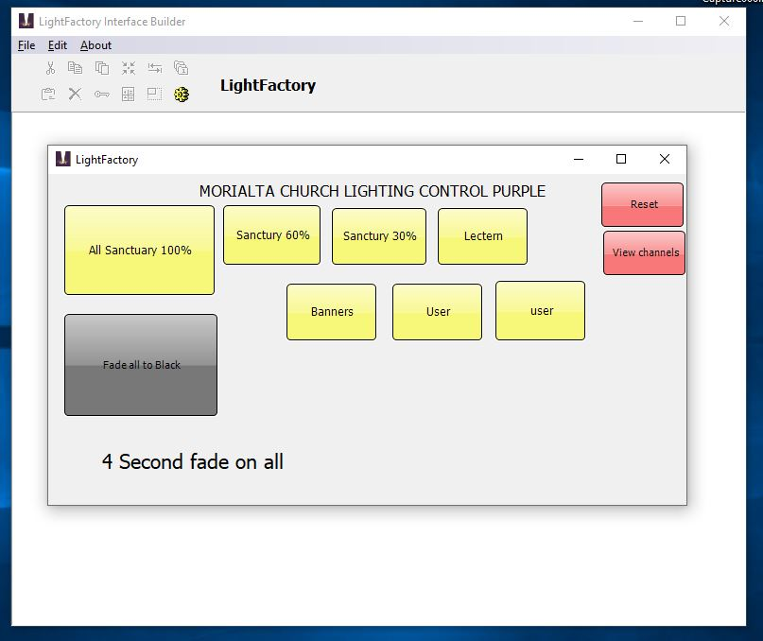

- It should be working???!!!

