Morialta Church Lighting Control

The easy to use front end
We have tried to keep it looking simple with only a few buttons.
A different file will need to loaded for each colour wash on the raredos or special occasions.
The name at the top of the screen will tell which file has been loaded – (loading files later)
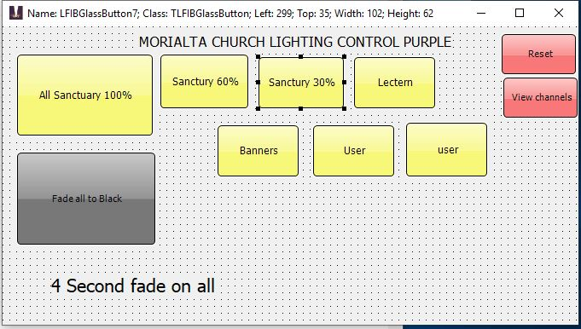

Each yellow Button will change the light state to what the button indicates over a 4 second fade time.
Grey button fade to black over 4 seconds.
Red Button reset (panic) is for when things are not going right – Will turn all lights off – May require 2 clicks.
Red View button for more advanced users – will take you to a screen that allows control of single lights.

To Change the file to change the colour or for a special occation
Behind the control window there is another window
Separate these 2 windows as below
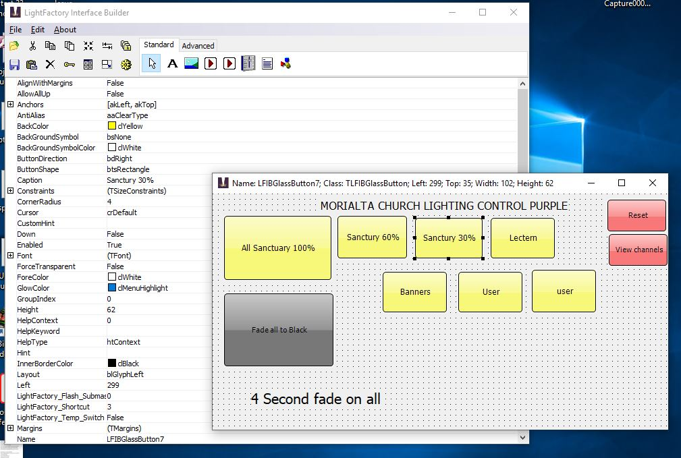

In the window called “LightFactory interface Builder” - Select the cog looking symbol called “Run/Test”
This will disable the operating window.
Close the operating window with the “X” in the top right corner
In the window called “LightFactory interface Builder” – click on “file”option - click on “open” and select the required file *****.lfi

On the window with “file”option click to open file and open the required ****.lfi File

On the same window click a cog looking symbol called “Run/Test”

In server box type “Local Host” (it may come up as the default)

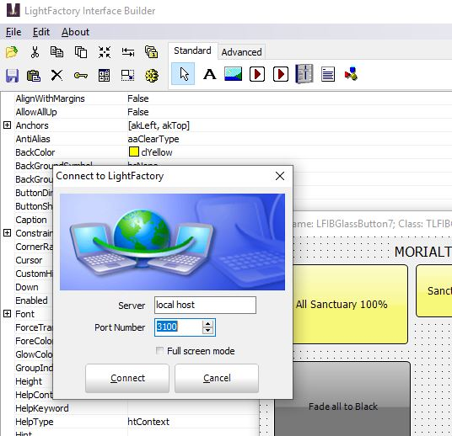

Click connect box

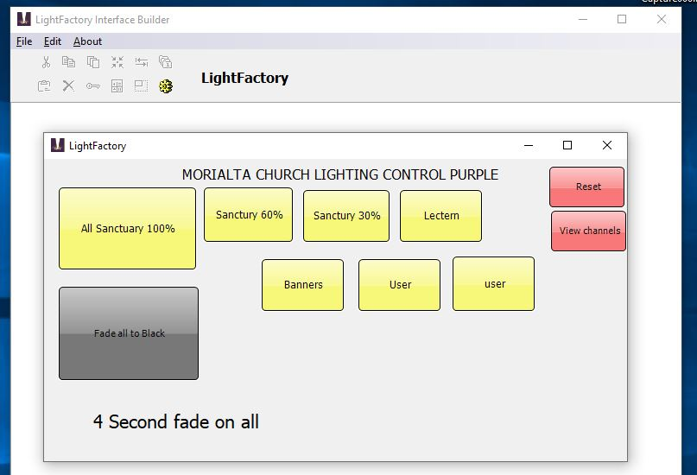

It should be working???!!!

The file options to date are:
Standard church – purple.lfi
Standard church – red.lfi
Standard church – white.lfi
Standard church – green.lfi
Maundy Thursday.lfi
Good Friday.lfi
Easter Day.lfi
All of the options in each of the files are all available in the system in an area called “Short Cuts”
List of all current “short cuts
Short Cut | Name
1 | Sanctuary 100% Purple R
2 | Sanctuary 60% Purple R
3 | Sancuary 30% purple R
4 | Lectern purple R
5 | banners purple r
11 | Sanctuary 100% green
12 | Sanctuary 60% Green R
13 | Sancuary 30% Green R
14 | Lectern Green R
15 | banners Green R
21 | Sanctuary 100% White R
22 | Sanctuary 60% White R
23 | Sancuary 30% White R
24 | Lectern White R
25 | banners White R
30 | blackout
31 | Sanctuary 100% Red R
32 | Sanctuary 60% Red R
33 | Sancuary 30% Red R
34 | Lectern Red R
35 | banners Red R
40 | space
50 | standart - no fade time
60 | sweep
71 -75 | Maundy Thursday
76 | Good Friday
81- 88 | Easter Day

Controlling each light
Click on the red button “View Channels and then attend the next lighting course.

